MARTIN LUTHER KING JR

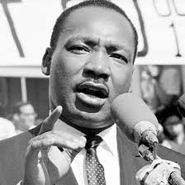
The following websites will help you to find all the answers :

http://www.enchantedlearning.com/history/us/MLK/
http://projects.seattletimes.com/mlk/index.html
https://www.infoplease.com/heroes-civil-rights-movement http://www.socialstudiesforkids.com/articles/ushistory/mlkihaveadreamspeech.htm

1) When and where was Martin Luther King Jr born ?

2) What was his father’s job? What was his mother’s job ?

3) Martin Luther King Jr. became a minister in Alabama. Find Alabama and Georgia on a map of the United States, and say if they are Northern states or Southern states.

4) When Martin Luther King Jr. was a child, black people did not have the same rights as white people in the Southern states of the USA. Give two examples of inequality. (https://www.floridamemory.com/onlineclassroom/civilrights/photos)

5) So what did he decide to do ?

6) Martin Luther King Jr. advocated non-violent action. What sort of actions did he organise ?

7) What was the name of his wife ? Did he have any children ?

8) What prize did Martin Luther King Jr. receive and when ?

9) When and how was Martin Luther King Jr. killed ?

10) How do people in the US commemorate his life and achievements ?

11) Martin Luther King’s most famous speech is “I have a dream”. What was his dream ?

12) Where did he deliver his speech ? Why was it important ?

13) What happened in 1964 (that is to say only one year after the famous speech) ?

