
Lesson 4: The Civil War
https://www.dailymotion.com/video/x2zj18f

Part 1 – What led to the Civil War? Complete the tables. 0:19-0:44
a, How it started:
When?
How many states seceded?
What does “secede(d)” mean?

b, The two enemies:
Name
President

Part 2 – The reasons. Finish the sentence and answer the question. 0:54 – 1:05
a, The secession was the “trigger” for the Civil War, the real reason was the disagreement over ________________________.
b, A trigger is a cause, an excuse to start a war. How would you say it in French? ________________________

Part 3 – The beginning of the war. Complete the table. 1:14 – 1:54
When?
What?
Where?
Why?
The consequences:
Number of states that stayed with the Union:

Part 4 – The Civil War’s beginnings. Label the pictures. 1:55 – 3:03
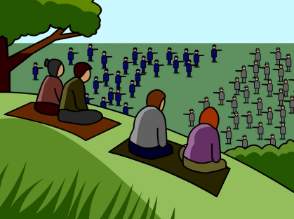
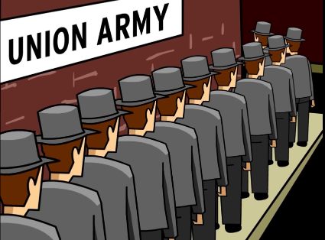

What was his title?

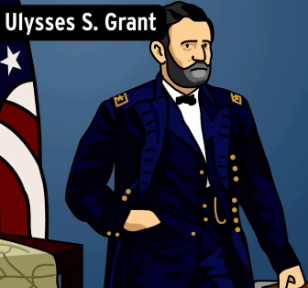
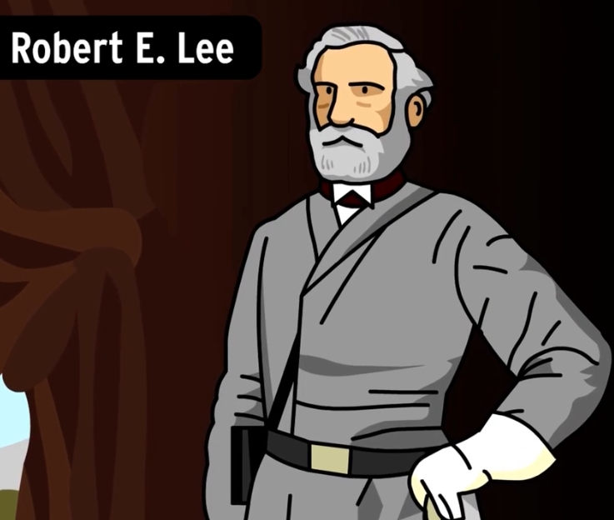
Whose part was he on? (the Confederacy/ the Union)
Whose part was he on? (the Confederacy/ the Union)
What was his title?

Part 5 – The Emancipation Proclamation 3:04 – 3:44

When?
Who?
What for?

True or false? (underline the false elements and correct them)

a, There were no states left that held slaves. T F
Correction: ______________________________________________________________________________________
b, The Confederacy formed units of all African American soldiers. T F
Correction: ______________________________________________________________________________________
c, Slavery was abolished in all states in 1865. T F
Correction: ______________________________________________________________________________________
d, The Battle of the First Battle of Bull Run was a turning point. T F
Correction: ______________________________________________________________________________________

Part 6 - The end of the Civil War. Write the keywords next to the picture. 4:15 – 4:48

