

WHAT ARE YOU LIKE?
- Read the following adjectives and highlight the ones you understand.
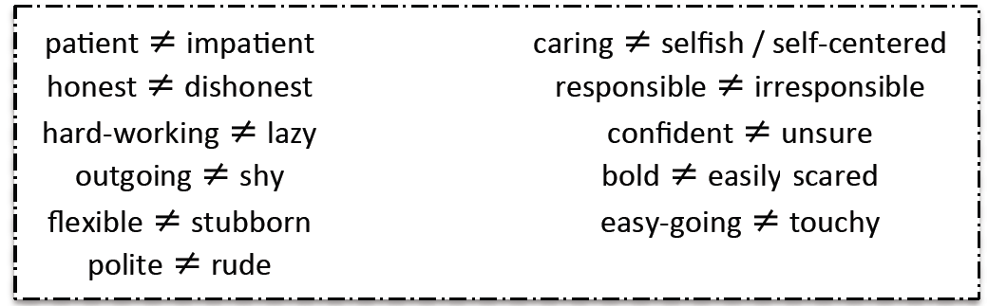

- Read the definitions and find the corresponding adjective.
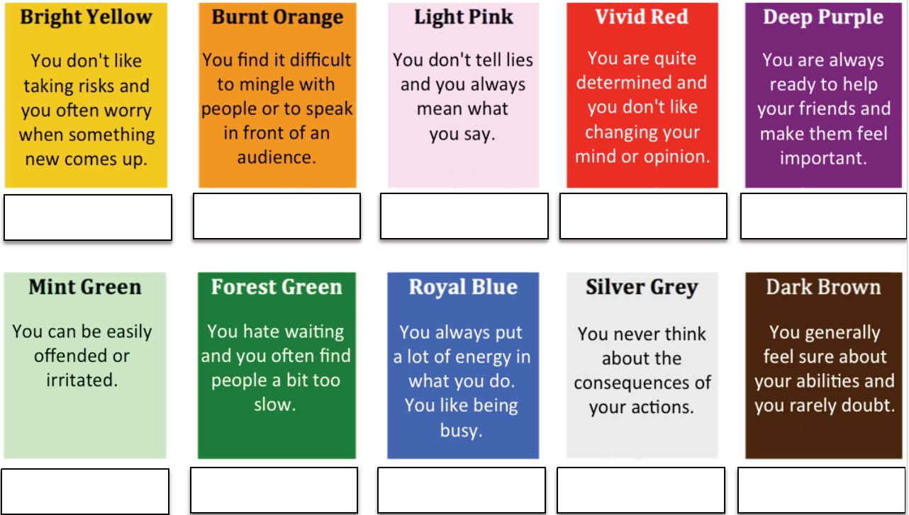

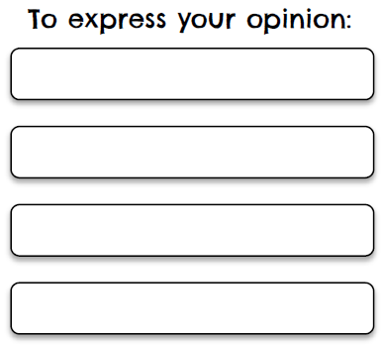

WHAT ANIMAL ARE YOU?
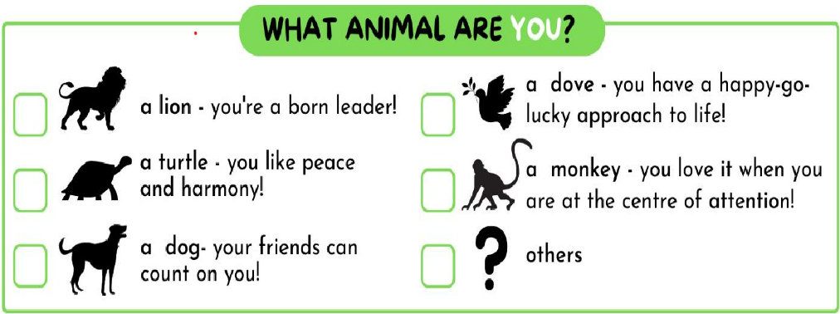





DO YOU HAVE…?

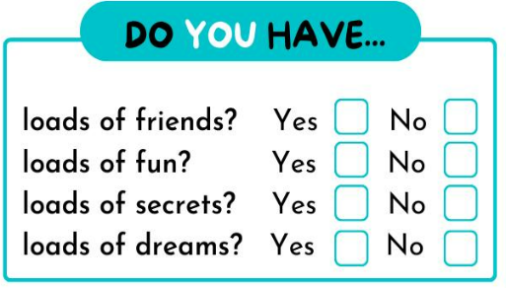




WHAT CAN’T YOU LIVE WITHOUT?

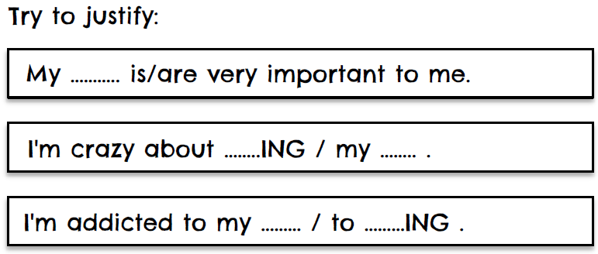
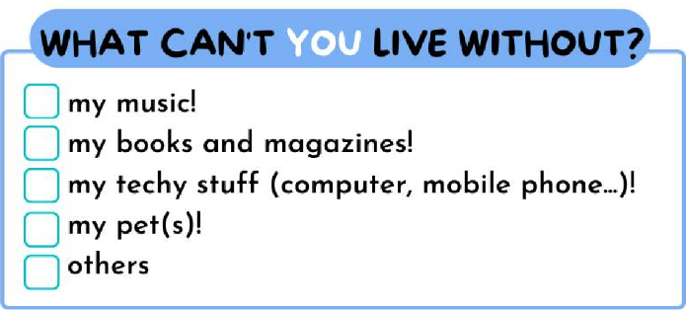

DO YOU ENJOY…?
WHAT DO YOU LIKE DOING ON A SATURDAY?

