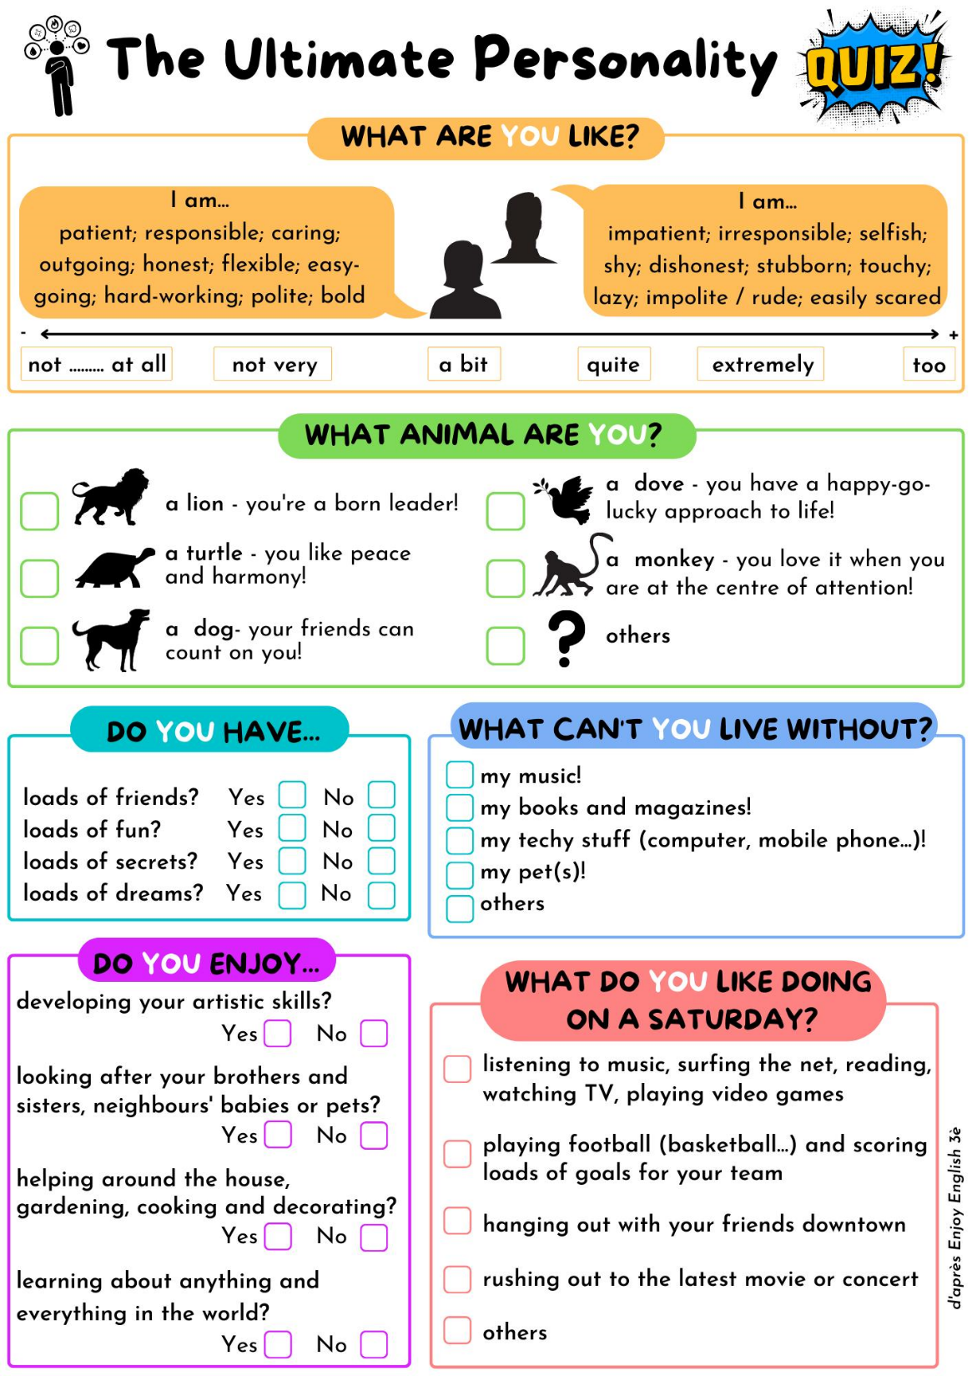
x
x
x
x
x
x
x
x
x
x
extremely hard-working
quite polite
not very impatient
x
x
x
x
a bit stubborn
extremely hard-working
not selfish at all
Charlotte
James

