
STEP 3: MAKE A GROUP PRESENTATION ABOUT A FEMINIST TOPIC
- form groups of 4 people
- choose your topic:
EQUAL PAY SEXUAL HARASSMENT WOMEN’S RIGHTS
BODY IMAGE ACCESS TO WORK
GENDER STEREOTYPES DOMESTIC VIOLENCE
- make an oral presentation based on this structure:
1. Present the topic (what is it?)
2. In the past
3. Nowadays
4. Solutions
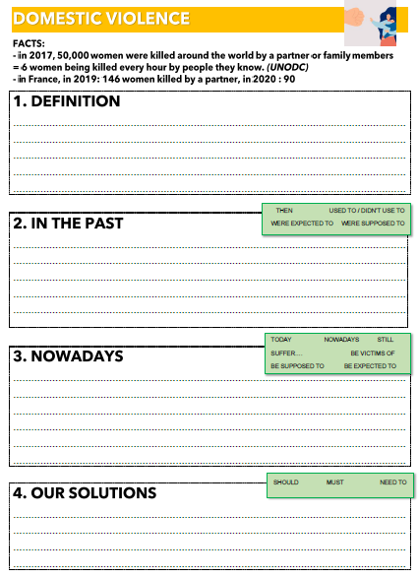
- Complete this worksheet
(use the facts and statistics, and the vocabulary)

- Choose who will present each part

- Practice your presentation (pronunciation, intonation)

- Don’t read your text, use it to help you

