Vocabulary for the unit
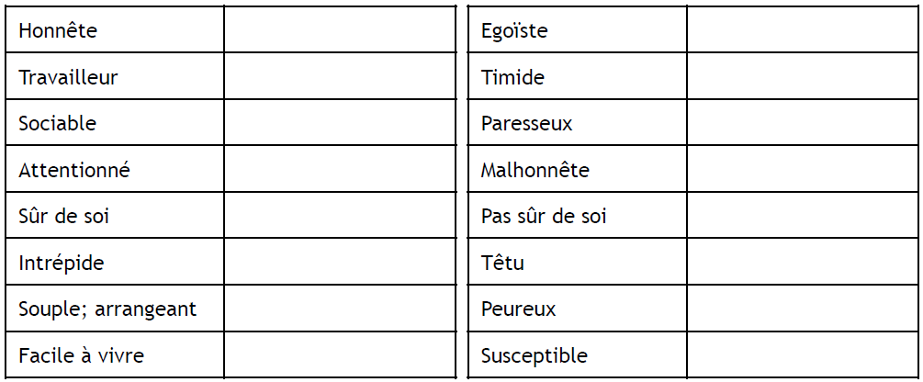
Ex. 2. Find the equivalent in English:
Ex. 3: Find the words:

What animal are you?

Do you enjoy… + What do you like doing on a Saturday?

Vocabulary for the unit
Ex. 2. Find the equivalent in English:
Ex. 3: Find the words:

What animal are you?

Do you enjoy… + What do you like doing on a Saturday?

