PART TWO: WOMEN’S INFERIORITY IN THE WORKPLACE
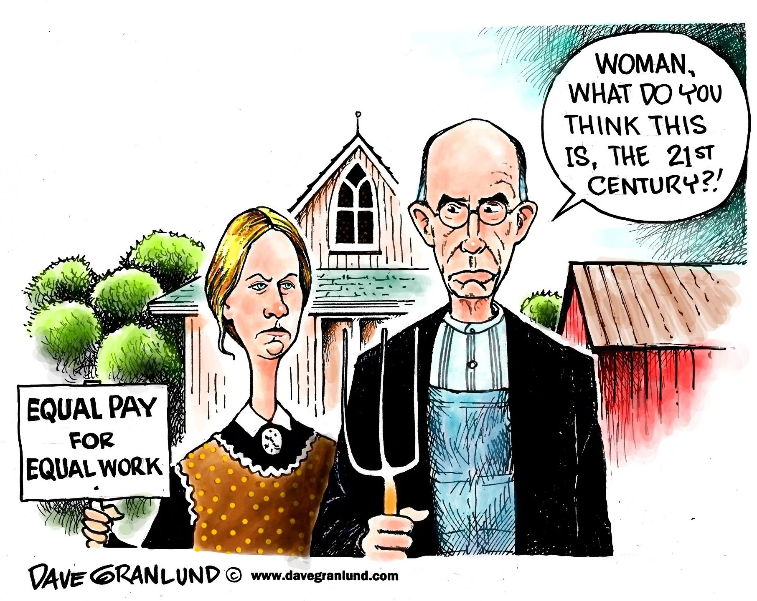
CARTOON: “The gender pay gap” (Dave Granlund, “Equal pay for equal work”, 2014)

VIDEO: “Explaining Patricia Arquette’s speech at the Oscars” (Wall Street Journal, 2015)

Type of document
Where?
When?
Who?
What?
How much?


SPEAKING: Work in pairs. You are two HR managers in a movie company. Present why women actresses are victims of discrimination. Explain how discrimination can impact their motivation and/or the company’s image.
MORE… THAN… ADJECTIVE + ER… THAN…
LESS… THAN…
Good morning everyone! Today we will talk about gender discrimination. We think men and women are unequal in our company because… Discrimination can have negative consequences. For example,...
Thank you for your attention.

ARTICLE: “Eliminating the glass ceiling” (Melanie Lockert, Business Insider, 2022)

- Read the text.

- Highlight elements to answer who/where/when/how many.

- Find a title for each paragraph.
Many women and minorities face discrimination and are often not chosen for top jobs because of the "glass ceiling." This term was first used by Marilyn Loden in 1978 at the Women’s Exposition in New York. It is a metaphor for the invisible barriers that stop women and people of color from moving up in their careers.
Between 1991 and 1996, the U.S. Department of Labor studied this problem through a group called the Glass Ceiling Commission. In 1995, they found that most leadership positions in companies were held by white men.
Today, more women than men get higher education degrees, and women are very important to the workforce. Still, there are fewer women than men in top positions like CEO (Chief Executive Officer), CFO (Chief Financial Officer), or CMO (Chief Marketing Officer). In 2021, the Bureau of Labor Statistics said that women made up only 29% of all chief executives. Another report in 2021 showed that only 8.2% of CEOs in the 500 biggest U.S. companies were women. That means 459 of the Fortune 500 companies were still led by men.
This is not because women don’t have talent or ambition. Instead, people who make hiring decisions often have unconscious bias and don’t always see women’s skills. Human resource (HR) managers need to be careful not to follow these stereotypes. Companies should try harder to hire women and minorities for leadership jobs. They should also be open and clear about how they hire and promote people.
Write a report. First, define what the glass ceiling is. Then, explain the position of women in American companies today. Finally, present measures that companies can adopt to limit gender discrimination.

SPEAKING: You are a member of the Women Business Collaborative, which is in charge of presenting the 2021 “Women CEOs in America” report. Introduce the report and its conclusions at the American Economic Association’s annual meeting.

MORE / LESS… THAN… MUST + BASE VERBALE
Ladies and gentlemen, today we are here to introduce the 2021 “Women CEOs in America” report.
In the United States, women…
To stop discrimination, companies must… Thank you for your attention.

