Moko controversy
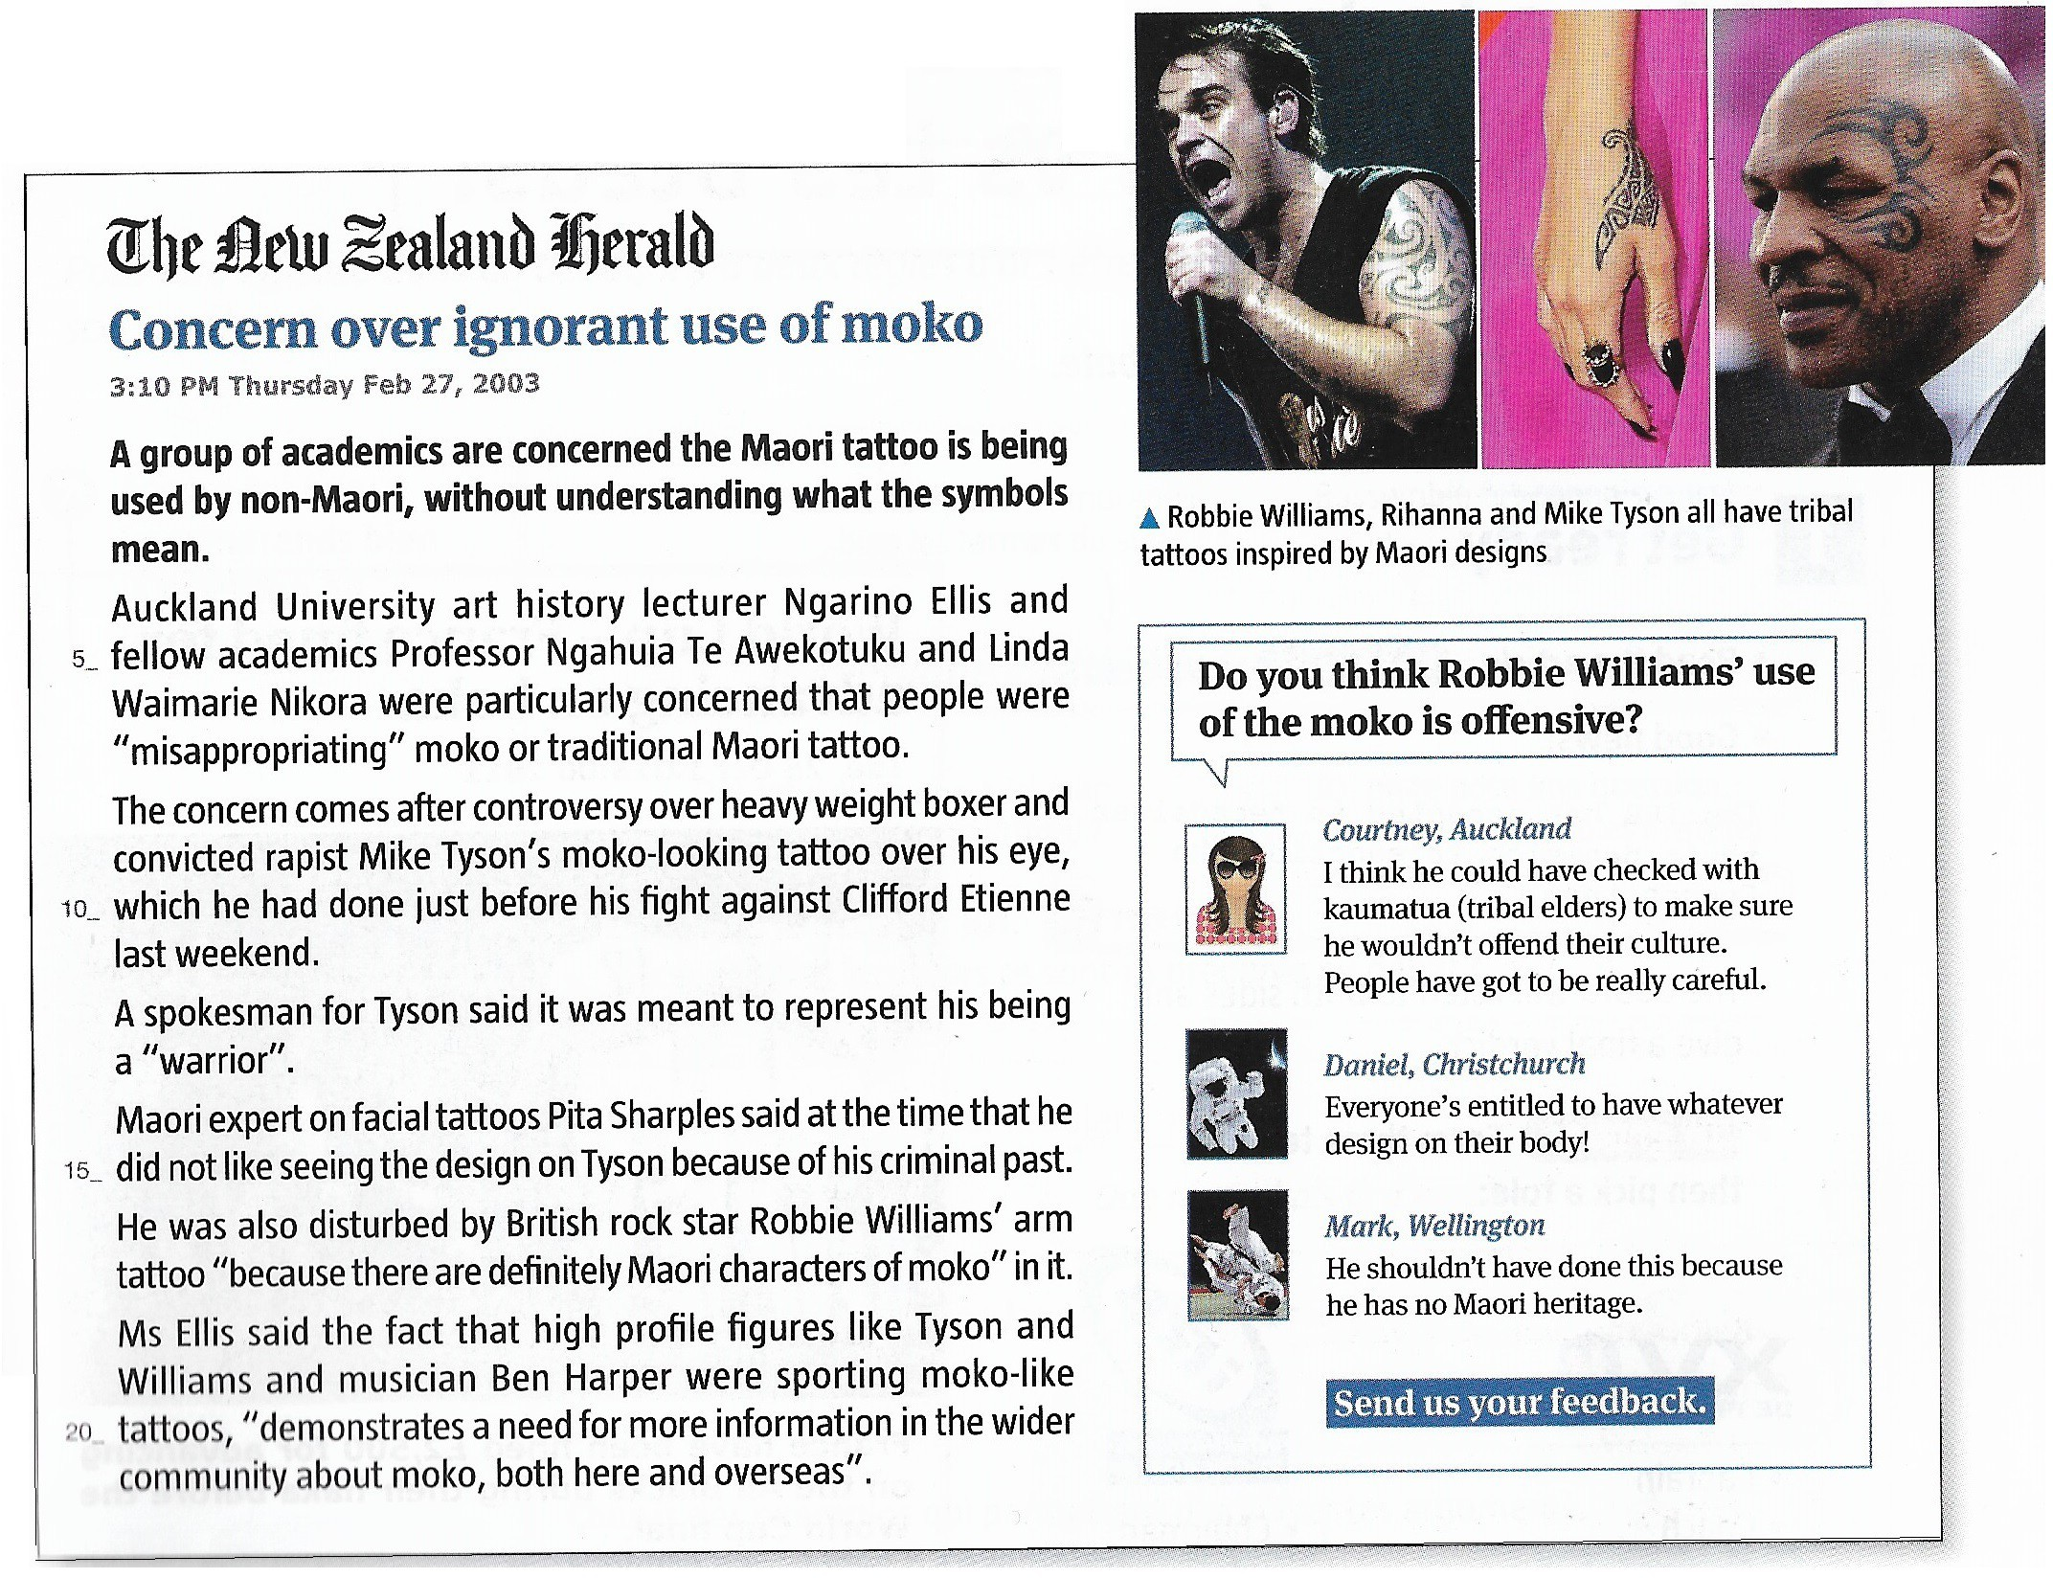
Activity 1 : Reading comprehension

- Present the text (type of document, title, date, author, main topic...)

- Look at the photos. Why do you think these celebrities chose such tattoos ?

- Read the text. Underline/highlight in different colours the elements that correspond to :
Concern
Ignorant use
Maori moko

Activity 2 : Your opinion matters
I think...
In my opinion, ... For me, ...
In my view, ...
Focus on the feedback on Robbie Williams' use of moko.
Do you agree with Courtney, Daniel or Mark ?
Write your own feedback and justify your opinion.

Grammaire: should have, could have, must have

Lis les phrases suivantes extraites des commentaires des internautes.
  - He shouldn't have done this.
  - I think he could have checked with kaumatua (tribal elders).
  - That must have hurt the Maoris.
Ces structures permettent d'exprimer :
- une suggestion après coup = phrase ...
- une hypothèse = phrase ...
- un reproche/ un jugement = phrase ...
Pour exprimer un point de vue (suggestion, hypothèse, reproche...) à propos d'un fait passé,

on a besoin d'un …............................, comme should, must, could
+ …………………………………… à l'infinitif + le verbe au ……………………………..………
1. Souligne la bonne expression:
- We (should have / could have / must have) listened to the guide more carefully.
- He (should have / could have / must have) gone to Rotorua if he had had more money.
- You (should have / could have / must have) tried traditional Māori food.
- They (should have / could have / must have) stayed longer if they hadn’t been tired.
- She (should have / could have / must have) been more careful with nature.
2. Complète avec should have, must have ou could have puis ajoute le participe passé du verbe indiqué.
- Captain Cook (think) he had stumbled into paradise
when he arrived in New Zealand.
- Do you think scientists (predict) this earthquake ?
- It was a frustrating game – the All Blacks (win).
- I (agree) to do bungee jumping – I'm scared of heights !
- We were supposed to take the bus to Wellington at 4pm, he …............................................... (forget).
3. Traduis en anglais
- Il a dû aimer la culture maorie.
- Tu aurais dû respecter les animaux.
- Nous aurions pu visiter l’île du Sud.
- Elle a dû être impressionnée par les paysages.
- Ils auraient pu prendre plus de photos.

