Bonus – science and english : speed limit

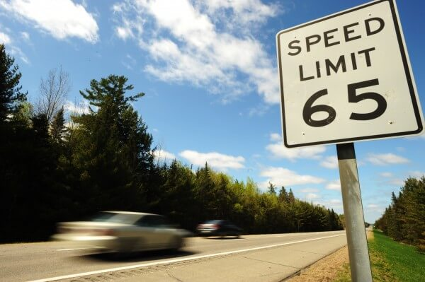

Why this american sign
can be very dangerous for french drivers ?

