Bet You Didn’t Know – Rosa Parks

🟢 LEVEL A2 – Understand the main idea
Listen to the video and answer the questions.
- Who is the video about?
- Where does the story take place?
- What did Rosa Parks refuse to do?
- Was segregation fair? Why?
- Name one other person in the video.

🔵 LEVEL A2+ – Understand and explain
Listen again and answer in 1 or 2 sentences.
- Why is Rosa Parks famous?
- Who was Claudette Colvin?
- Why does the video say Rosa Parks was not the first ?
- What happened because of Rosa Parks’s arrest?
- Why did Rosa Parks say she refused to move?

🟣 LEVEL B1 – Analyse and justify
Answer in complete sentences.
- Why was Claudette Colvin important in the fight against segregation?
- Why were Black leaders looking for a “test case”?
- How does the video change the story of Rosa Parks?
- Do you think Rosa Parks’s action was spontaneous or prepared? Justify your answer.
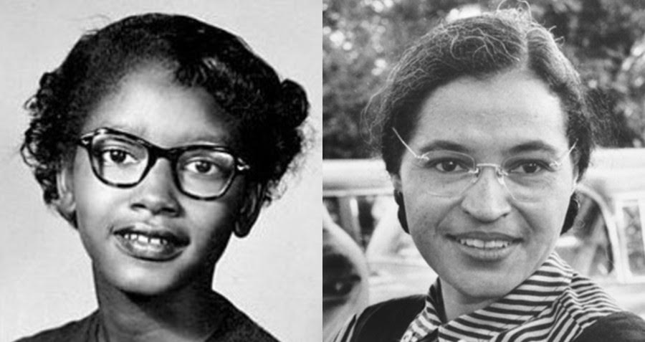
- Why does the video talk about “ordinary women”?

