Tree seeds
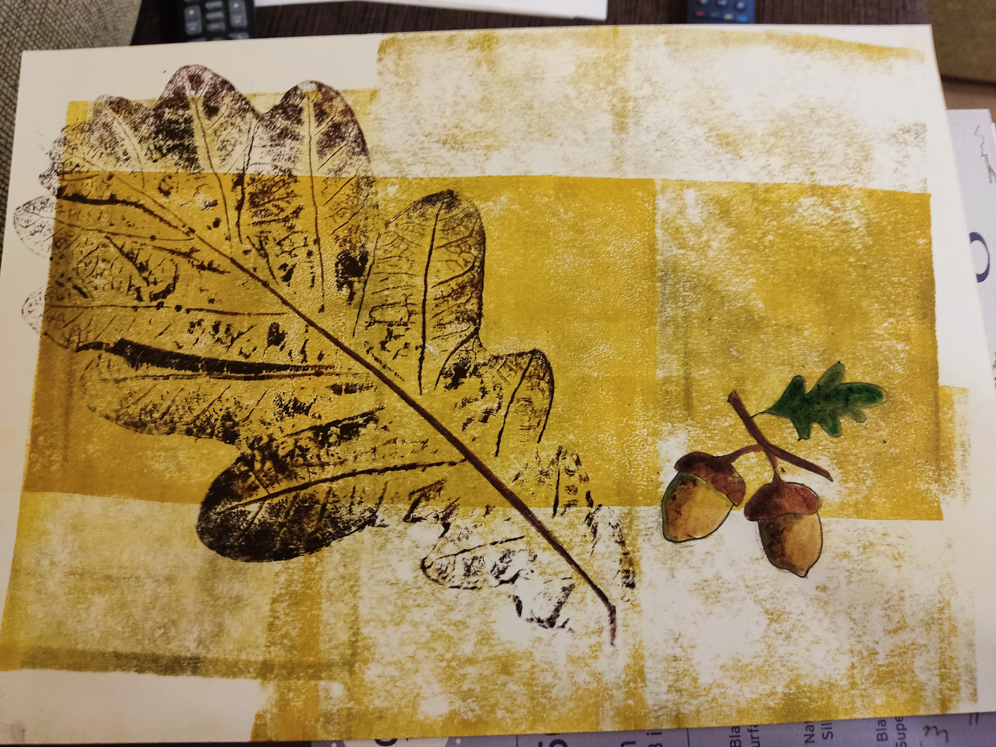
Summary.
A series of paintings showing different trees and their seeds.
Resources.
Paper, graphic roller, Aquawash graphic paints, tree leaves, markers.
Workflow.
Rolling graphic inks onto glass or plastic, transferring the inks onto wood leaves with a roller. The wood leaf with the ink is placed on a clean sheet of paper and pressed down. Draw the tree seed with felt-tip pens.
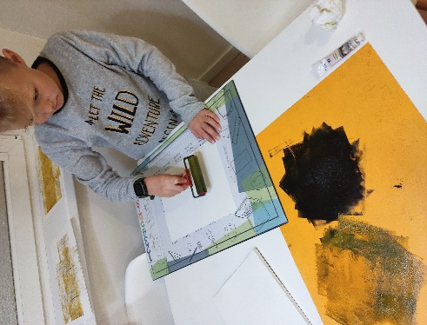
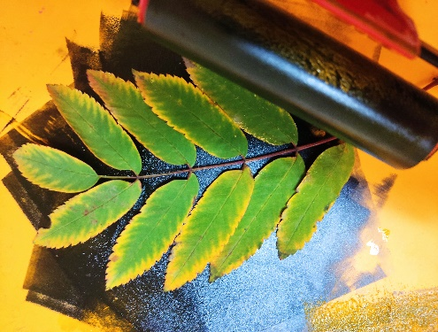
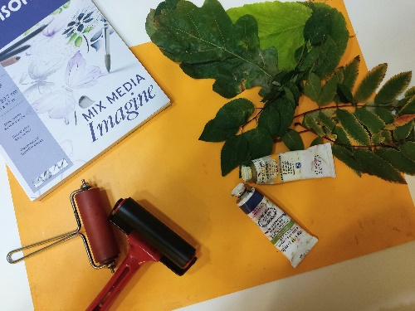

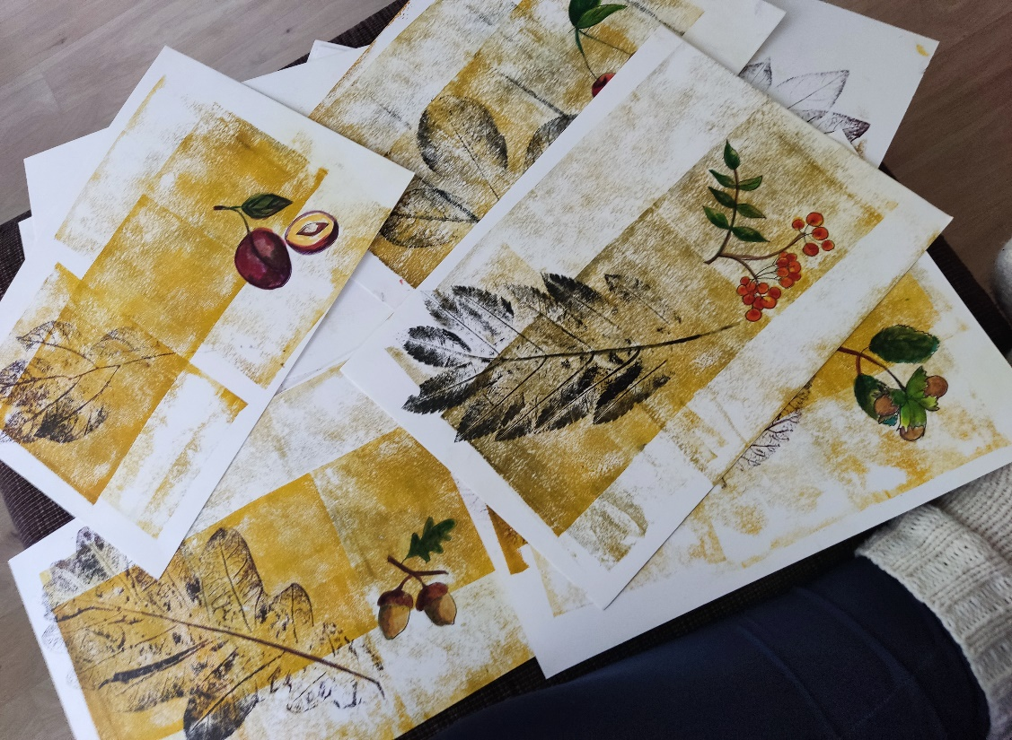
Results.

