PLEASE FIND THE NAMES OF 10 TREES THAT GROW IN THE TERRITORY OF THE BALTIC STATES.
C | B | E | E | Y | O | M | P | F | U
H | A | I | A | O | H | A | I | I | P
E | S | A | R | R | M | P | N | R | L
R | H | X | T | C | N | L | E | T | I
R | T | W | H | H | H | E | T | R | M
Y | R | O | O | A | K | T | R | E | E
T | E | N | P | Z | B | R | E | E | T
R | E | D | I | E | D | E | E | G | R
E | P | A | L | L | Y | E | Z | S | E
E | A | P | P | L | E | T | R | E | E
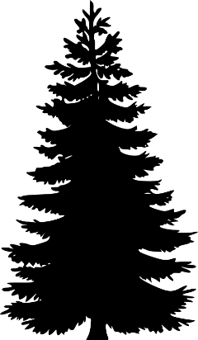
ANSWERS:
- OAK TREE
- APPLE TREE
- FIR TREE
- MAPLE TREE
- CHERRY TREE
- HAZEL
- ASH TREE
- LIME TREE
- BIRCH
- PINE TREE

