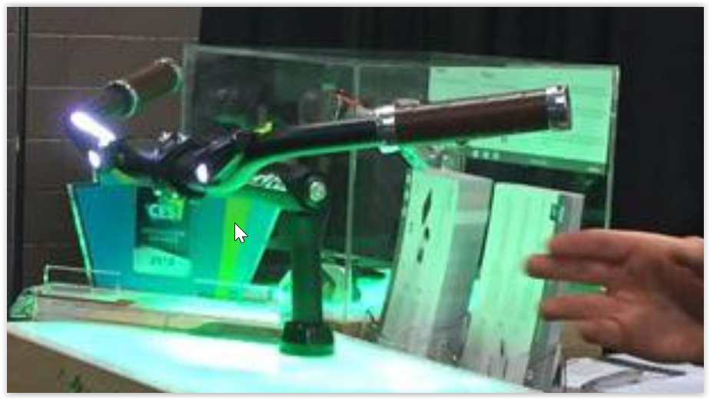
Velco Wink Bar
What is it? What features/traits could it have? Use modals...

Velco's Wink Bar is the first connected handlebar for bikes. The bar can be set to any bike so that riders can access technology like GPS-assisted navigation, geolocation of the bike in the case of theft and integrated smart headlights that automatically switch on when it's dark. All of this can be controlled via a complimentary app on the smartphone. The Velco Wink Bar will ship in the U.S. market by the end of 2018, with a launch price of $337.


HOMNI Smart Sleep Solution
What is it? What features/traits could it have? Use modals...

HOMNI Smart Sleep Solution
Terraillon's HOMNI a lamp that acts as a smart sleep solution for consumers. The small lamp, which can change colors and play music, connects to a sensor, called "Dot." Dot sticks on a pillow and tracks the sleeper's movement, sending that data to a free app so that users can see how well they slept. The lamp itself also follows external conditions like humidity and temperature so users can see that information and how it impacted their sleep. HOMNI and Dot will be available at the end of the first quarter for $199.

RemoBell
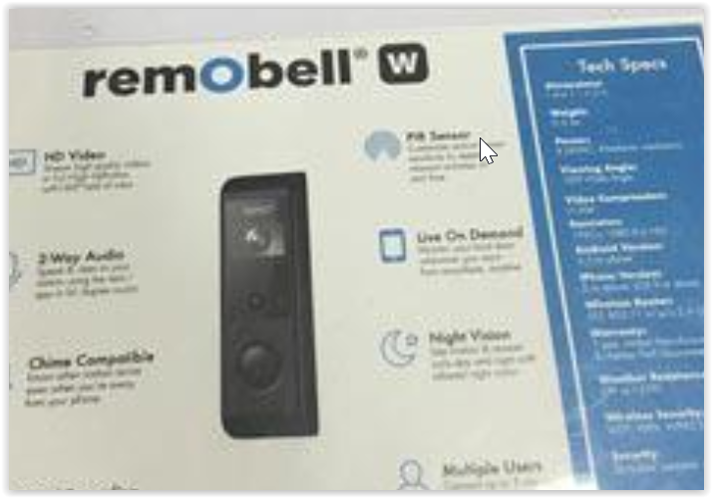
RemoBell
What is it? What features/traits could it have? Use modals...

RemoBell
Among the smart home products at CES is RemoBell, a smart doorbell that allows users to answer their doors – even if they're not home. The doorbell comes with a built-in motion sensor that detects movement and streams HD live video to users' phones. The $149 RemoBell, now on the market, not only alerts users if someone's at their door via a complementary app, but also features 2-way audio so they can answer their doors.

