A letter/an email
Layout of a letter
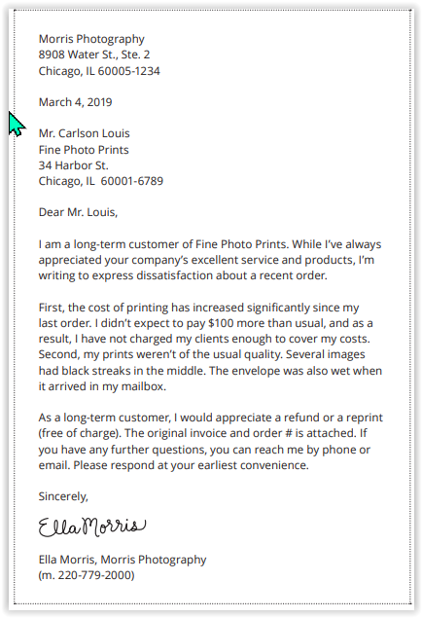
Opening dear Mr/Ms LLL
Explain why your are writing
The body of the letter or email
One idem one paragraph
Closing : ending the letter
Yours sincerely si on connaît a personne “dear Mr Louis”

Yours faithfully si on ne la connaît pas
The sender
The recipient or consignee
Date US : March 4 2019 , Date UK 4 2019

Layout of an email
From
To
Sent
Subject line

Opening
I am writing to....(to = pour ici)
- Complain about
- Inform you of
I would like to....
- Outline
- Expose ....the problem in a few words
- Explain
- Tell you about

Requesting
Could you please...
- Look into
- Investigate ....the matter as soon as possible?
If only you could...
- Find
- Offer ....a suitable solution!
- Figure out
I request....
- The invoice
- The right document
- Another solution
- Some further explanations
I would like you to... (je voudrais que VOUS)
- Give me some explanations
- Grant me discount (me faire un réduction)
- offer me some compensation

Verbs related to problems/damage
1 To deal with/handle | a-Être confronté à
2 To face | b-Une erreur est survenue
3 To tackle | c-Regarder le pb de près
4 To solve/resolve | d-gérer
5 To figure out what the trouble is | e-Vous avez l’air d’avoir bcp de pb à résoudre
6 To look into a problem | f-Se plaindre d’un dégât
7 To complain about a damage | g-S’attaquer à
8 A problem occurred | h-Résoudre un pb
9 The problem has been solved | i-Comprendre quel est le pb
10 A mistake/error has arisen | j-Un problème est survenu
11 To sort out | k-Arranger
12 You seem to have a lot of problems to work out | l-Le pb a été résolu

Verbs related to solutions
1 To look for a suitable solution | a-Trouver une solution à un pb
2 To find a solution to a problem | b-Trouver une solution à un pb
3 I have found the best solution | c-Nous trouverons quoi faire afin de résoudre ce problème
4 To offer an appropriate solution | d-J’ai trouvé la meilleure solution
5 To figure out a solution to a problem | e-Chercher une solution qui convienne bien
6 We will figure out what to do in order to solve this matter | f-Proposer une solution appropriée

Reply to a letter/email
Verbs related to apologies
1 We would like to apologize for the inconvenience | a- Je vous assure que le service reçu n’est pas représentatif de nos pratiques
2 Please accept our apologies for the inconvenience | b-Veuillez accepter nos excuses pour ce désagrément
3 I assure you that the service you received is not typical of what we provide | c-Nous voudrions nous excuser pour le désagrément
4 I am sorry for the trouble caused by... | d-Je suis désolée des problèmes causés par…

Explaining the mistake
The mistake was due to/was caused by...
- A flaw/ a default (un défaut) in…
- A mistake/ an error in the invoice/the delivery/the packing process/

Applying for a job
- I am writing to apply to the job offer n°KJ45, that I found on the your website.

Thanking
- I would like to thank you
- I am grateful

Faire remarquer qqch
- I would like to point out that
- I have noticed that (remarquer que)

Donner un conseil
- You should to that.
- I advise you to do that

PJ:
Please find enclosed the document

Closing
Thank you for + ing
- Taking the time to tell me about..
- Informing us of this error.
- Bringing our attention on this unfortunate matter.
We are confident....
- You will be satisfied with the new items.
- You will be pleased with the next delivery.
I assure you (that)...
- that will never occur again.
- this unacceptable mistake is unlikely to occur gain.

Last sentence
- I look forward to seeing you soon.
- I look forward to hearing from you.
- Do not hesitate to contact me.
- I am at your disposal for any information you may need.

Yours sincerely (letters, if you know the name of the person)
Yours faithfully (letters, if you don’t know the name of the person)
Best regards, kind regards, kindest regards etc… (emails only)

