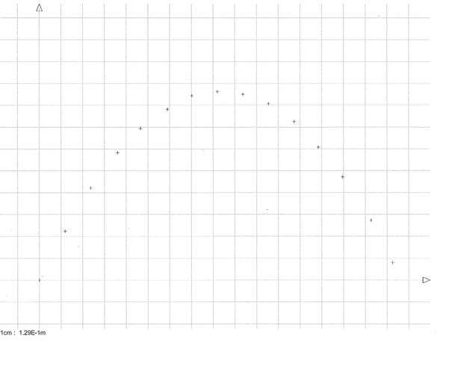
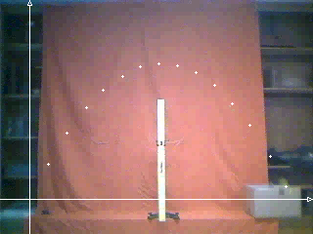
Pointages AviMéca
t x y
s m m
0.000 0.00E+0 0.00E+0
0.067 1.52E-1 2.88E-1
0.133 3.04E-1 5.44E-1
0.200 4.64E-1 7.52E-1
0.267 6.00E-1 8.96E-1
0.334 7.60E-1 1.01E+0
0.400 9.04E-1 1.09E+0
0.467 1.06E+0 1.11E+0
0.534 1.21E+0 1.10E+0
0.601 1.36E+0 1.04E+0
0.667 1.51E+0 9.36E-1
0.734 1.66E+0 7.84E-1
0.801 1.80E+0 6.08E-1
0.868 1.97E+0 3.52E-1
0.934 2.10E+0 1.04E-1

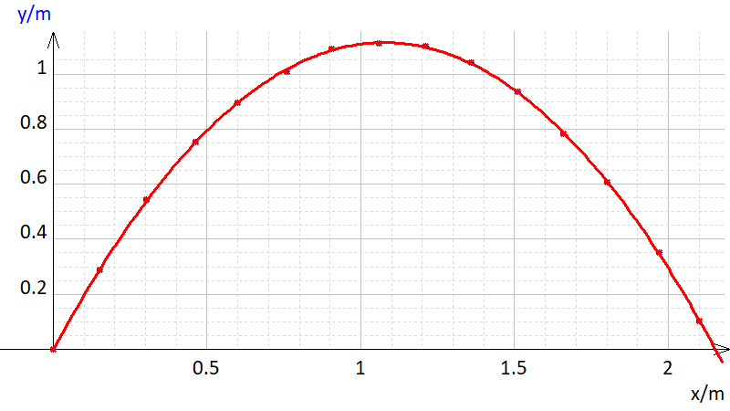
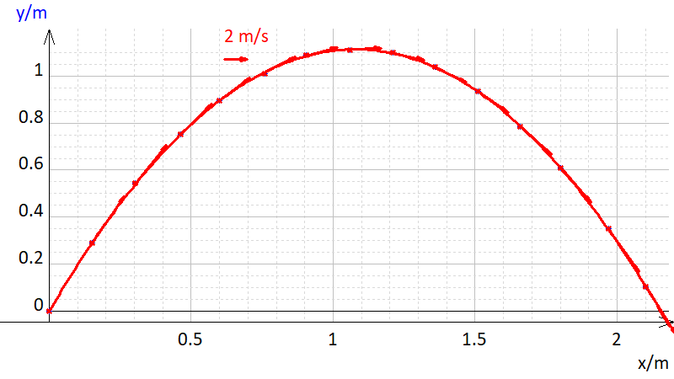

t x y vx vy v ax ay a
s m m m/s m/s m/s m/s² m/s² m/s²
0.000 0.000 0.000 2.379 4.833 5.387 -1.008 -11.15 11.20
0.0670 0.1520 0.2880 2.323 4.105 4.717 -0.7569 -10.86 10.88
0.1330 0.3040 0.5440 2.267 3.388 4.076 -0.5098 -10.56 10.58
0.2000 0.4640 0.7520 2.264 2.693 3.518 -0.2808 -10.27 10.28
0.2670 0.6000 0.8960 2.239 2.017 3.014 0.006277 -9.841 9.841
0.3340 0.7600 1.010 2.243 1.360 2.623 0.03224 -9.623 9.623
0.4000 0.9040 1.090 2.279 0.7665 2.405 0.08898 -9.631 9.632
0.4670 1.060 1.110 2.255 0.1087 2.257 -0.006127 -9.748 9.748
0.5340 1.210 1.100 2.263 -0.5697 2.334 -0.1879 -9.849 9.851
0.6010 1.360 1.040 2.249 -1.229 2.563 -0.04834 -9.889 9.889
0.6670 1.510 0.9360 2.219 -1.855 2.892 -0.08209 -9.689 9.689
0.7340 1.660 0.7840 2.260 -2.547 3.405 -0.07126 -9.449 9.449
0.8010 1.800 0.6080 2.231 -3.141 3.853 -0.09592 -9.198 9.198
0.8680 1.970 0.3520 2.219 -3.740 4.349 -0.2818 -8.807 8.811
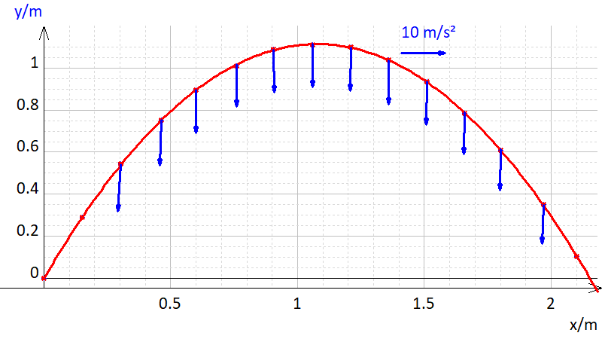
0.9340 2.100 0.1040 2.208 -4.331 4.861 -0.4650 -8.422 8.435

