EAT UGLY FRUITS ! Campus Agricole de Vire, France

In a lesson called "Adding value to production", owing to the Economy teacher, our pupils learn that, according to estimates, 30% of agricultural produce is wasted because it is never sold, which means over-production with the image of trailers of tomatoes/melons left to rot at the end of fields, but also the emergence of new shops with "ugly" fruit/vegetable type channels which also correspond to current consumer expectations in this inflationary context because they are sold more cheaply.

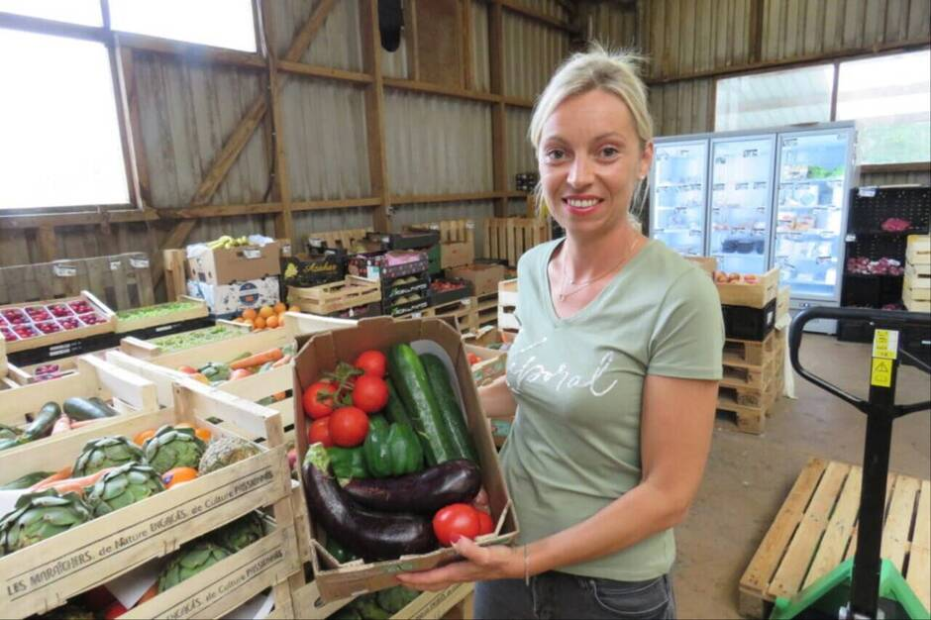
To combat food waste, a Breton cooperative is offering seasonal baskets at a lower price. These products are on sale in the Ecomiam shop in Vire Normandie.

Our pupils also see the example of fruit and vegetable producers who prefer to sell at the farm gate at knock-down prices - exceptionally - rather than leave their produce to rot. Destruction should be the last solution, and it's better to recycle through methanisation today (which may already be the case for our future livestock farmers in the case of rotting silos that can't be used for their animals).

