Campus Agricole de Vire
How to achieve zero waste in the landscaping workshop : what our students learn !

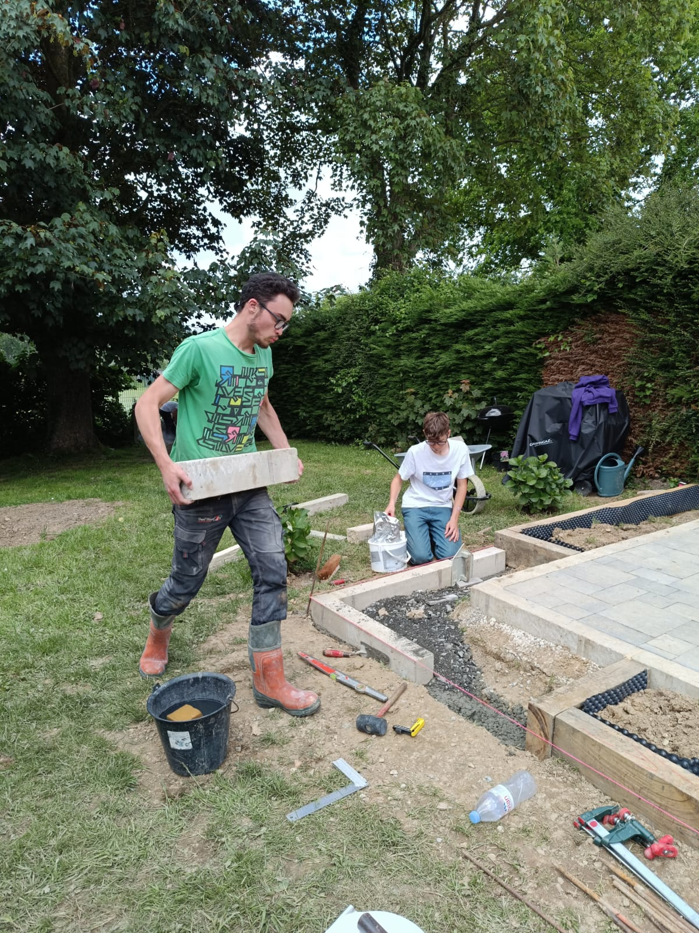

1 - woody plant waste (branches and wood) is shredded and reused in the flower beds.
2 - low-lignified and herbaceous plant waste (grass clippings and kitchen scraps) are piled up and turned over for optimal composting. This compost is then reused as a substrate for planting the flower beds.
3 - Inert waste (concrete, stones, broken paving slabs, broken bricks, broken paving blocks, etc.) is used to stabilise and drain driveways.
4 - Defective equipment is kept within the limits of the space available to reuse spare parts. They are only recycled at the end of their useful life.
5 - Plastics that cannot be reused are disposed of at waste collection centres. It should be noted that containers are often reused several times before being disposed of.



