CERCHIA IN ROSSO I NOMI DELLE PARTI DEL VISO.
ASCOLTA IL CHANT ED ESEGUI I COMANDI.
QUALE PAROLA NON APPARTIENE AL VISO? DISEGNALA

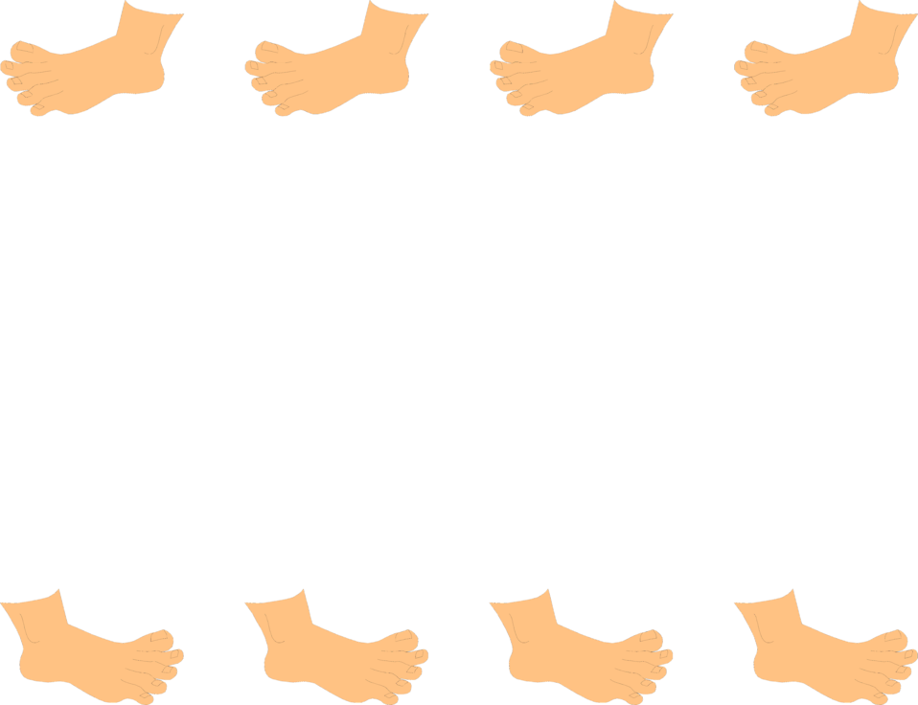
By Teacher Marilù
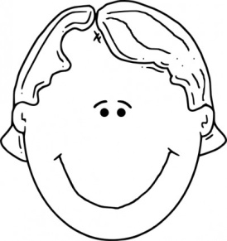
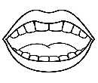
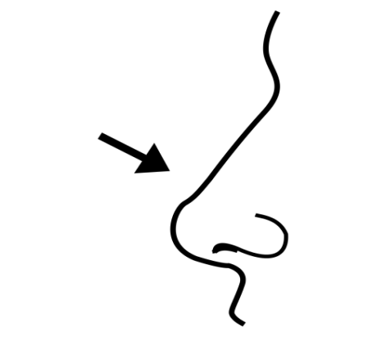
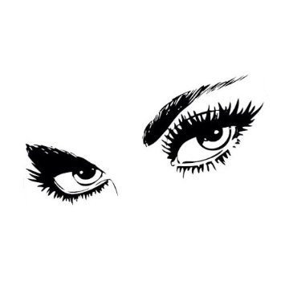
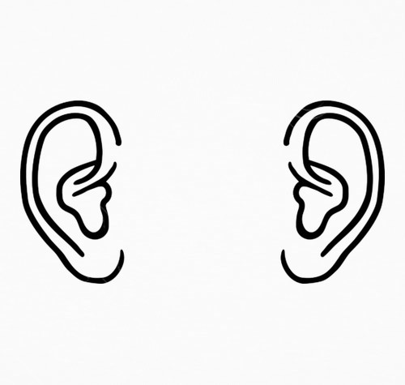
TOUCH YOUR FACE
TOUCH YOUR FACE, TOUCH YOUR FACE.
CLAP YOUR HANDS AND TOUCH YOUR FACE.
TOUCH YOUR EARS, TOUCH YOUR EARS.
CLAP YOUR HANDS AND TOUCH YOUR EARS .
TOUCH YOUR EYES, TOUCH YOUR EYES.
CLAP YOUR HANDS AND TOUCH YOUR EYES.
TOUCH YOUR NOSE, TOUCH YOUR NOSE.
CLAP YOUR HANDS AND TOUCH YOUR NOSE.
TOUCH YOUR MOUTH, TOUCH YOUR MOUTH.
CLAP YOUR HANDS AND TOUCH YOUR MOUTH.

