The ten snowmen
ONE LITTLE, TWO LITTLE,
THREE LITTLE SNOWMEN,
FOUR LITTLE , FIVE LITTLE,
SIX LITTLE SNOWMEN
SEVEN, LITTLE EIGHT,
LITTLE NINE, LITTLE SNOWMEN,
TEN LITTLE SNOWMEN
ROLLING IN THE SNOW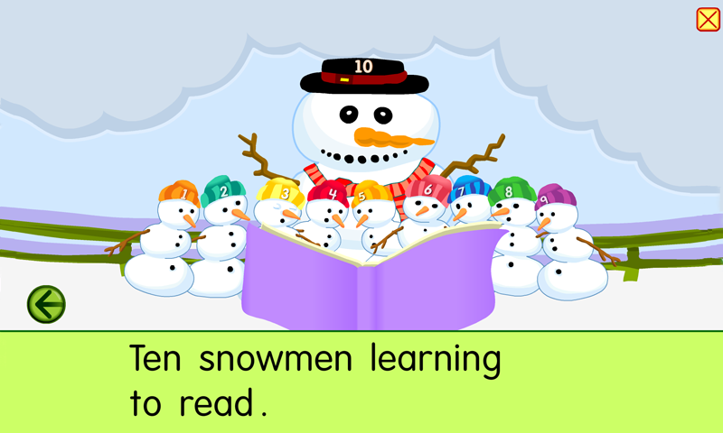
By Teacher marilu’

The ten snowmen
ONE LITTLE, TWO LITTLE,
THREE LITTLE SNOWMEN,
FOUR LITTLE , FIVE LITTLE,
SIX LITTLE SNOWMEN
SEVEN, LITTLE EIGHT,
LITTLE NINE, LITTLE SNOWMEN,
TEN LITTLE SNOWMEN
ROLLING IN THE SNOW
By Teacher marilu’

