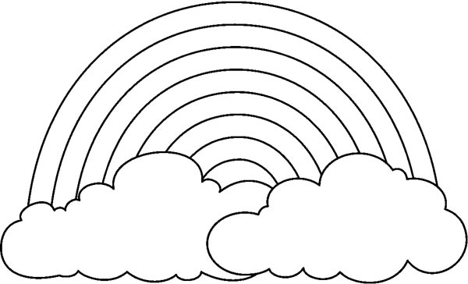
SING THE SPRING SONG
I’M A LITTLE FLOWER
PINK AND WHITE
I LOOK AT THE RAINBOW IN THE SKY.
WHEN I SEE A BIRDIE I SAY:
HI !
FLY OFF, LITTLE BIRDIE…
BYE , BYE, BYE !
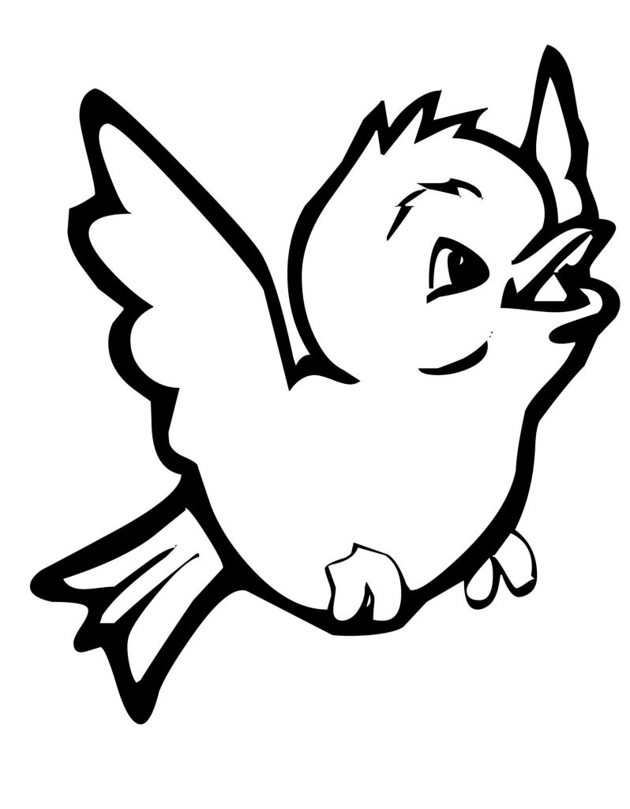
By Teacher Marilù

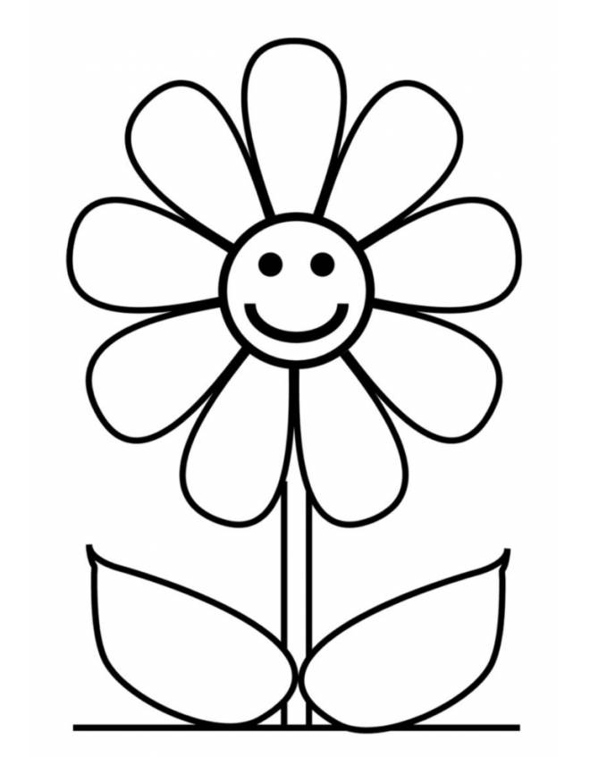
SING THE SPRING SONG
I’M A LITTLE FLOWER
PINK AND WHITE
I LOOK AT THE RAINBOW IN THE SKY.
WHEN I SEE A BIRDIE I SAY:
HI !
FLY OFF, LITTLE BIRDIE…
BYE , BYE, BYE !
By Teacher Marilù

