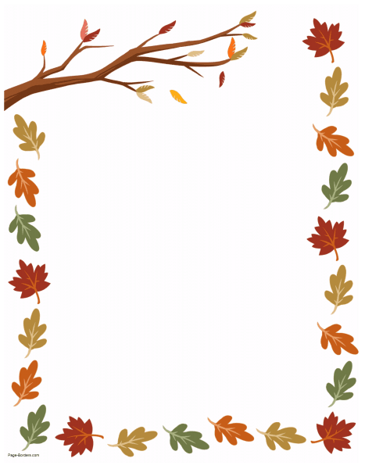
By Teacher Marilù

By Teacher Marilù
ALL THE LEAVES ARE FALLING DOWN
FALLING DOWN FALLING DOWN
ALL THE LEAVES ARE FALLING DOWN
ORANGE, RED AND BROWN.

ALL THE LEAVES ARE FALLING DOWN
FALLING DOWN FALLING DOWN
ALL THE LEAVES ARE FALLING DOWN
ORANGE, RED AND BROWN.

