EASTER SONG
EASTER BUNNY
HOP HOP HOP!
EASTER BUNNY
STOP STOP STOP!
HOP HERE, HOP THERE
NOW YOUR EGGS ARE EVERYWHERE.

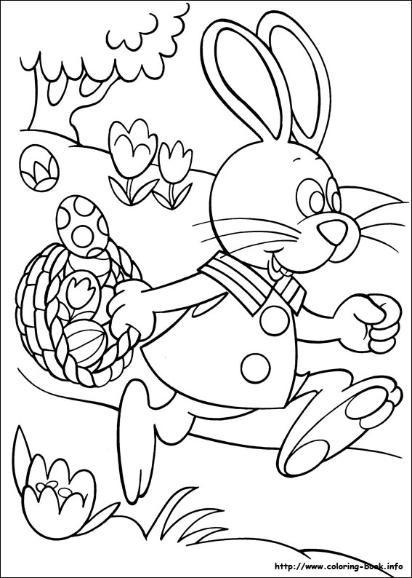
By Teacher Marilù

EASTER SONG
EASTER BUNNY
HOP HOP HOP!
EASTER BUNNY
STOP STOP STOP!
HOP HERE, HOP THERE
NOW YOUR EGGS ARE EVERYWHERE.

By Teacher Marilù

