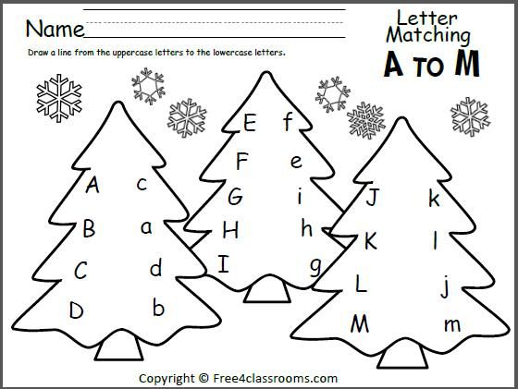
By Teacher Marilù
ABBINA LE LETTERE DALLA A ALLA M CON COLORI DIFFERENTI
ABBINA LE LETTERE DALLA A ALLA M CON COLORI DIFFERENTI

By Teacher Marilù
CANTA LA CANZONE POI RIPASSA LE PAROLE. COLORA LA SCENA
Frosty the Snowman
IS A HAPPY SNOWMAN
WITH A SMILING FACE
AND A BUTTON NOSE
AND A MAGIC HAT ON HIS HEAD.
Thumpety thump thump
Thumpety thump thump
Look at Frosty go
Thumpety thump thump
Thumpety thump thump
Over the hills of snow !
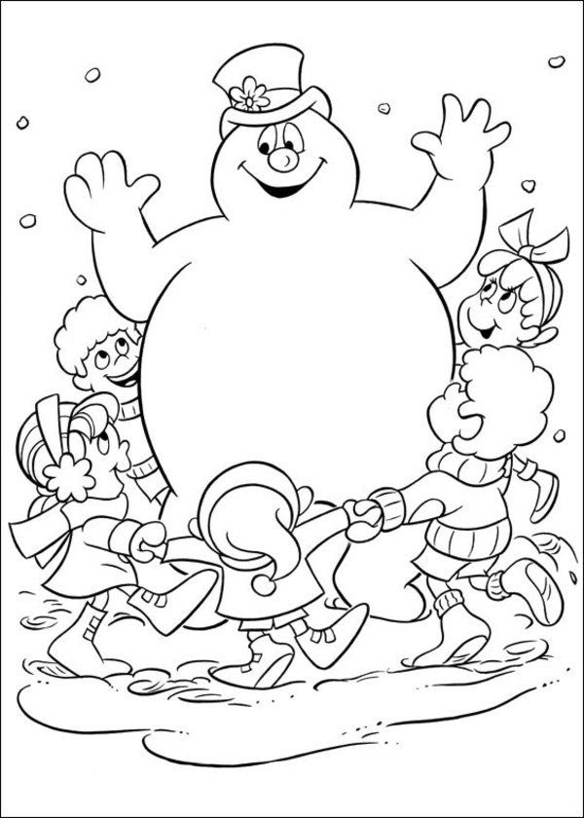
By Teacher Marilù

