LISTEN TO THE TEACHER AND COLOUR THE LETTERS
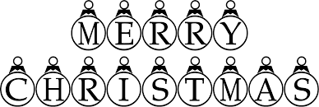
By Teacher Marilù

LISTEN TO THE TEACHER AND COLOUR THE LETTERS

By Teacher Marilù

