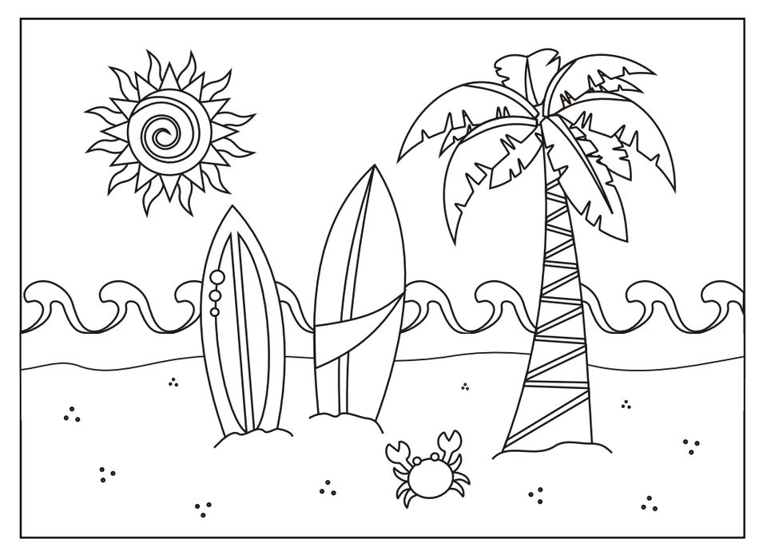
SAY THE SUMMER CHANT
IN THE SUMMER I CAN SEE
THE SEA, THE BLUE SEA.
IN THE SUMMER I CAN SEE
THE SEASHELLS, THE BIG SEASHELLS.
IN THE SUMMER I CAN SEE
THE STARFISH, THE SMALL STARFISH.
IN THE SUMMER WHAT CAN YOU SEE ?

By Teacher Marilù

By Teacher Marilù

SAY THE SUMMER CHANT
IN THE SUMMER I CAN SEE
THE SEA, THE BLUE SEA.
IN THE SUMMER I CAN SEE
THE SEASHELLS, THE BIG SEASHELLS.
IN THE SUMMER I CAN SEE
THE STARFISH, THE SMALL STARFISH.
IN THE SUMMER WHAT CAN YOU SEE ?

By Teacher Marilù

