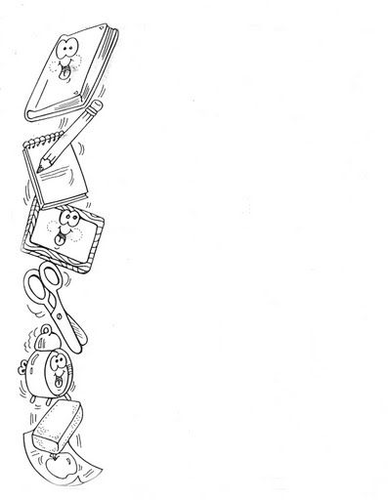
CERCHIA IN ROSSO I NOMI DEGLI OGGETTI SCOLASTICI
THE SCHOOL OBJECTS SONG

WHAT HAVE I GOT TO GO TO SCHOOL?
A PENCIL CASE,
A PEN, A BOOK
A PEN, A BOOK… BOOK, BOOK, BOOK
BOOK, BOOK, BOOK, BOOK.

WHAT HAVE I GOT TO GO TO SCHOOL?
A FELT-TIP PEN, RUBBER AND BOOK
RUBBER AND BOOK…. BOOK, BOOK, BOOK
BOOK, BOOK, BOOK, BOOK.

WHAT HAVE I GOT TO GO TO SCHOOL?
A PENCIL CASE, PENCIL AND BOOK
PENCIL AND BOOK… BOOK, BOOK, BOOK
BOOK, BOOK, BOOK, BOOK.
By Teacher Marilù

CERCHIA IN ROSSO I NOMI DEGLI OGGETTI SCOLASTICI
THE SCHOOL OBJECTS SONG

WHAT HAVE I GOT TO GO TO SCHOOL?
A PENCIL CASE,
A PEN, A BOOK
A PEN, A BOOK… BOOK, BOOK, BOOK
BOOK, BOOK, BOOK, BOOK.

WHAT HAVE I GOT TO GO TO SCHOOL?
A FELT-TIP PEN, RUBBER AND BOOK
RUBBER AND BOOK…. BOOK, BOOK, BOOK
BOOK, BOOK, BOOK, BOOK.

WHAT HAVE I GOT TO GO TO SCHOOL?
A PENCIL CASE, PENCIL AND BOOK
PENCIL AND BOOK… BOOK, BOOK, BOOK
BOOK, BOOK, BOOK, BOOK.
By Teacher Marilù

