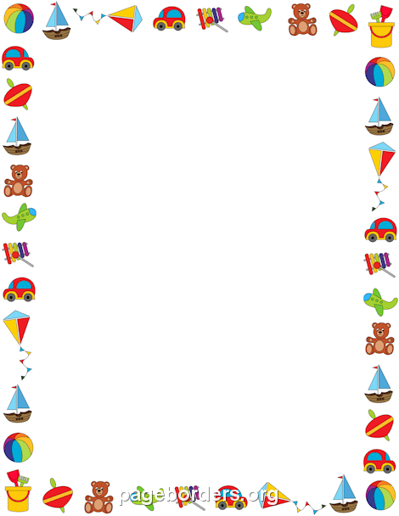
By Teacher Marilù

By Teacher Marilù
HOMEWORK
Copia la canzone e disegna il tuo giocattolo preferito.

LOTS OF TOYS
Toys, toys, toys
Lots of lovely toys !
A skateboard, a doll,
A car, a ball,
A train, a plane.
Toys, toys, toys
Lots of lovely toys !

HOMEWORK
Copia la canzone e disegna il tuo giocattolo preferito.

LOTS OF TOYS
Toys, toys, toys
Lots of lovely toys !
A skateboard, a doll,
A car, a ball,
A train, a plane.
Toys, toys, toys
Lots of lovely toys !

