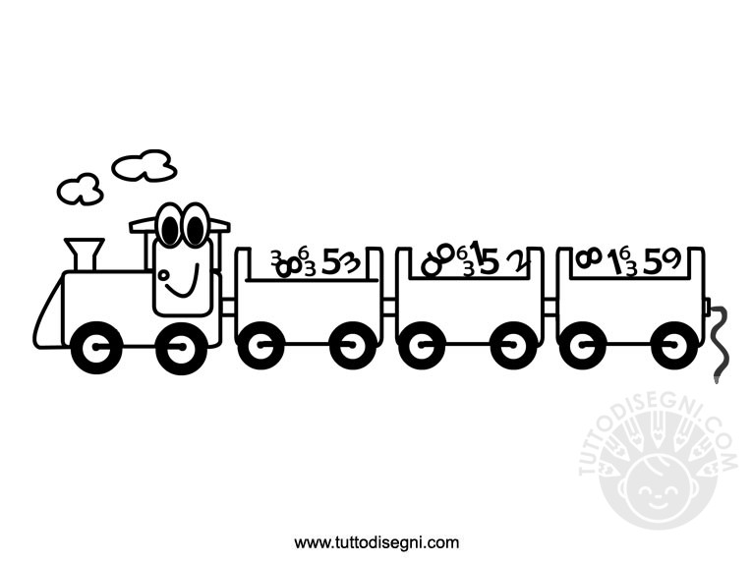
THE NUMBER TRAIN
ONE, TWO, THREE
ONE, TWO, THREE
GET ON THE TRAIN AND SING WITH ME
FOUR AND FIVE
FOUR AND FIVE
I SAY “ HI “
YOU SAY “ BYE ”
SIX, SEVEN, EIGHT, NINE, TEN
WAVE YOUR HANDS
AND START AGAIN !
By Teacher marilu’

THE NUMBER TRAIN
ONE, TWO, THREE
ONE, TWO, THREE
GET ON THE TRAIN AND SING WITH ME
FOUR AND FIVE
FOUR AND FIVE
I SAY “ HI “
YOU SAY “ BYE ”
SIX, SEVEN, EIGHT, NINE, TEN
WAVE YOUR HANDS
AND START AGAIN !
By Teacher marilu’

