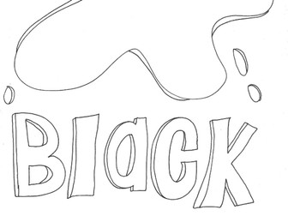
BLACK AND WHITE
HERE COMES GREY
WHITE AND BLACK
GREY COMES BACK !
YELLOW, RED AND BLUE
YELLOW, RED AND BLUE
BROWN FOR YOU, BROWN FOR YOU


By Teacher Marilù

BLACK AND WHITE
HERE COMES GREY
WHITE AND BLACK
GREY COMES BACK !
YELLOW, RED AND BLUE
YELLOW, RED AND BLUE
BROWN FOR YOU, BROWN FOR YOU
By Teacher Marilù

