By Teacher Marilù
ENJOY YOUR HOLIDAYS
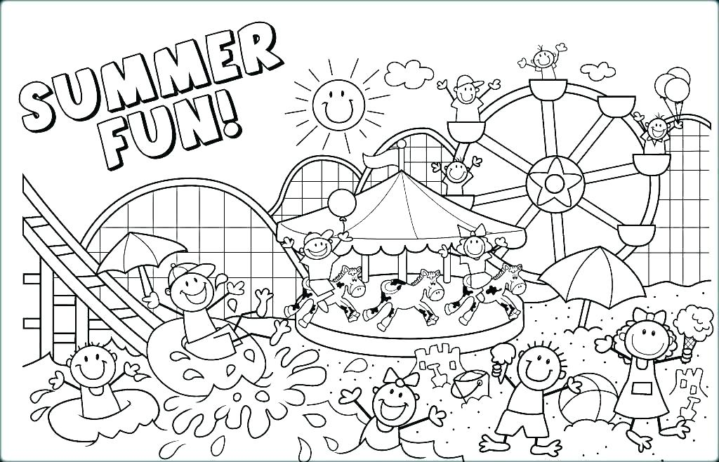
ENJOY YOUR HOLIDAYS
By Teacher Marilù

