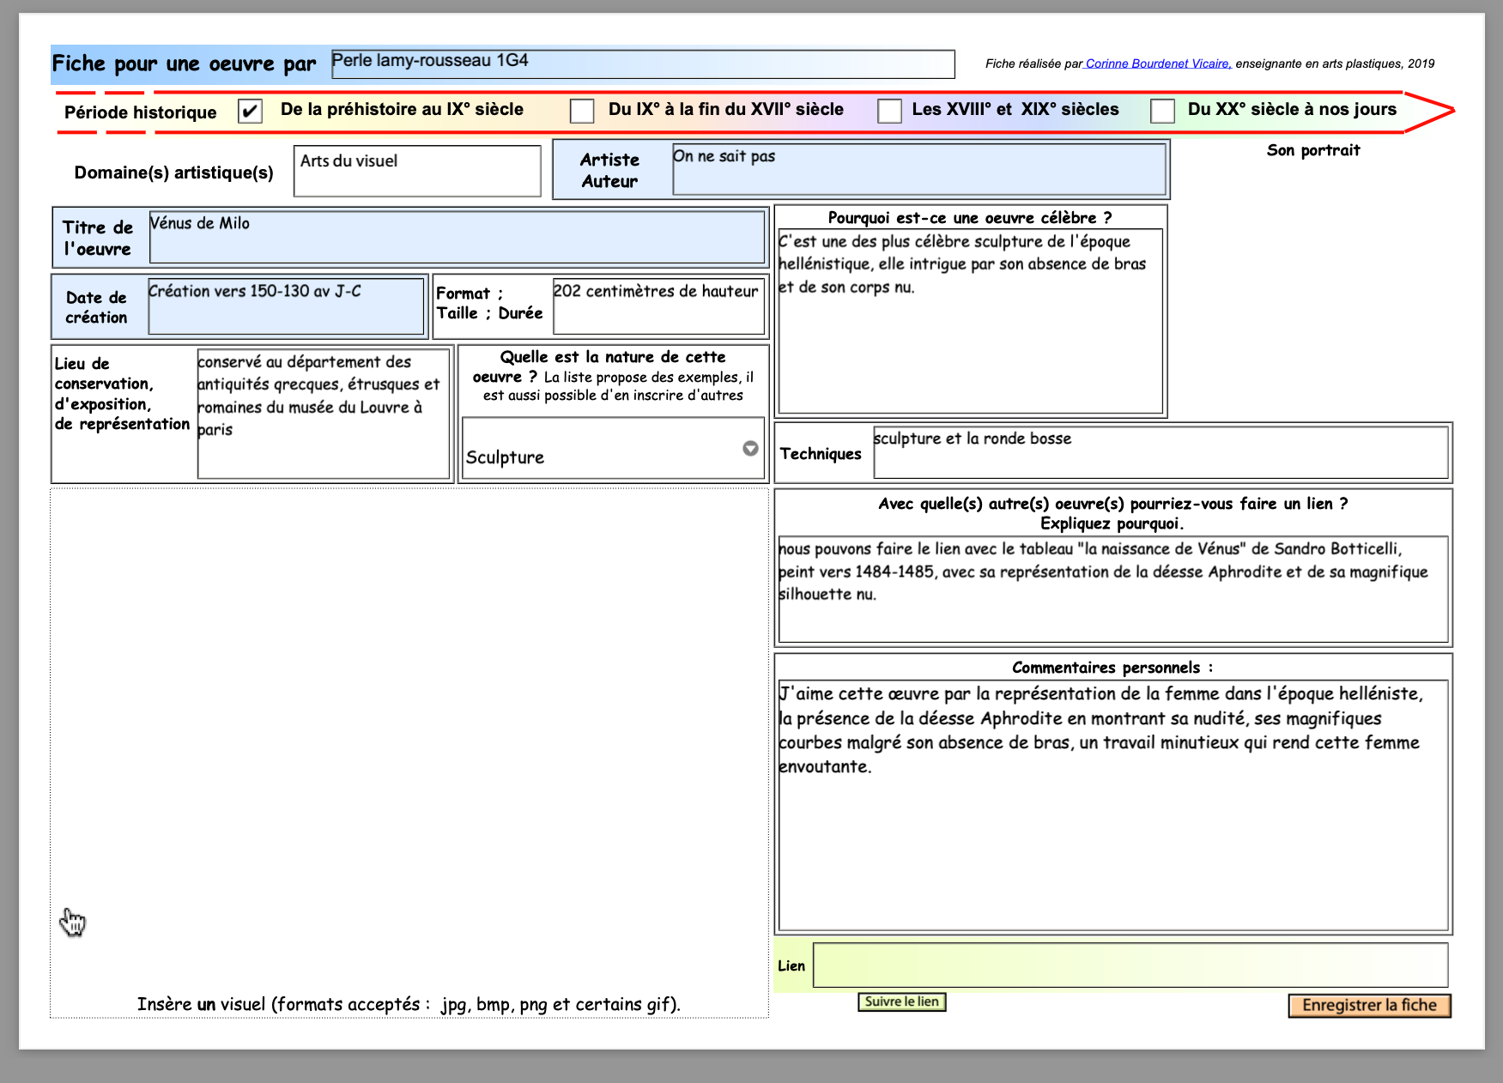
https://www.google.com/url?sa=i&url=https%3A%2F%2Fwww.leparisien.fr%2Fculture-loisirs%2Fune-exposition-retrace-comment-la-venus-de-milo-est-arrivee-au-louvre-22-12-2021-

