Inspired by Leaving Home by William Gilbert Gaul, painted in 1907. It is around the subject of the Civil War (1861-1865), between the Northerners against the Southerners. It depicts a young boy, old enough to get drafted in this war with his family biding him goodbye.
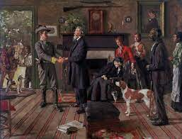
The second inspiration is a poem written by Rudyard KIPLING in Rewards and Fairies that could represent words of encouragement from the father to the son, to stay strong and brave, to triumph and come home glorious.
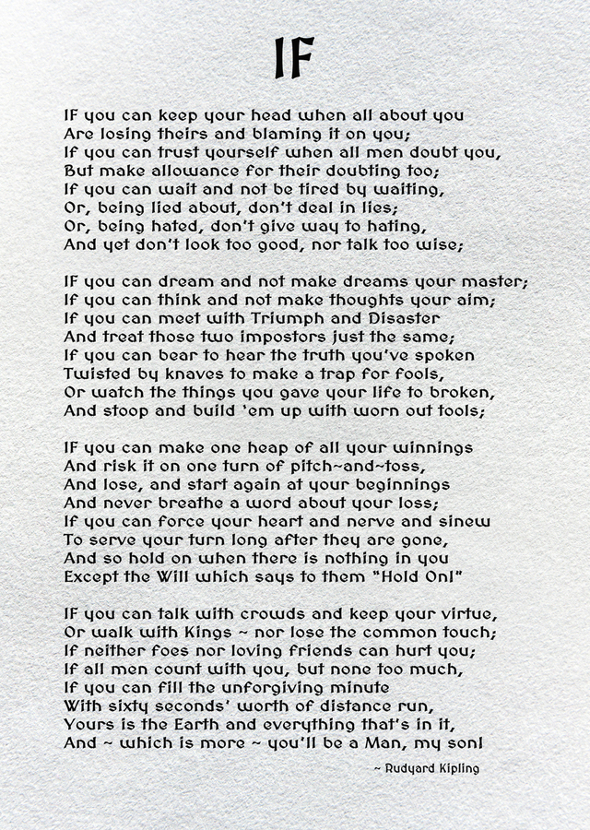
Prompt: Write a speech from the servants to the boy getting drafted in, inspired by “If-“ by Rudyard KIPLING in Rewards and Fairies and the painting Leaving Home by William Gilbert Gaul.

You who are leaving to fight against my rights,
Your view of us stramped in your blood.
Seeing the once naïve boy, the master’s son, now,
Wearing this uniform, about to be drafted in.
A certain fondness would like your return yet,
A selfish desire wants to get this freedom we longed for.
To see this loyal mount, its brown coat returning,
Home, alone, with only the memory of you by his side.
To wash up the no longer used bedding from your room,
That will stay unchanged, at the will of the master’s spouse.
But, perhaps, a wishful star will keep you well from those ill-intended cravings of mine.

