

English Grammar

Ms Lombart 2018-2019
Table des matières

- Revision 3rd year
- Personal pronouns + possessive adjectives
- To be
- Have got
- Question words
- Like and Don’t like

- Chapter 1: Day after day
- Simple present
- Adverbs of frequency

- Chapter 2: Around town
- There is/there are
- The imperative

- Chapter 3: What are you doing?
- Present continuous
- Some / Any - How much / How many

- Chapter 4: What’s the matter?
- Les auxiliaires de modes

Grammar revision 3rd year

1. Personal pronouns and possessive adjectives

1. Fill in by writing the translation on the dotted line.
(Complète en indiquant la traduction sur les pointillés)
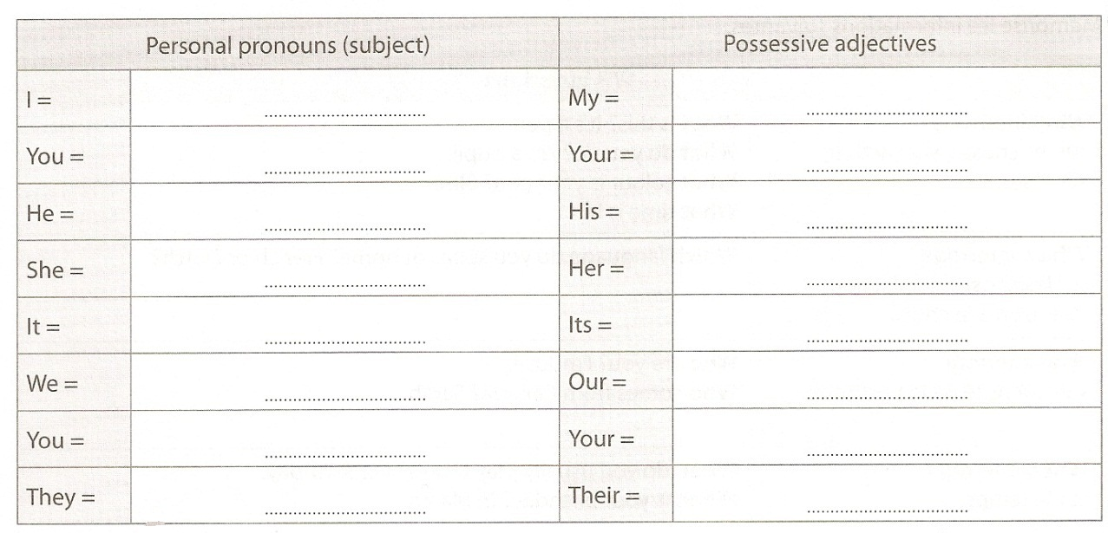

2. Fill in with a pronoun or a possessive adjective.
(Complète avec un pronom personnel sujet ou un déterminant possessif)

1. Who are ………………..? ……………….. am Tom Blake.
2. Where is John from? ……………….. is from Germany.
3. Where are ……………….. from, children? ……………….. are from Manchester.
4. Is Kim Connie’s sister? No, ………………..isn’t. ……………….. is ……………….. friend.
5. What’s this? ………………..is a pencil sharpener.
6. Emily and Jennifer are Connie’s sisters. ……………….. are twins. ……………….. brother is David.
7. ……………….. am speaking. Listen to me! Do you like ……………….. voice?
8. David plays tennis once a week. This is ……………….. racket.
9. Where’s the dog? ……………….. is here. What’s ……………….. name?
10. ……………….. are in the third form (=3e). Mr Blake is ……………….. English teacher.
11. Where are the children? Where are ……………….. schoolbags?
12. Where’s Mrs Small from? ……………….. is from London.
13. Hello Emily! How are ………………..? ……………….. am fine, thanks.
14. Good morning, Jane! Where is ……………….. brother David?
15. Where do ……………….. come from Lucy? ……………….. am from Liverpool.

2. To be(être)

1. Fill in by writing the translation on the dotted line.
(Complète en indiquant la traduction sur les pointillés)
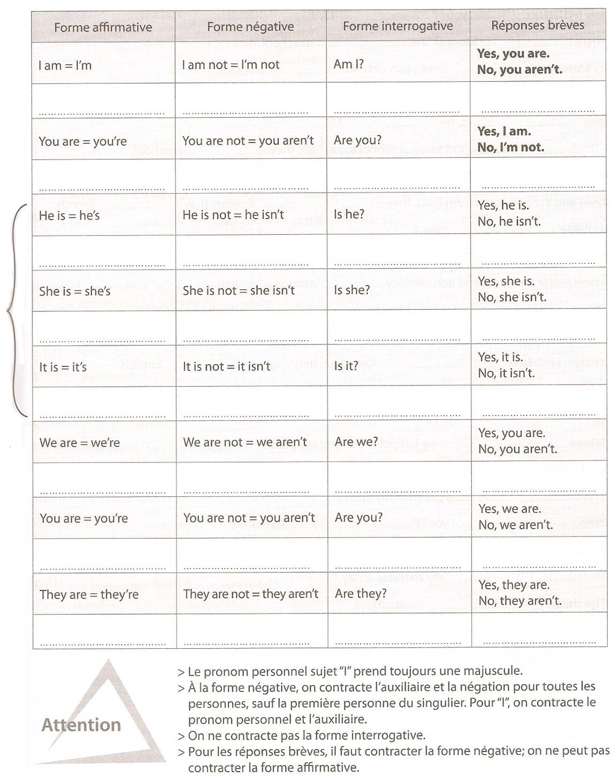

2. Complete with the right form of the verb “to be”.
(Complète avec la bonne forme du verbe « être »)

1. How old ……………….. you? I ……………….. 15.
2. Where ……………….. Sandra? She ……………….. at school.
3. My sister and I ……………….. 14 years old. We ……………….. twins.
4. How old ……………….. you Sean? I ……………….. 15.
5. Sean ……………….. 16, he ……………….. 15!
6. ……………….. Sandra and Sarah at school today? No, they ……………….. at school, they ……………….. on holiday.
7. David and Barbara come from Paris, they ……………….. Belgian, they ………………..French.
8. My name ……………….. John, I ……………….. a girl!
9. Who ……………….. you? ……………….. you James? Yes, I ……………….. .
10. Harry Potter and his friend Ron Weasley ……………….. wizards (=sorciers).

3. Ask questions. Read the answers first.
(Pose des questions. Lis d’abord les réponses)

1. (your name?) …………………………………………………….? Tom Blake.
2. (Belgian?) …………………………………………………….? No, I’m not.
3. (where, from?) …………………………………………………….? I’m from London.
4. (how old?) …………………………………………………….? I’m 31.
5. (you, married?) …………………………………………………….? No, I’m not.

4. Complete the questions with the right form of the verb “to be”. Then match with the answers.
(Complète les questions avec la bonne forme du verbe « être ». Ensuite, relie avec les réponses)
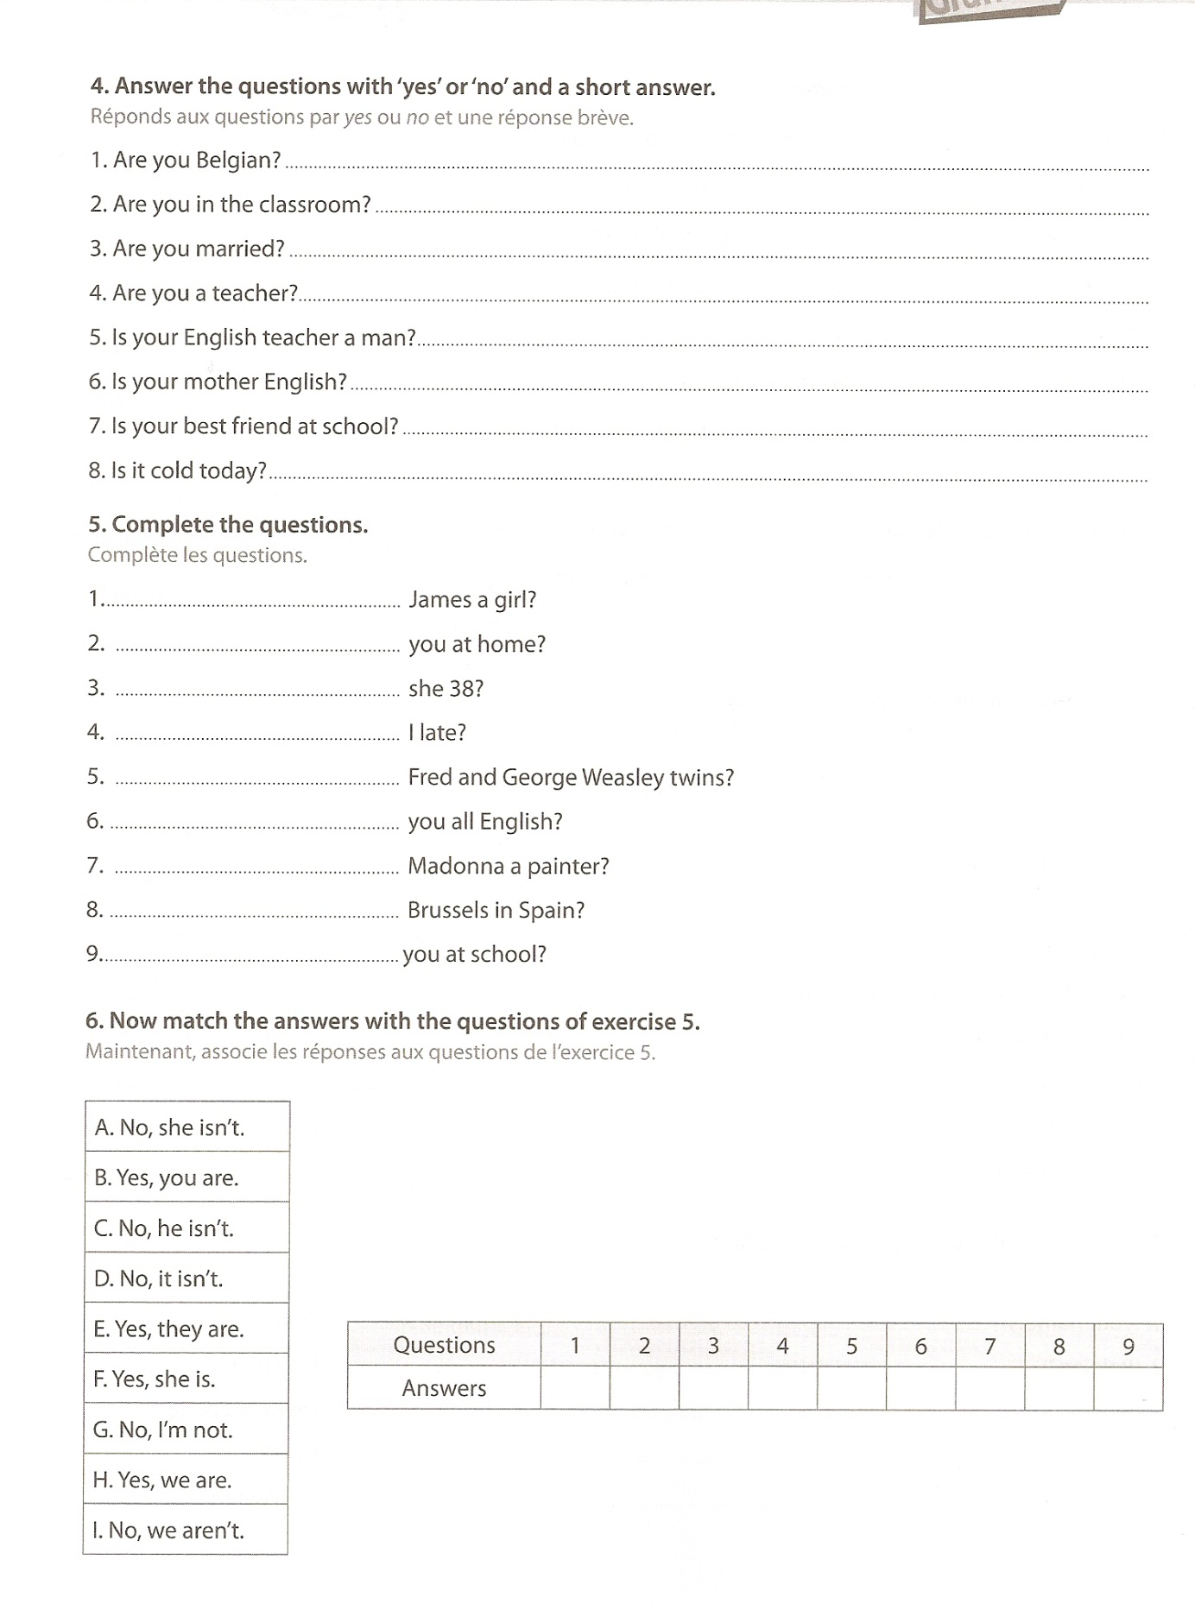
1. …………………………………. James a girl?
2. …………………………………. you at home?
3. …………………………………. she 38?
4. …………………………………. I late?
5. …………………………………. Fred and George Weasley twins?
6. …………………………………. you all English?
7. …………………………………. Madonna a painter?
8. …………………………………. Brussels in Spain?
9. …………………………………. you at school ?

3. To have got (avoir)

1. Fill in by writing the translation on the dotted line.
(Complète en indiquant la traduction sur les pointillés)
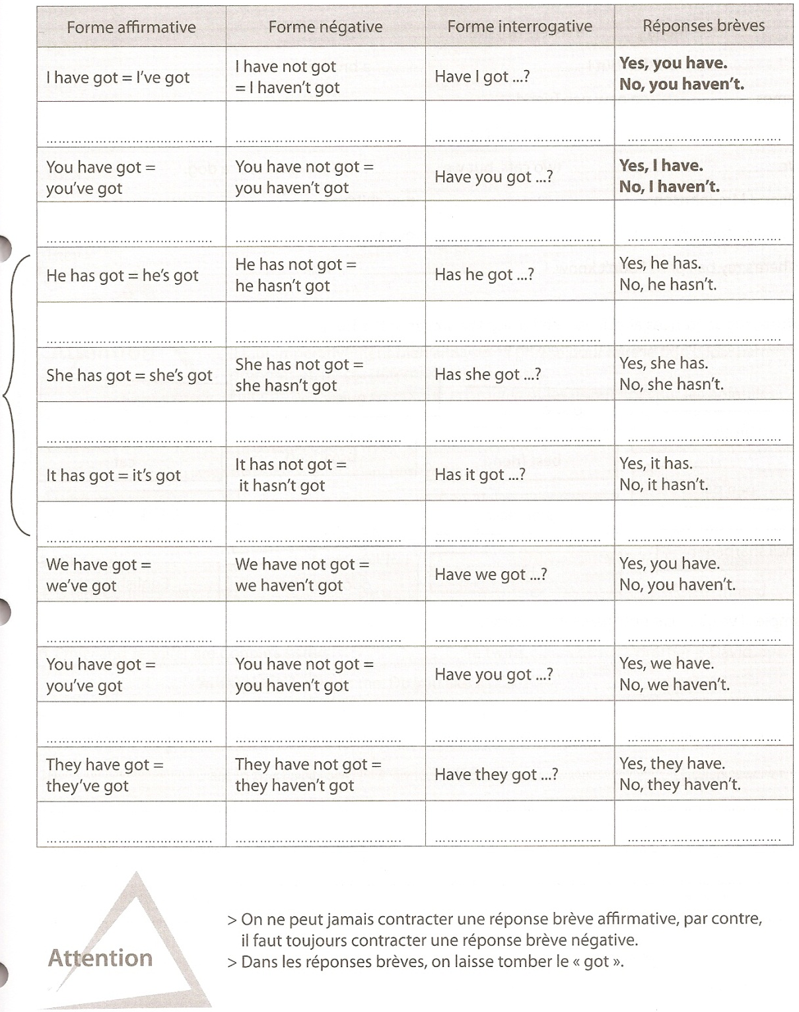

2. Fill in with the right form of “have got”.
(Complète avec la bonne forme du verbe « avoir »)

1.……………….. you ……………….. a pen? Yes, I ……………….. .
2. ……………….. Maria ……………….. a sister? No, she ……………….. .
3. I ……………….. a sister, but I ……………….. a brother.
4. James ……………….. a new pen friend.
5. ……………….. you ……………….. a dog? No, I ……………….. .
6. We ……………….. two cats, but we ……………….. a dog.
7. Mr and Mrs Johnson ……………….. two children.
8. It’s a nice town. It ……………….. a very nice mall.
9. Where’s my ball pen? I don’t know. I ……………….. it.

3. Write true sentences about yourself using the words below.
(Ecris des phrases te concernant en utilisant les mots ci-dessous)

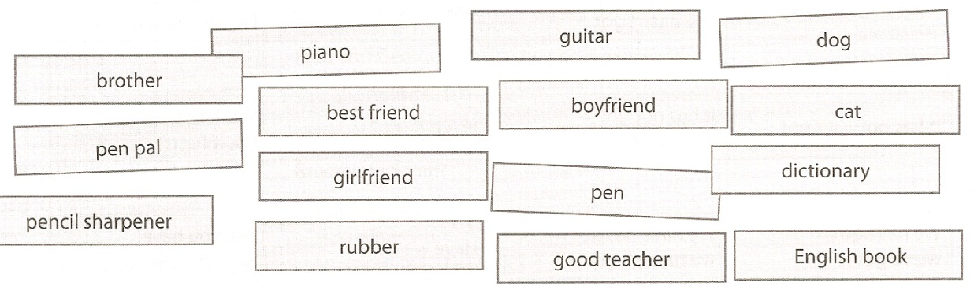

Ex.: I’ve got a cat but I haven’t got a dog.

…………………………………………………………………………………………………………………………………………………………………………………………………………………………………………………………………………………………………………………………………………………………………………………………………………………………………………………………………………………………………………………………………………………………………………………………………………………………………………………………………………………………………………………
………………………………………………………………………………………………………………………………………………………………………………………………………………………………………………………………………………………………………………………………………………………………………………………………………………………………………………………………………………………………………………………………………………………………………………………………………………

4. Question words

1. Study the following information.
(Mémorise les informations suivantes)

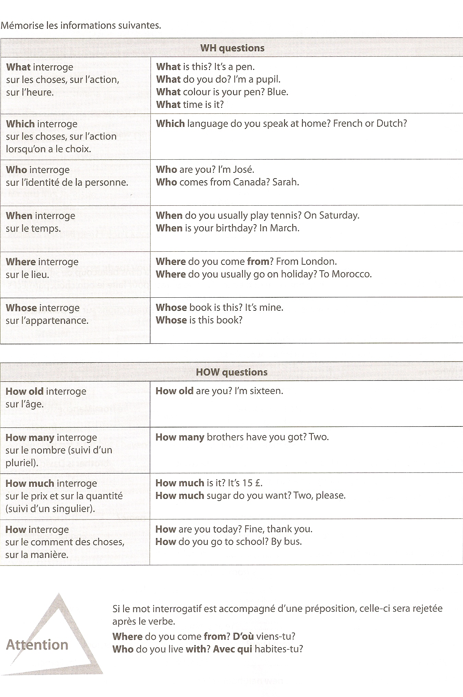

2. Find the interrogative word.
(Trouve le mot interrogatif)

1. ………………………….. is your name? My name is Michael.
2. ………………………….. is London? In Great Britain.
3. ………………………….. are you? Fine, thank you.
4. ………………………….. do you come from? From New Zealand.
5. ………………………….. are you? I’m sixteen.
6. ………………………….. brothers and sisters have you got? Three.Two brothers and a sister.
7. ………………………….. do you play tennis? On Saturday.
8. ………………………….. are your hobbies? I like skiing.

3. Ask questions about the bold typed words.
(Pose des questions à propos des mots en gras)

1. José comes from New York. ………………………………………………………….
2. Sarah is from Canada. …………………………………………………………
3. There are 10 provinces in Canada. …………………………………………………………
4. I have got four brothers. ………………………………………………………....
5. She is fifteen years old. …………………………………………………………

4. Match the answers with the right questions.
(Relie les réponses avec les bonnes questions)
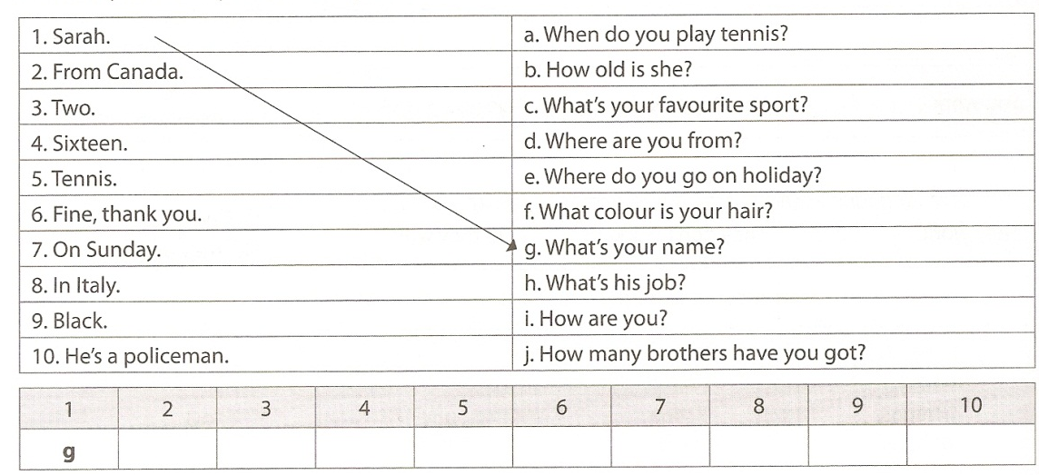

5. Like/ Don’t like

1) Theory
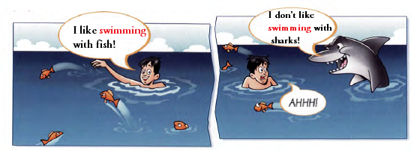

Structure de phrase:(+) Sujet + Verbe (« +s » à la 3me personne du sg)
Ex.: I like / helikes

(-) Sujet + Aux. « do »(do does 3mepersonnesg)+ not + Verbe
Ex.: I don’t like / He doesn’t like

(?) Aux. « do »(do does 3me personne sg)+ Sujet + Verbe
Ex.: Do you like? / Does he like?

Affirmative | Negative |  | Interrogative
Affirmative | Long form | Short form | Interrogative
I like  You like  He likes  She likes  It likes  We like  You like  They like | I do not like  You do not like  He does not like  She does not like  It does not like  We do not like  You do not like  They do not like | I don’t like  You don’t like  He doesn’t like  She doesn’t like  It doesn’t like  We don’t like  You don’t like  They don’t like | Do I like?  Do you like?  Does he like?  Does she like?  Does it like?  Do we like?  Do you like?  Do they like?

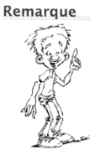
Quand utilise-t-on la forme –ing :
- On utilise la forme –ing comme un nom.
I like swimming

- On utilise la forme –ing après le verbe:
Enjoy, love, hate, like, dislike, look forward to, stop.
He enjoys reading

- On utilise la forme –ing après go pour des activités physiques.
He goes fishing every Sunday.

- On utilise la forme –ing après les prépositions.
She’s tired of working long hours.

2) Exercises

1. Put the verbs in brackets into the –ing form.
(Mets les verbes entre parenthèses à la forme –ing)

Sally and her family love going (go) to the park in the summer. They like …………………… (have) picnics and love …………………… (sit) on the grass. Sally’s mum hates …………………… (make) sandwiches so her dad always makes them. Sally and her brother love …………………… (play) with a ball in the park. Sally’s mum likes …………………… (lie) on the blanket and loves …………………… (read) her favourite magazines. Sally loves …………………… (listen) to the birds singing in the tress and her brother likes …………………… (watch) the people in the park. Sally’s family likes the park because they love ……………………(be) outdoors.

2. Write the sentences and change the verbs.
(Ecris les phrases et change les verbes)

Ex.: 1. Ben / hate / play / tennis Ben hates playing tennis
1. We / like / eat / chicken - …………………………………………………………….
2. My friends / love / watch / TV - ………………………………………………………….
3. Jenny / not like / read / comics - ………………………………………………………….
4. I / hate / clean / my room - ………………………………………………………….
5. The boys / love / listen / to music - ………………………………………………………...
6. You / not like / wear / hats - …………………………………………………………
7. My dad / like / drive / his car - …………………………………………………………
8. I / hate / dance - ……………………………………………………………

3. Write questions and answers. Look at the example.
(Ecris des questions et des réponses. Aide-toi de l’exemple)
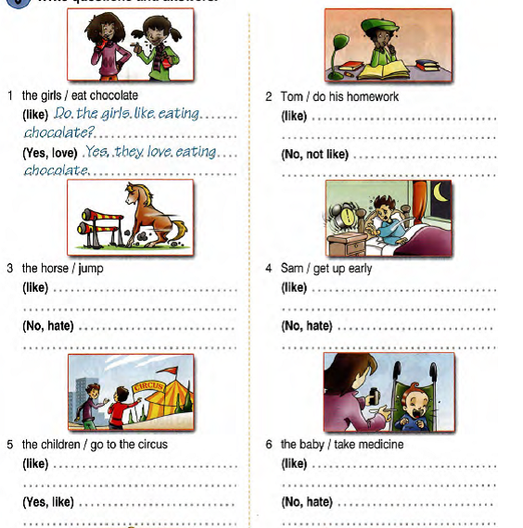

1. The girls / eatchocolate 2. Tom / do his homework
(like)Do the girls like eating chocolate? (like) ………………………………….
(Yes, love) Yes, they love eating. (no, not like) ……………………………

3. The horse / jump 4. Sam / get up early
(like) ……………………………………. (like) ………………………………….
(no, hate) ………………………………. (no, hate) ……………………………..

Chapter 1: Day after day

Lesson 1: Simple present

1. Fill in by writing the translation on the dotted line.
(Complète en indiquant la traduction sur les pointillés)

2. Complete with the right form of the verb in brackets (affirmative)
(Complète avec la bonne forme du verbe entre parenthèses (affirmatif))

1. I ……………………… (to play) the piano every evening.
2. She ……………………… (to watch) TV at night.
3. He ……………………… (to go) to school on foot.
4. You ……………………… (to run) with your father once a week.
5. Victoria and her mother ……………………… (to drink) tea in the afternoon.
6. She ……………………… (to finish) her homework around 5 o’clock.
7. It ……………………… (to rain) a lot in Scotland.
8. I ……………………… (to live) in London.
9. Victoria ……………………… (to hang around) with her friends after school.
10. They ……………………… (to like) playing golf on Sundays.
11. You ……………………… (to write) a letter to your brother every week.
12. He ……………………… (to get up) at 7 o’clock every day.
13. The dog ……………………… (to eat) twice a day.
14. She ……………………… (to go) to bed at 10 o’clock every night.
15. He always ……………………… (to buy) a lot of clothes in the sales.
16. She never ……………………… (to kiss) anyone.

3. Complete with the right form of the verb in brackets.
(Complète avec la bonne forme du verbe entre parenthèses)

1. What time ……………………… you ……………………… (+) in the morning? (to get up)
2. How ……………………… he ……………………… (+) to school? (to go)
3. Victoria ……………………… (-) clubbing because she ……………………… (+) too young. (to go-to be)
4. Victoria and her parents ……………………… (-) to the movies, they ……………………… (+) to the restaurant. (to go)
5. ……………………… you ……………………… (+) your old teacher well! (to remember)
6. Where ……………………… your father ……………………… (+)? (to work)
7. What ……………………… your friends ……………………… (+)? (to do)
8. When ……………………… Victoria ……………………… TV (+)? (to watch)
9. When ……………………… you ……………………… TV (+)? (to watch)
10. I ……………………… (-) late in the morning, I ……………………… early (+). (to get up)
11. ……………………… Victoria’s father ……………………… (+) with her every day? (to run)
12. When ……………………… he ……………………… (+) his second job? (to start)
13. He ……………………… TV (+) every night until 10 o’clock. (to watch)

4. Ask questions about the words in bold.
(Pose des questions sur les mots en gras)

1. ……………………………………………………..? I live in London
2. ……………………………………………………..? He gets up at 7 o’clock every day.
3. ……………………………………………………..? We come to school on foot.
4. ……………………………………………………..? He plays tennis every Friday.
5.……………………………………………………..? They usually have lunch at school.
6. ……………………………………………………..? I have tea and toast for breakfast.
7. ……………………………………………………..? She catches the quarter past four bus.
8. ……………………………………………………..? I have dinner at home.
9. ……………………………………………………..? I sometimes go to the movies at night.
10. ……………………………………………………..? School starts at 8.30.
11. ……………………………………………………..? School finishes at 3.30.
12. ……………………………………………………..? We go home by bus.
13. ……………………………………………………..? I often have a shower in the morning.
14. ……………………………………………………..? She does her homework at 7 pm.
15. ……………………………………………………..? He washes the car on Saturdays.
16. ……………………………………………………..? Her father works in a bakery.

Lesson 2: Adverbs of frequency

1) Theory
On utilise les adverbes de fréquence pour dire à quelle fréquence on fait quelque chose.
Voici quelques exemples d’adverbes de fréquence : -always - rarely
- usually - sometimes
- often - never
- seldom - hardly ever

a. Avant le verbe principal:
En règle générale, on place l’adverbe de fréquence avant le verbe principale dans la phrase.

Affirmative (+) | Negative (-) | Interrogative ( ?)
Ex.: I always come late | Ex.: I don’talways come late | Ex.: Do you alwayscome late?

b. Après le verbe « to be »:
Attention!! L’adverbe de fréquence se place TOUJOURS après le verbe « to be ».

Affirmative (+) | Negative (-) | Interrogative ( ?)
Ex.: I amalways late | Ex.: I am notalways late | Ex.: Are you always late?

c. Time expressions:
Les compléments de temps avec plus de 1 mot se place soit au début soit à la fin de la phrase.
Ex.:Once a month Jon visits his aunt.
I meet my friends at the sports centrethreetimes a week.
We go to the cinema on Sundays.
I get up at 7.30 every day.

2) Exercises
1. Put the adverbs in the right place in the sentence.
(Mets les adverbes de fréquence à la bonne place dans la phrase)

1. Victoria runs in Central Park with her father. (often)
…………………………………………………………………………………………………
2. She starts school at 8 am. (usually)
…………………………………………………………………………………………………
3. At the weekend I hang around with my friends. (generally)
…………………………………………………………………………………………………
4. I don’t go to the restaurant. (often)
…………………………………………………………………………………………………
5. Do you travel by plane? (sometimes)
…………………………………………………………………………………………………
6. I go clubbing. (never)
…………………………………………………………………………………………………
7. My parents play tennis. (hardly ever)
…………………………………………………………………………………………………
8. Do you work late? (usually)
…………………………………………………………………………………………………
9. She is late. (always)
…………………………………………………………………………………………………
10. Our teacher gives us a lot of homework. (normally)
…………………………………………………………………………………………………

2. Put the words in the correct order to make a sentence.
(Mets les mots dans le bon ordre afin de faire une phrase)

1. by car / always / go / I / to school.
…………………………………………………………………………………………………
2. often / my father / tennis / plays.
…………………………………………………………………………………………………
3. go clubbing / never / we / on Saturdays.
…………………………………………………………………………………………………
4. with her / sometimes / runs / her father.
…………………………………………………………………………………………………
5. go / they / to the restaurant / usually / on Friday evenings.
…………………………………………………………………………………………………
6. has / she / breakfast / hardly ever.
…………………………………………………………………………………………………
7. a football match / go to / you / ever / do?
…………………………………………………………………………………………………
8. from 7 to 5 / work / normally / my parents.
…………………………………………………………………………………………………
9. doesn’t / in Spain / it / often / rain.
…………………………………………………………………………………………………

10. do / get up / at 6 o’clock / usually / you?
…………………………………………………………………………………………………

3. Answer the questions about you. Use frequency adverbs in your answers.
(Réponds aux questions suivantes pour toi. Utilise des adverbes de fréquence)

Ex.: What time do you go to bed? I usually go to bed at 10 o’clock.
1. Do you play tennis? …………………………………………………………..
2. When do you do your homework? …………………………………………………………..
3. How do you go to school? …………………………………………………………..
4. What time do you get up? …………………………………………………………..
5. Where do you have lunch? …………………………………………………………..
6. Do you go clubbing? …………………………………………………………..
7. What do you do at the weekend? …………………………………………………………..

Chapter 2: Around town

Lesson 1: There is/there are

1) Theory

Pour énumérer des objets, pour décrire un lieu, on utilise l’expression “il y a”.
Il y a = There is si le sujet est au singulier.
There are si le sujet est au pluriel.
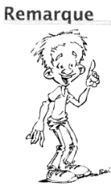
Pour poser une question, il suffit d’inverser « there » et le verbe.
Ex.: Is there any bedroom? (sg)
Are there any bedrooms? (pl)

 | Affirmative (+) |  | Negative (-) |  | Interrogative ( ?)
 | Long form | Short form | Long form | Short form
Singulier | There is | There’s | There is not | There isn’t any… | Is there any…?
Pluriel | There are | / | There are not | There aren’t any… | Are there any… ?

Ex. Singulier: There is a cellar at home il y a une cave à la maison.

+Thereisonekitchen il y a une cuisine dans ma maison.
- There isn’t any kitchen il n’y a pas de cuisine.
? Is there any kitchen?

Ex. pluriel: There are two bedrooms at home il y a deux chambres à la maison

+ There are five windows il y a cinq fenêtres.
- There aren’t any beds il n’y a pas de lit.
? Are there any chairs Y a t-il des chaises?

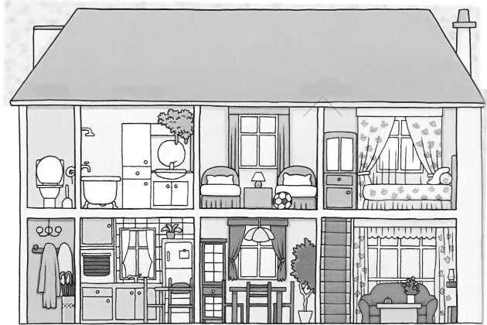

2) Exercises

1. There is or there are?
(Complète avec « there is » ou there are »)

- There ………. a bathroom in my house.
- There ………. a kitchen at home.
- There ………. three toilets, two upstairs and one downstairs.
- At home there ………. an enormous living room.
- In my house there ………. 3 floors.
- There ………. many rooms at home.
- There ………. a big indoor terrace.
- There ………. a two-car garage.

2. Look at the picture and write the correct sentences.
(Regarde le dessin et écris les bonnes phrases)
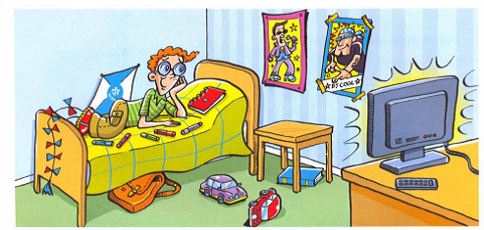

Ex.: There are three pens on the bed.
No, there aren’t. There are five pens on the bed.
- There’s a radio on the desk.
…………………………………………………………………………………………
- There are four posters on the wall.
…………………………………………………………………………………………
- There’s a box under the table.
…………………………………………………………………………………………
- There are two T-shirts on the floor.
…………………………………………………………………………………………
- There is a T-shirt under the bed.
…………………………………………………………………………………………

3. Write questions. Look at the answers.
(Ecris des questions. Regarde les réponses)

Ex.: Are there 2 bedrooms? Yes, there are (bedrooms)
1. …………………………………………………………? No, there isn’t (terrace)
2. …………………………………………………………? No, there aren’t (bathrooms)
3. …………………………………………………………? Yes, there is (garage)
4. …………………………………………………………? Yes, there is (dining room)
5. …………………………………………………………? Yes, there are (toilets)
6. …………………………………………………………? No, there isn’t (cellar)
7. …………………………………………………………? Yes, there are (living rooms)
8. …………………………………………………………? No, there aren’t (kitchen)
9. ………………………………………………………….? Yes, there is (attic)
10. ………………………………………………………...? No, there isn’t (garden)

4. Speaking activity. Look at the rooms for 2-3 minutes. Then in turn, with books closed, say what are in the rooms.
(Activité orale. Regarde les pièces pendant 2-3 minutes. Ensuite, chacun à son tour sans regarder, dit ce qui se trouve dans chaque pièce)
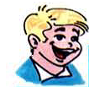
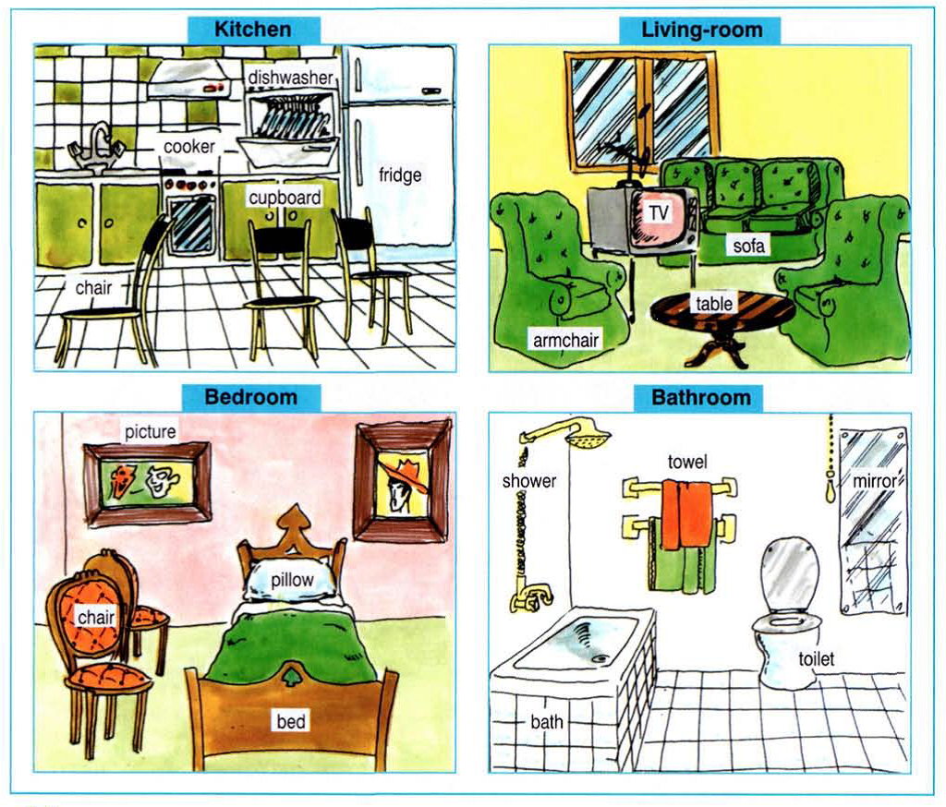

Lesson 3: The imperative

1) Theory
On utilise l’impératif pour dire à une ou plusieurs personnes de faire ou ne pas faire quelque chose.

a. 2e personne du singulier et 2e personne du pluriel:
Pour former l’impératif, on prend : (+) le verbe et les compléments.
(-) don’t, le verbe et les compléments.

 | Affirmative (+) |  | Negative (-)
 | Verbe | Compléments | Don’t | Verbe | Compléments
Ex.: | Go | away! | Don’t | go | away!
Ex.: | Sit | down! | Don’t | sit | down!

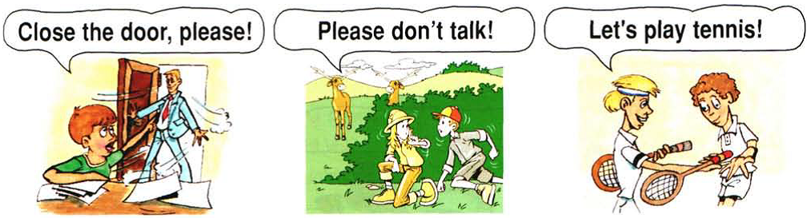

b. 1re personne du pluriel:
Pour former l’impératif, on prend la forme « Let’s », le verbe et les compléments.

 | Let’s | Verbe | Compléments
Ex.: | Let’s | go | to the cinema.
Ex.: | Let’s | dance
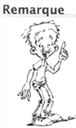
On utilise l’impératif à la 1re personne du pluriel pour faire une proposition, une suggestion.

2) Exercises

1. Put the words in the right order.
(Mets les mots dans le bon ordre)

1. hair / brush / your. ………………………………………………………….
2. the / music / listen to. ………………………………………………………….
3. picture / look at / the. ………………………………………………………….
4. down / jump / and / up! ………………………………………………………….
5. to / count / 10. ………………………………………………………….
6. cola / don’t / drink. ………………………………………………………….
7. sing / in class / don’t. ………………………………………………………….
8. your / dinner / eat. ………………………………………………………….

2. Turn the positives into negatives, and the negatives into positives.
(Transforme les phrases positives en négatives et vice versa)

Ex.: Go to bed! Don’t go to bed.
1. Close the door! …………………………………………………
2. Don’t talk! …………………………………………………
3. Eat your breakfast! …………………………………………………
4. Don’t look at her! …………………………………………………
5. Listen to him! …………………………………………………

3. Match the sentences with the right pictures.
(Relie les phrases avec les bonnes images)
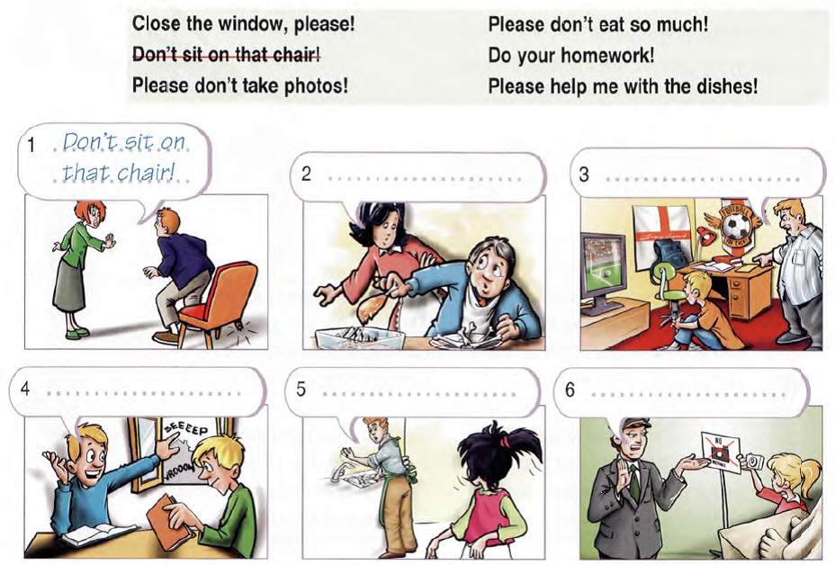

4. These are the Williams. What do you think their mother is saying? Use the verbs in the list.
(Voici les Williams. Que pensez-vous que leur mère est en train de leur dire? Utilise les verbes dans la liste)
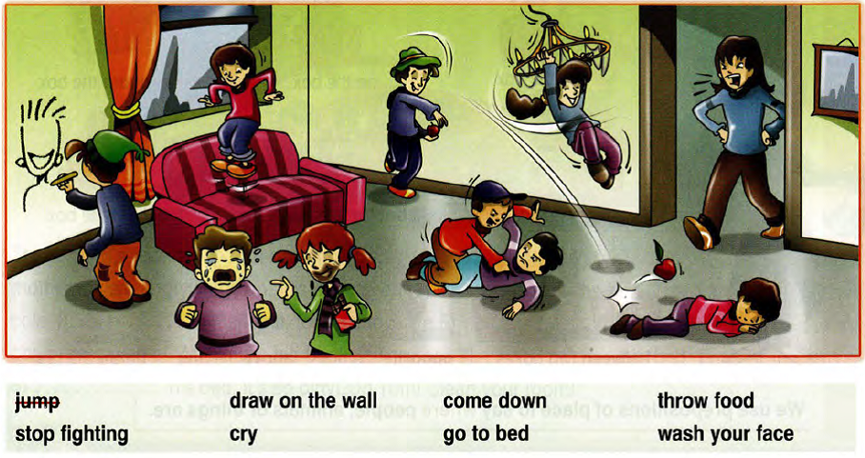

1.Ex.: Don’t jump 5. …………………………………….
2. ……………………………………. 6. …………………………………….
3. ……………………………………. 7. …………………………………….
4. ……………………………………. 8. …………………………………….

5. Speaking activity. One pupil gives an order to another one. The pupil mimes the action and gives another order to the next pupil. If a pupil fails to mime the action, he/she is out of the game.
(Activité orale. Un élève donne un ordre à un autre élève. L’élève mime l’action et donne à son tour un ordre à un autre élève. Si l’élève se trompe, il est hors du jeu)
Example of orders:
to jump – to drink – to read a book – to turn around – to sit down –to sing – to touch one’s head – to close one’s eyes – to raise one’s hand – to take one’s pencil – to say thank you – to brush one’s teeth – to work – to eat – to be quiet – to ask a question – to touch one’s nose – to touch one’s toes - …

Chapter 3: What are you doing?

Lesson 1: Present continuous

1) Theory
On utilise le « Simple Past » pour des actions qui se passent dans la passé à un moment bien précis et qui sont terminées.

Structure de phrase: (+) Sujet + Verbe (Was ou Were)
Ex.: I was / you were

(-) Sujet + Verbe (was ou were) + Not
Ex.: I wasn’t / youweren’t

(?) Verbe (was ou were) + Sujet + ?
Ex.: was she? / were you?

Affirmative | Negative |  | Interrogative
Affirmative | Long form | Short form | Interrogative
I  You  He  Was  She  It  We  Were  You  They | I  You  He  Was not  She  It  We  Were not  You  They | I  You  He  Was  Wasn’t  She  It  We  Were  Weren’t  You  They | I  You  He  She  It  We  You  They
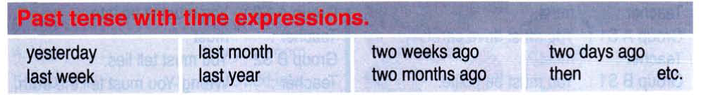

2) Exercises

1. Fill in the blanks with « was » or « were ».
(Complète avec « was » ou « were »)

Lesson 2: Some / Any – How much / How many

1) Theory
En anglais, il existe les « Countable » et les « Uncountable »nouns.

a. Countablenouns:
Ce sont des noms « dénombrables » c’est-à-dire qu’on sait les compter (Ex.: a biscuit, a cup,…): one biscuit, two biscuits, three biscuits,…
Ces noms peuvent être singuliers OU pluriels

Affirmative |  | Negative | Interrogative
Singular | plural | Negative | Interrogative
a/an + noun  Ex.: I want a biscuit | some + noun  Ex.: I want some biscuits  a few  a lot of | any + noun  there aren’t any biscuits  many  a lot of | … + any + noun?  Is there any biscuits?  many  a lot of
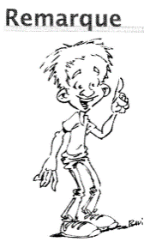
Pour poser une question on utilise « How many ».
Ex.: How many biscuits do you want? Not many

b. Uncountable nouns:
Ce sont des noms « indénombrables » c’est-à-dire qu’on ne sait pas les compter (Ex.: milk, bread, toast,…)
Ces noms sont TOUJOURS singuliers

Affirmative |  | Negative | Interrogative
Singular | plural | Negative | Interrogative
some + noun  Ex.: I want some money  a little  a lot of |  | any + noun  there isn’t any money  much  a lot of | … + any + noun?  Is there any money?  much  a lot of
Pour poser une question on utilise « How much ».
Ex.: How much money do you want? Not much

2) Exercises

1. Write « C »after the countable nouns and «U»after the uncountable nouns.
(Note un « C » à côté des noms dénombrables et un « U » à côté des noms indénombrables)
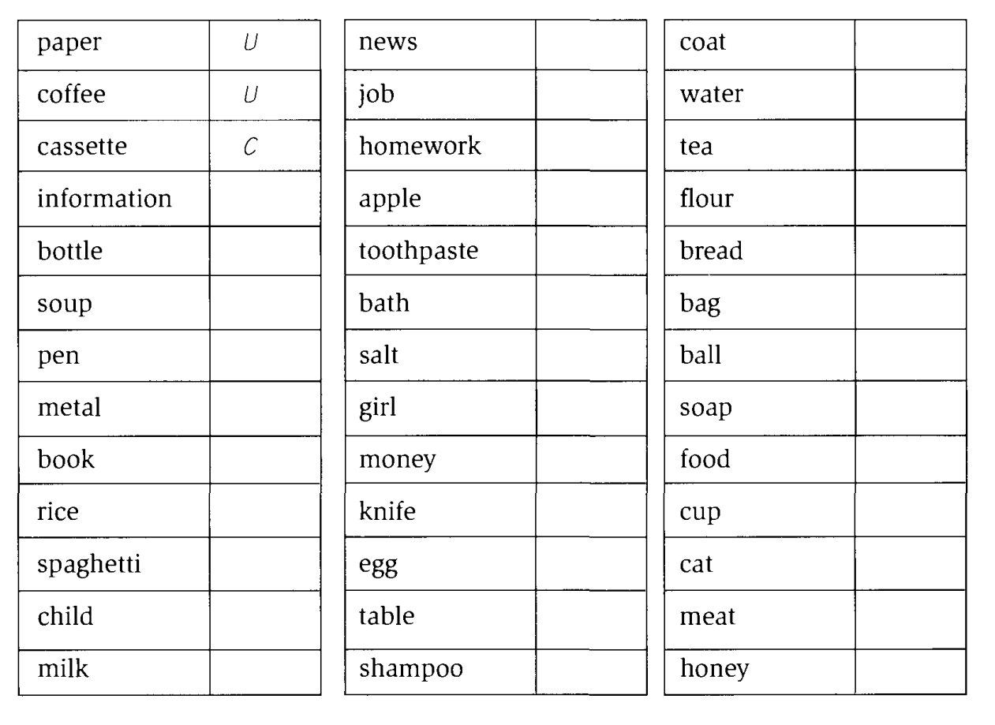

2. Complete with « a » or « some ».
(Entoure le ou les bons mots)

Peter and Harry are at a takeaway.
Assistant: What would you like?
Peter: I’d like …………………….. burger and ……………………..fries, please.
Harry: I’d like …………………….. cheese sandwich.
Assistant: and to drink?
Peter: I’d like …………………….. orange juice, please.
Harry: And I’d like …………………….. can of cola, please.
Assistant: Anything else?
Peter: Yes. I’d like …………………….. popcorn, please.
Harry: And I’d like …………………….. bar of chocolate.
Oh, and …………………….. chocolate biscuits.

3. Circle the right word or words.
(Entoure le ou les bons mots)

Ex.: I’m sorry but I haven’t got much/many time.
- There are a few/a little grapes in the fridge.

- Have you got some/any butter?
- She has got a lot of/a little friends at school.
- He made a/some lovely meal last night.
- I met some/any friends of yours last night.
- Do you write much/many letters?
- We waited a few/a little minutes and then left.
- I like fruit juice but I don’t drink some/much milk.
- I don’t have much/many homework to do tonight.
- Have you got some/any spaghetti? – Yes, but not much/many.

4. Fill in the blanks with « how many » or « how much ».
(Complète avec « how many » ou « how much »)

- ………………………………………… sugar is there in your tea?
- ………………………………………… toys are there in the room?
- ………………………………………… children are there in the classroom?
- ………………………………………… milk is there in the bottle?
- ………………………………………… meat is there?
- ………………………………………… ink is there in the bottle?

5. Ask and answer questions about the pictures. Use « how much » or « how many ».
(Pose et réponds aux questions à propos des images. Utilise « how much » ou « how many »)
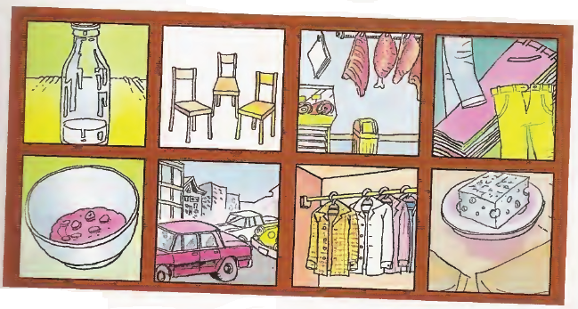

5. ………………………………………………?
………………………………………………
6. ………………………………………………?
………………………………………………
7. ………………………………………………?
………………………………………………
8.………………………………………………?
………………………………………………

- ……………………………………………?
……………………………………………
- ……………………………………………?
……………………………………………
- ……………………………………………?
……………………………………………
- ……………………………………………?
……………………………………………

Chapter 4: What’s the matter?

Lesson 1: Modal auxilary

1) Theory
On utilise le « Simple Past » pour des actions qui se passent dans la passé à un moment bien précis et qui sont terminées.

