# 1 This is / That’s
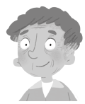


1. This is my family.
2. __________ my mum.
3. __________ my dad.
4. __________ my grandpa.
5. __________ my sister.
6. __________ my grandma.
7. __________ my brother.
8. __________ my baby sister.
# 2
1. my / is / This / family. ______________________________________________
2. is / This / mum. / my _______________________________________________
3. dad. / That / my / ‘s _______________________________________________
4. That / grandpa. / my / ‘s ____________________________________________
5. This / my / is / sister. ______________________________________________
6. my / is / This / grandma. ____________________________________________
7. brother. / That / my / ‘s ____________________________________________
8. my / That / baby sister. / ‘s _________________________________________
# 3 Write This is / That’s and colour.
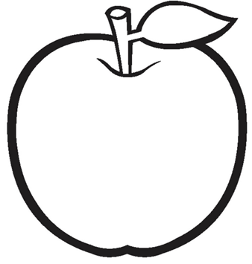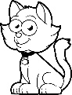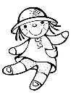
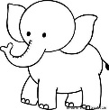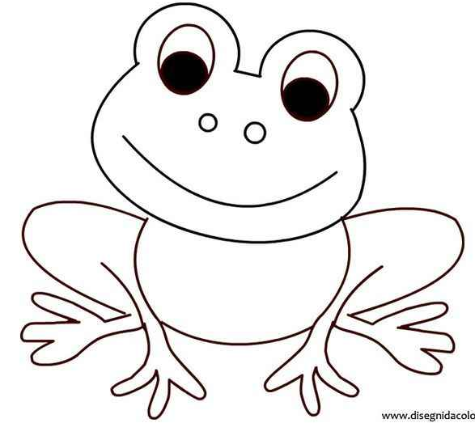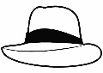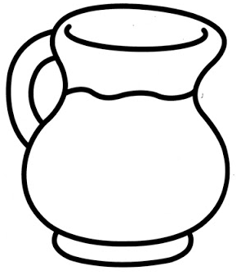

1. This is my elephant. It’s grey.
2. _________________ my frog. It’s green.
3. _________________ my apple. It’s red.
4. _________________ my hat. It’s yellow.
5. _________________ my ball. It’s pink.
6. _________________ my cat. It’s black.
7. _________________ my jug. It’s orange.
8. _________________ my doll. It’s white.

