# 1 Learn the words
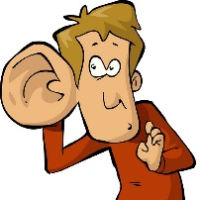 | 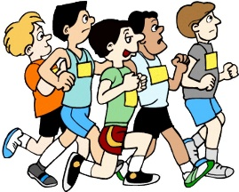 |  | 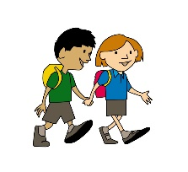 | 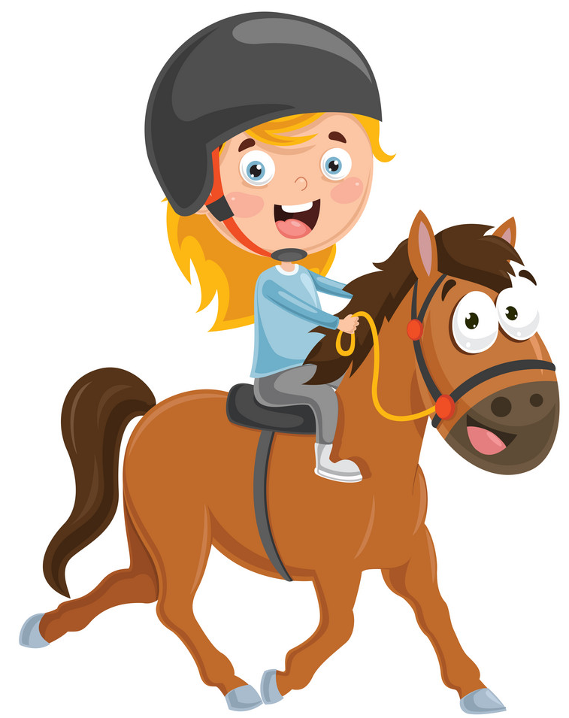
hear | run | see | walk | ride a horse

# 2 Write
1. I / the song. / hear / can I can hear the song.
2. the dogs. / He / hear / can’t ___________________________________________________
3. run. / Ben / can ____________________________________________________________
4. can’t / The bird / run. _______________________________________________________
5. see. / can’t / kitten / The small _________________________________________________
6. The cat / see. / can __________________________________________________________
7. My baby / can’t / sister / walk. _________________________________________________
8. We / walk / the dog. / can ____________________________________________________
9. Ken / a horse. / ride / can ____________________________________________________
10. a horse. / Sam / ride / can’t __________________________________________________

# 3 Look and write
1 Ben  hear | 2 Sam  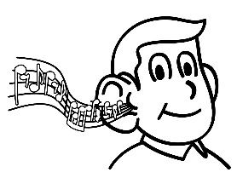  hear | 3 They  run | 4 Ken  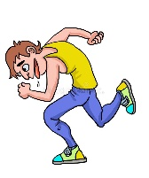  run | 5 Bob  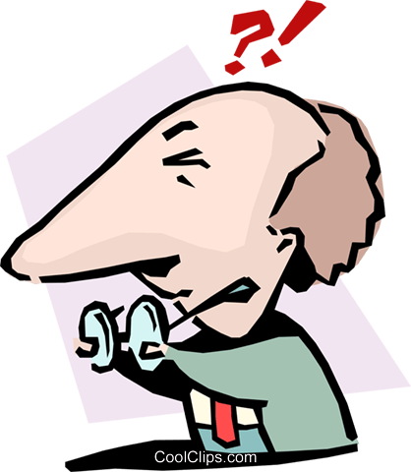  see
6 Mike  see | 7 They  walk | 8 Tim  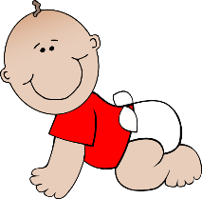  walk | 9 Kate  ride a horse | 10 John  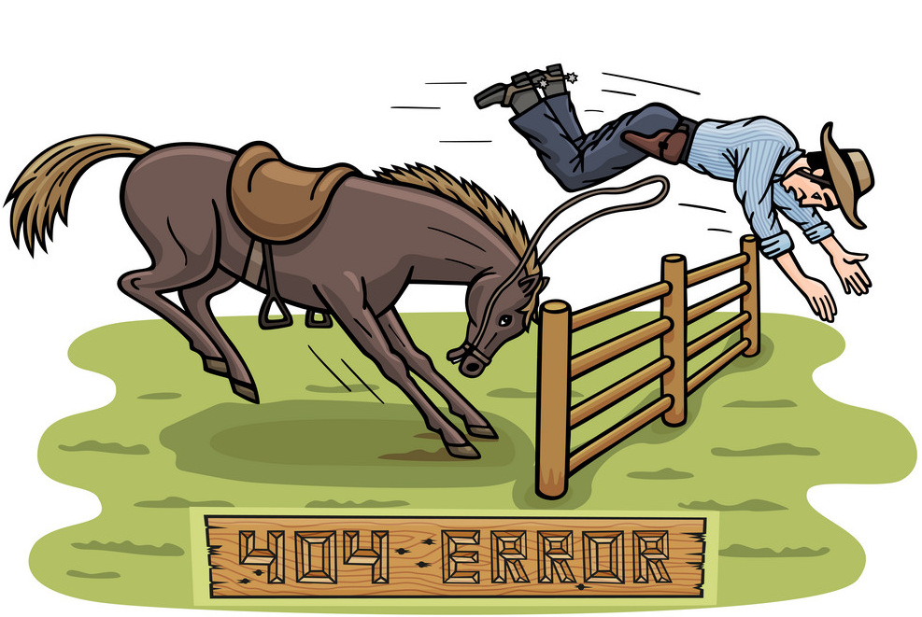  ride a horse
1. Ben can’t hear.
2. _________________________________________________________________________
3. _________________________________________________________________________
4. _________________________________________________________________________
5. _________________________________________________________________________
6. _________________________________________________________________________
7. _________________________________________________________________________
8. _________________________________________________________________________
9. _________________________________________________________________________
10. ________________________________________________________________________
# 4 Look and write can or can’t.
1. The baby ____________ walk. | 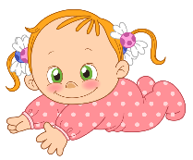
2. The small kittens ____________ see. | 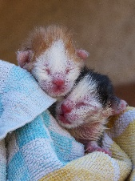
3. The snake ___________ hear. | 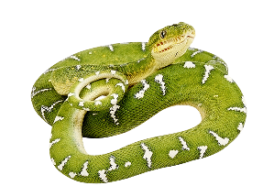
4. The fish ___________ run. | 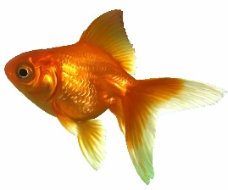
5. She ____________ ride a horse. | 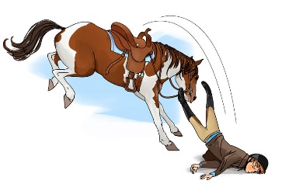
6. The bat _________ hear. | 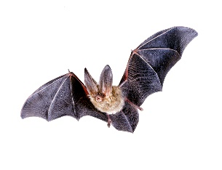
7. The tiger _________ run. | 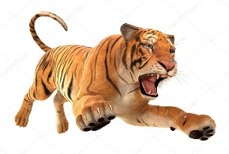
8. The cat ___________ see. | 