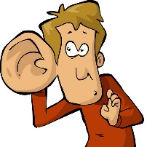 | 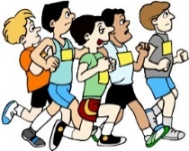 |  | 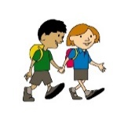 | 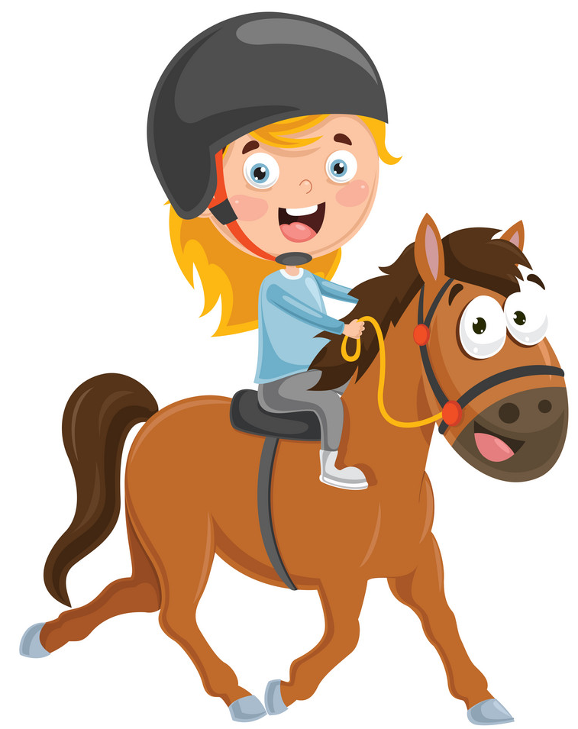
hear | run | see | walk | ride a horse | clap your hands | stamp your feet

# 1 Read and write (+) Yes, I can. / (-) No, I can’t.
1. Can you hear the dog? (+) Yes, I can.
2. Can you hear the kitten? (-) ___________________________________________________
3. Can you see the sun? (+) ______________________________________________________
4. Can you hear the wind? (-) ____________________________________________________
5. Can you run? (+) ____________________________________________________________
6. Can you see the bird? (-) _____________________________________________________
7. Can you walk? (+) ___________________________________________________________
8. Can you ride a horse? (+) _____________________________________________________
9. Can you clap your hands? (+) ___________________________________________________
10. Can you stamp your feet? (-) __________________________________________________

# 2 Write
1. sing / can / you ? Can you sing?
2. kick / you / can / a ball ? _____________________________________________________
3. bike / ride / a / can / you ? ___________________________________________________
4. hear / the wind / you / can ? __________________________________________________
5. can / see / a bird / you ? _____________________________________________________
6. stamp / you / can / your feet ? _________________________________________________
7. your hands / you / can / clap ? _________________________________________________
8. you / climb / can / a tree ? ___________________________________________________
9. a ball / you / catch / can ? ____________________________________________________
10. can / a ball / throw / you ? ___________________________________________________
11. a horse / can / ride / you ? ___________________________________________________
12. see / the sun / you / can ? ___________________________________________________

# 3 Write.
 | hear the wind | run | see the sun | walk | ride a bike | clap your hands | stapm your feet
Mark, 10 | - | + | + | + | - | + | +
Sally, 1 | + | - | + | - | - | + | -
You

1. Mark, can you hear the _________? – No, I can’t.
2. Mark, can you run? - _________________________________________________________
3. Mark, can you see the _________? - _____________________________________________
4. Mark, can you walk? - _________________________________________________________
5. Mark, can you ride ___________? - _____________________________________________
6. Mark, can you clap your ________? - _____________________________________________
7. Mark, can you stamp your ________? - ___________________________________________
8. Sally, can you hear _____________? - ___________________________________________
9. Sally, can you run? - _________________________________________________________
10. Sally, can you see _____________? - ___________________________________________
11. Sally, can you walk? - ________________________________________________________
12. Sally, can you ride ____________? - ____________________________________________
13. Sally, can you clap ________________? - ________________________________________
14. Sally, can you stamp _______________? - _______________________________________
15. Can you __________________________________________? - _____________________
16. Can _____________________________________________? - _____________________
17. ________________________________________________? - _____________________
18. ________________________________________________? - _____________________
19. ________________________________________________? - _____________________
20. ________________________________________________? - _____________________
21. ________________________________________________? - _____________________

