subject | object
I | me
you | you
he | him
she | her
we | us
you | you
they | them

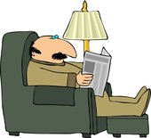 |  | 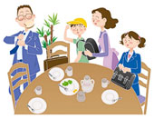 | 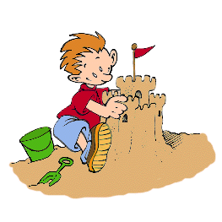
Mr Black - 2h | Ann - 10m | The Johnson family  15 m | Bill - 3h
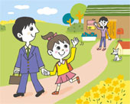 | 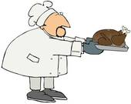 | 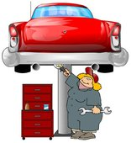 | 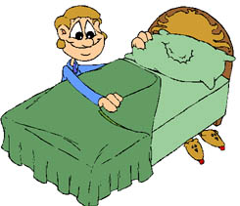
The children - 20m | The chef – 1,30 h | The mecanic –  one day | My brother - 5m
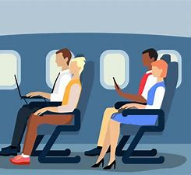 | 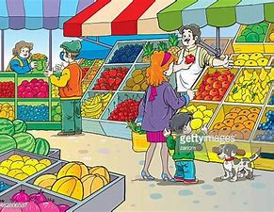 | 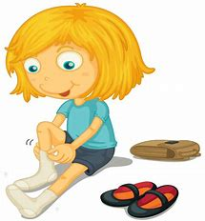 | 
The passengers - 8h | Emily - 40m | You - get dressed - 3m | Dad – the whole life
catch a big fish – fix the car – prepare a chicken – build a sandcastle – have breakfast take a shower – read the newspaper – go to school – make the bed
shop at the grocery store – get dressed – travel to London

Example: How long does it take M. Black to read the newspaper?
It takes him 2 hours.

Make sentences following the example.

- ____________________________________________________________________________________________________________________________________
- ____________________________________________________________________________________________________________________________________
- ____________________________________________________________________________________________________________________________________
- ____________________________________________________________________________________________________________________________________
- ____________________________________________________________________________________________________________________________________
- ____________________________________________________________________________________________________________________________________
- ____________________________________________________________________________________________________________________________________
- ___________________________________________________________________________________________________________________________________
- ____________________________________________________________________________________________________________________________________
- ____________________________________________________________________________________________________________________________________
- ____________________________________________________________________________________________________________________________________
- ____________________________________________________________________________________________________________________________________

