# 1 Write
1. is / kitten / This / and / brown / white. _________________________________
________________________________________________________________
2. isn’t / It / hungry. ________________________________________________
3. hot / thirsty. / and / It / ‘s _________________________________________
4. kittens / These / white. / and / orange / are _____________________________
________________________________________________________________
5. tired. / ‘re / They ________________________________________________
6. white. / and / black / kitten / This / is _________________________________
________________________________________________________________
7. It / happy. / isn’t _________________________________________________
8. ‘s / angry. / It ___________________________________________________
9. and / grey / white. / is / This / kitten _________________________________
________________________________________________________________
10. scared. / ‘s / It _________________________________________________

# 2 Write is / isn’t.
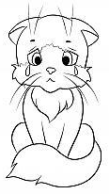This kitten _____ happy. It ___ sad. | 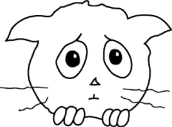 This kitten _____ happy.  It ____ scared.
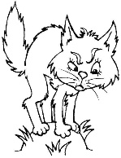 This kitten _____ tired.  It _____ angry. | 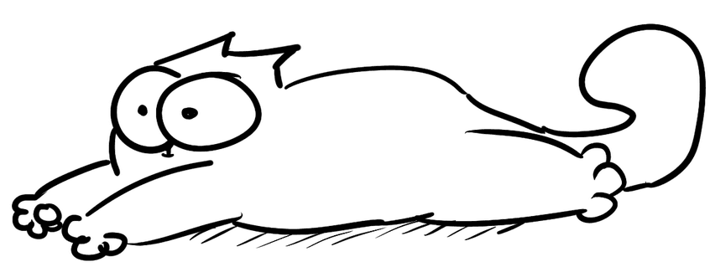  This kitten ________ thirsty.  It ______ tired.
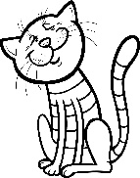This kitten _____ sad.  It ____ happy. | 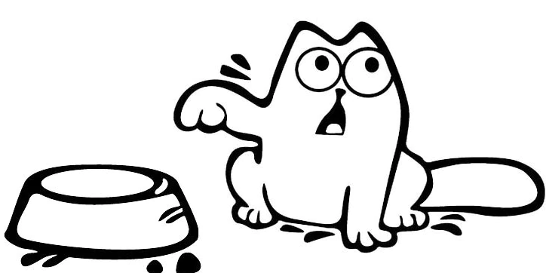 This kitten _____ thirsty.  It _____ hungry.
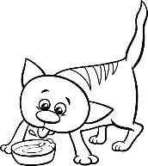 This kitten _______ tired.  It _____ thirsty. | 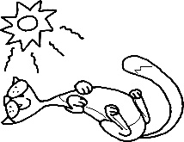This kitten ______ cold.  It _____ hot.
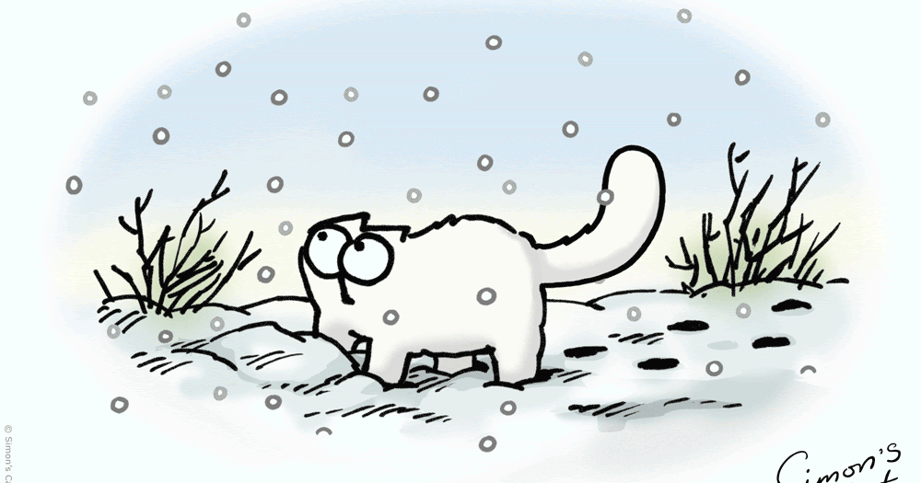This kitten ______ hot.  It ____ cold. | 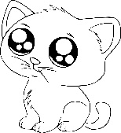This kitten ________ tired.  It _____ cute.

