# 1 Learn
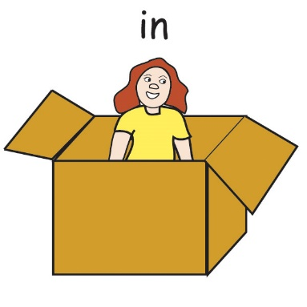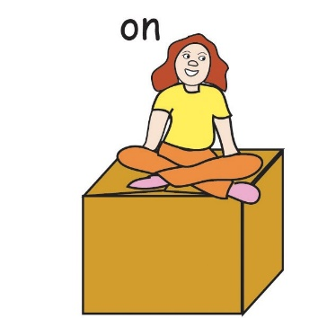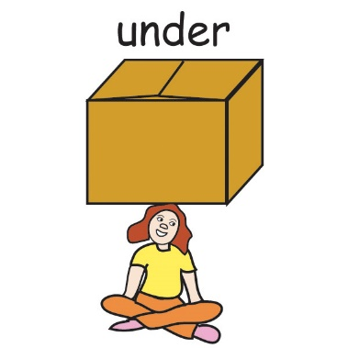
# 2 Write in, on, under, next to.
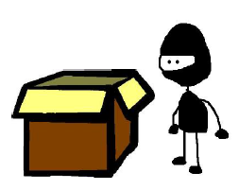  Where’s the Ninja?  He’s ___________ the box. | 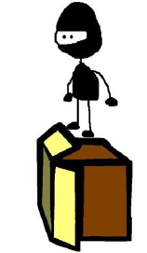 Where’s the Ninja?  He’s _________ the box. |  Where’s the Ninja?  He’s ________ the box.
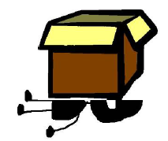  Where’s the Ninja?  He’s _________ the box. | 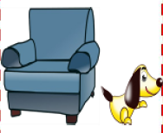  Where’s the dog?  It’s _________ the armchair. | 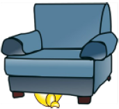  Where’s the dog?  It’s _______ the armchair.
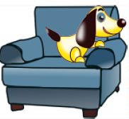  Where’s the dog?  It’s ______ the armchair. | 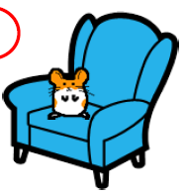  Where’s the hamster?  It’s ______ the armchair. | 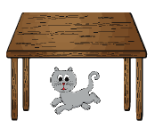  Where’s the cat?  It’s ______ the table.
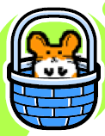  Where’s the hamster?  It’s _______ the basket. | 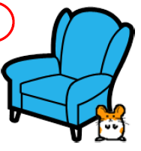  Where’s the hamster?  It’s ________ the armchair. | 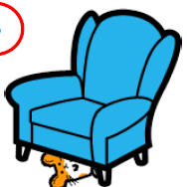  Where’s the hamster?  It’s _______ the armchair.
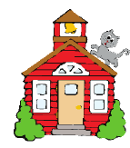  Where’s the cat?  It’s ______ the house. | 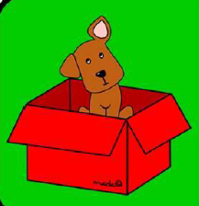  Where’s the dog?  It’s _______ the box. | 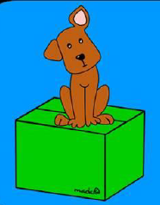  Where’s the dog?  It’s _________ the box.
# 3 Write
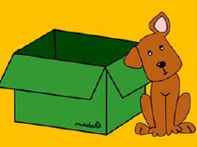 | ‘s / Where / dog /the / ? - Where’s the dog?  It / the / next / ‘s / to / box. – It’s next to the box.
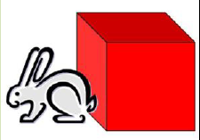 | rabbit / Where / the / ‘s / ? ___________________________________  ‘s / the / next / box / It / to /. ________________________________  _________________________________________________________
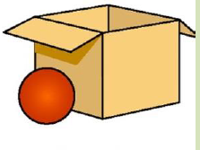 | the/ Where / ball / ‘s / ? ______________________________________  to / next / the / It / box / ‘s /. _________________________________  _________________________________________________________
 | Where / rabbit / ‘s / the / ? ___________________________________  It / in / ‘s / box / the / . ______________________________________
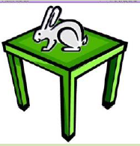 | rabbit / the / ‘s / Where / ? ___________________________________  on / It / ‘s / table / the /. _____________________________________
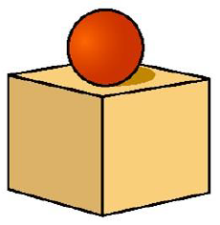 | ball/ the / ‘s / Where / ? _____________________________________  box / the / on / ‘s / It / . _____________________________________
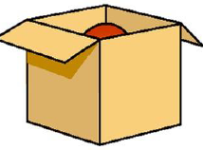 | ‘s / Where / the / ball / ? _____________________________________  the / in / box / It/ ‘s /. _______________________________________
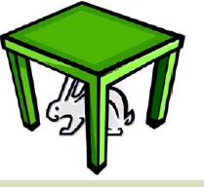 | the / Where / rabbit / ‘s / ? ___________________________________  It / table / under / ‘s / the /. __________________________________

