- An adverb is a word that describes a verb, an action.
- It tells us something about the way something is done.
- Many adverbs end with an -ly.

ADVERBS of MANNER  - Describes HOW something is done.  - Mostly placed at the end of a sentence.  - NOTE! FAST (adj.) - FAST (adv.)  HARD (adj.) - HARD (adv.)  GOOD ( adj.) - WELL (adv.)  - Quietly, carefully, noisily, closely, easily, beautifully, badly, angrily, mysteriously  painfully, kindly, smoothly, silently | 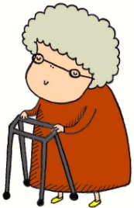  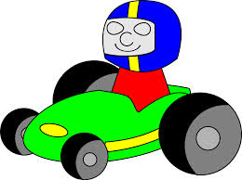  He drives safely. She walked slowly.
ADVERBS of TIME  - Describes WHEN something happens.  - Can be placed both at the beginning or the end of a sentence.  - Later, just, tonight, today, soon, yet, next week, this year, still, already, eventually, late, early, at the moment |     Tomorrow we go to London. I eat now.
ADVERBS of PLACE  - Describes WHERE something happens.  - Can be placed both at the beginning or the end of a sentence.  - On, off, over, under, outside, above, below, between, in the middle of, indoors, abroad, indoors, anywhere | 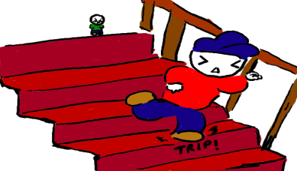  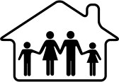  They are inside. He walks downstairs.
ADVERBS of FREQUENCY  - Describes HOW OFTEN something happens.  - Is placed before the verb, except the verb TO BE.  - Always, frequently, generally, never, hardly ever, infrequently, normally, regularly, seldom, sometimes, usually |   They are _____ kissing. They _____ kiss.  100 % - ALWAYS  90% - USUALLY  80% - FREQUENTLY  70 % - OFTEN  60 % - SOMETIMES  50 % - OCCASIONALLY  40 % - RARELY  30 % - SELDOM  20 % - HARDLY EVER  10 % - NEVER

