DEMONSTRATIVE PRONOUNS
Singular | Plural
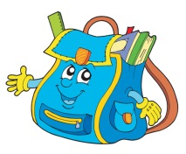  THIS  This is my schoolbag. |   THESE  These are my pencils.
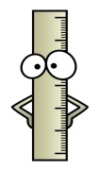  THAT  That is my ruler. |   THOSE  Those are my books.
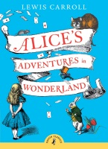
- Choose the right word.
1._____ is my favourite book.

a) These b) This c) That
2._____ students are happy.
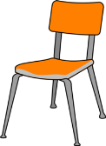
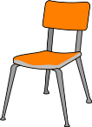
a) Those b) That c) These
3._____ chairs are comfortable.
a) That b) These c) This
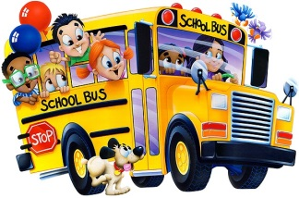
4._____ is the school bus.
a) Those b) These c) That

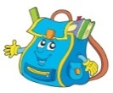
- Answer the questions. Follow the example.
Example: What is this? This is a schoolbag.
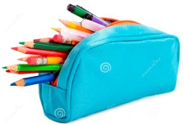
1. What is that? __________________________
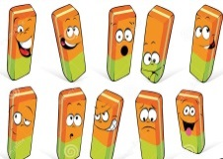
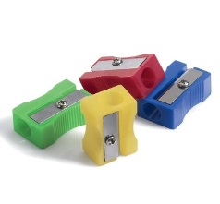
2. What are these? __________________________

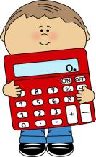
3. What are those? __________________________

4. What is this? __________________________

