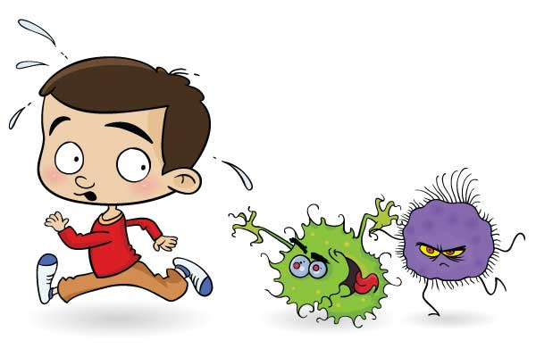    Problem: cough and a sore throat  Duration: 5 days ago  Symptoms:  - headache |   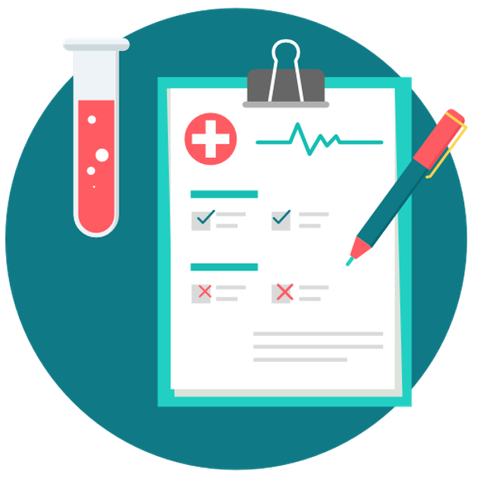  Examination:  - ask when it started  - take a temperature (+)  - ask about headache  - examine a throat (+)  Diagnosis: tonsillitis  Prescription:  - take medicine  - have a lot of warm drinks  - stay in bed for 2 days
  Problem: sneezing and a runny nose  Duration: 2 days ago  Symptoms:  - headache | Examination:  - ask when it started  - take a temperature (+)  - examine a throat (-)  - ask about headache  Diagnosis: cold  Prescription:  - take pills  - take nose drops  - stay in bed for 2 days
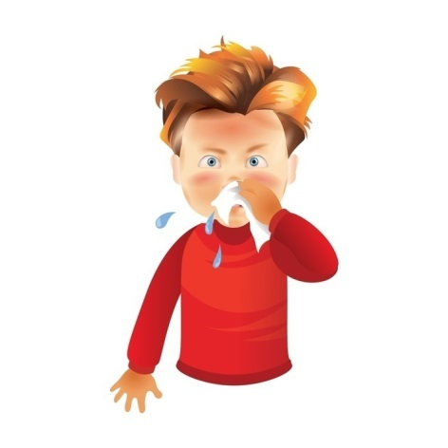  Problem: a runny nose and sneezing  Duration: 4 days ago  Symptoms:  - headache | Examination:  - ask when it started  - take a temperature (+)  - examine a throat (-)  - ask about headache  Diagnosis: cold  Prescription:  - take pills  - take nose drops
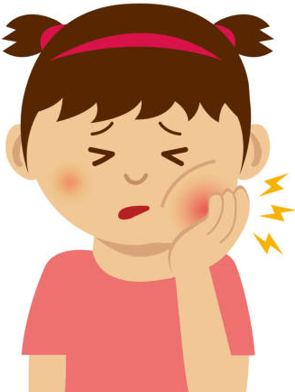  Problem: toothache  Duration: 2 days ago  Symptoms:  - earache | Examination:  - ask when it started  - examine teeth (+)  - ask about headache  - ask about earache  Diagnosis: a bad tooth (pulpitis)  Prescription:  - brush teeth every day  - don’t eat many sweets
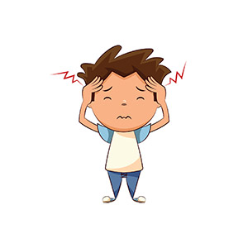  Problem: headache  Duration: 3 days ago  Symptoms:  - temperature | Examination:  - ask when it started  - take a temperature (+)  - examine a throat (+)  - ask about cough  Diagnosis: tonsillitis  Prescription:  - take medicine  - stay in bed for 2 days  - have a lot of warm drinks
Problem: cough  Duration: a week ago  Symptoms:  - headache  - backache | Examination:  - ask when it started  - ask about headache  - take a temperature (+)  Diagnosis: flu  Prescription:  - take pills and medicine  - stay in bed for 3 days  - have a lot of warm drinks
  Problem: earache  Duration: a week ago  Symptoms:  - headache | Examination:  - ask when it started  - take a temperature (+)  - ask about headache  Diagnosis: otitis  Prescription:  - take eardrops  - keep an ear warm
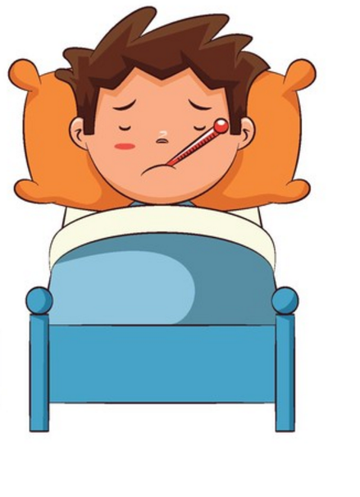  - Problem: cough, high temperature, sneezing  Duration: yesterday  Symptoms:  - headache | Examination:  - ask when it started  - ask about headache  - examine a throat (+)  - take a temperature (+)  Diagnosis: flu  Prescription:  - take pills and medicine  - stay in bed for 3 days  - have a lot of warm drinks
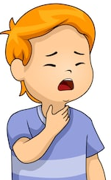  Problem: a sore throat, fever  Duration: 4 days ago  Symptoms:  - headache | Examination:  - ask when it started  - ask about headache  - ask about a cough  - take a temperature (+)  Diagnosis: tonsillitis  Prescription:  - take medicine  - stay in bed for 2 days  - have a lot of warm drinks
  Problem: stomachache  Duration: yesterday  Symptoms:  - headache  - vomiting | Examination:  - ask when it started  - ask about headache  - ask about vomiting  - take a temperature (+)  Diagnosis: food poisoning  Prescription:  - take medicine  - don’t eat till tomorrow  - drink a lot of water
- Come in please!
- Good morning, Doctor.
- Good morning, Mr. Smith. What’s the matter?
- I’ve got a terrible headache.
- And when did it start?
- It started 2 days ago.
- OK. Let me take your temperature… Well, you’ve got a temperature but it isn’t very high.
Let me examine your throat. Open your mouth and say “A-a-ah!”
- A-a-ah!
- You’ve got a sore throat. Have you got a cough?
- No, I haven’t.
- Well, it’s tonsillitis. You should take this medicine 2 times a day. Stay in bed for 2 days and have a lot of warm drinks.
- Thank you, Doctor. Good bye.
- Good bye. And don’t worry. You’ll be alright soon.

