# Read and write I’ve got / I haven’t got
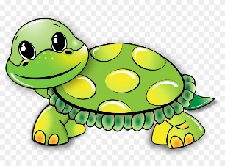 | _____________ two eyes.  _________________ ears.  ___________ a long tail.  ___________ a short tail.  ___________ four legs. | 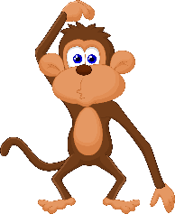 | ______________ two ears.  ______________ two eyes.  ____________ a short tail.  ______________ a long tail.  ____________ four arms.  ____________ two feet.  ____________ two arms.
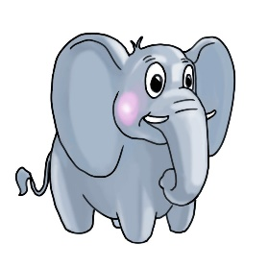 | ___________ a long tail.  ___________ a short tail.  ___________ two eyes.  ___________ two legs.  ___________ four arms.  ___________ small ears.  ___________ big ears. | 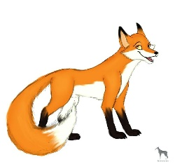 | ____________ four legs.  ____________ four arms.  ____________ four feet.  ____________ two big ears.  ____________ a long tail.  ____________ a short tail.  ____________ two eyes.
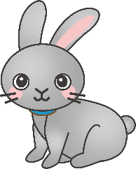 | ___________ short ears.  ___________ long ears.  ___________ a short tail.  ___________ a long tail.  ___________ four legs.  ___________ two eyes. |  | ____________ two eyes.  ____________ two arms.  ____________ four ears.  ____________ two legs.  ____________ two feet.  ____________ a tail.
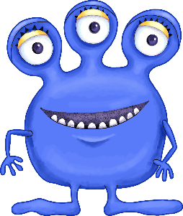 | ___________ three eyes.  ___________ ears.  ___________ four arms.  ___________ two legs.  ___________ two feet.  ___________ a tail. | 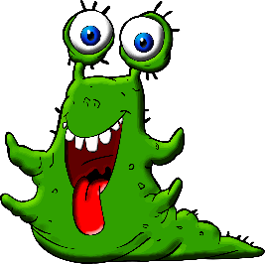 | ____________ two eyes.  ____________ ears.  ____________ four arms.  ____________ legs.  ____________ a long tail.  ____________ feet.

# 2 Read and draw monsters.
I’ve got four eyes. I’ve got six ears.  I’ve got eight arms. I’ve got one leg.  I’ve got two feet. I’ve got two long tails. | I’ve got one eye. I haven’t got ears.  I haven’t got arm. I’ve got eight legs.  I’ve got eight feet. I haven’t got a tail.
I’ve got twelve small eyes. I’ve got three long ears. I’ve got two long arms. I’ve got four short legs. I haven’t got feet. I haven’t got a tail. | I’ve got two big yellow eyes. I’ve got two small green ears. I’ve got six short brown hands. I’ve got two long purple legs. I’ve got four big red feet. I’ve got a long black and white tail.

