1. Read, look and choose Yes, I do or No, I don’t.
1. Do you fly a kite on Friday? | 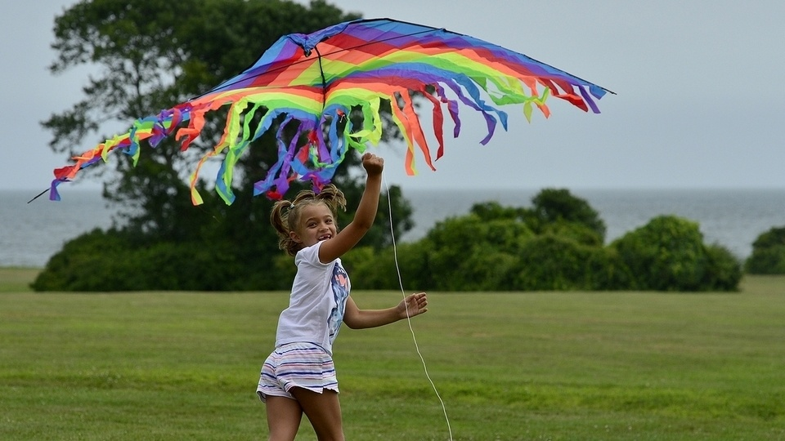 | Yes, I do.  No, I don’t.
2. Do you visit Grandma on Saturday? | 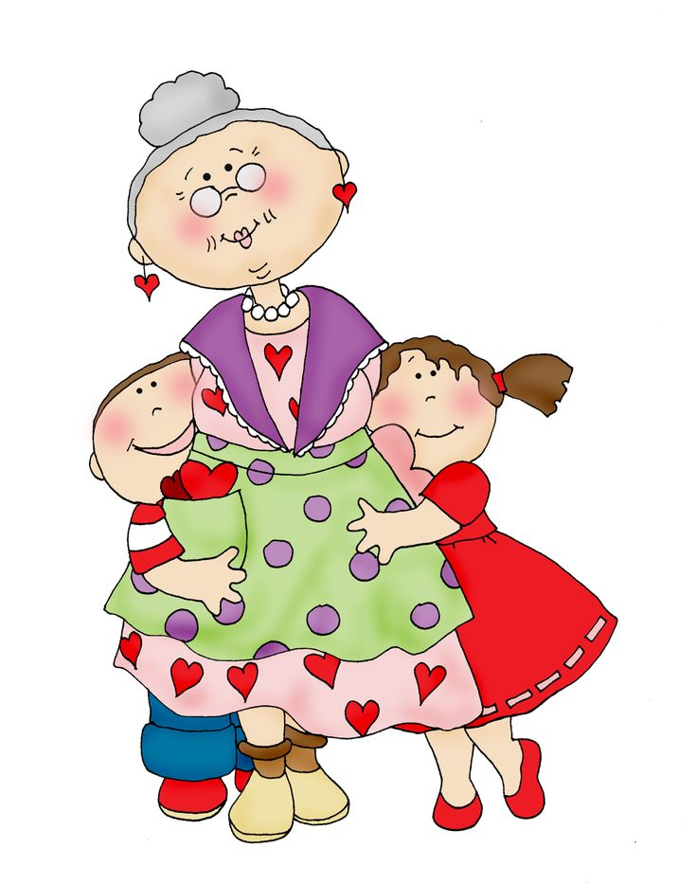 | Yes, I do.  No, I don’t.
3. Do you climb a tree on Sunday? | 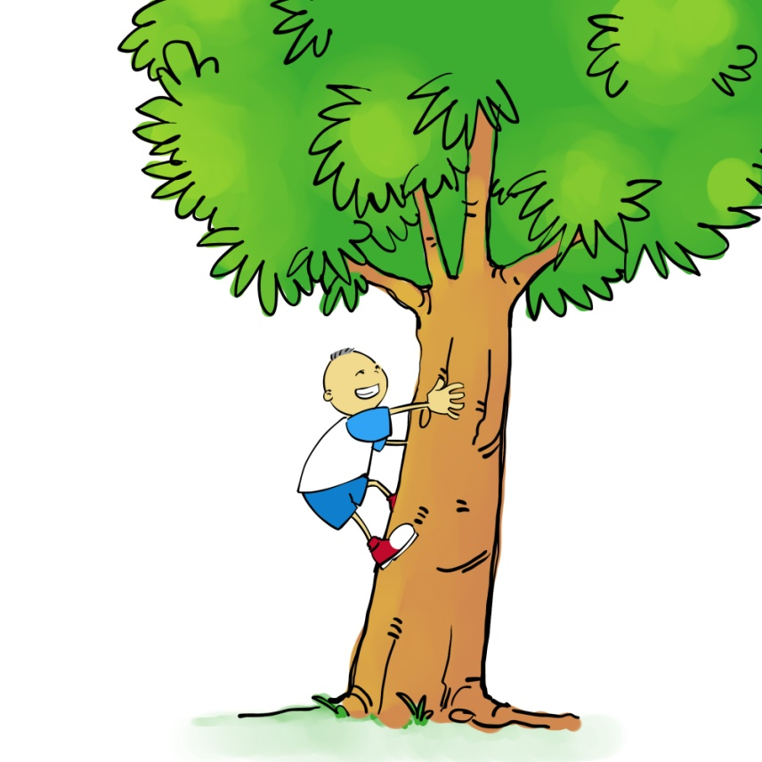 | Yes, I do.  No, I don’t.
4. Do you have fun on Monday? | 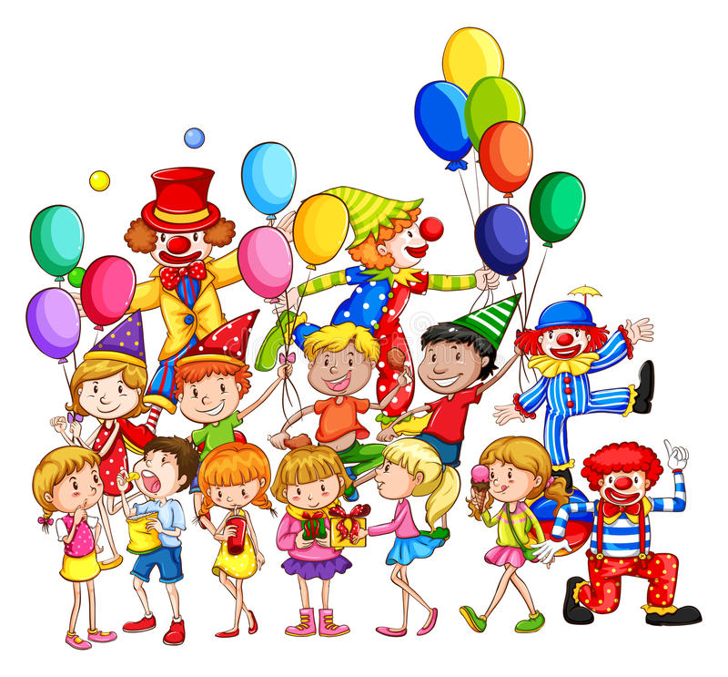 | Yes, I do.  No, I don’t.
5. Do you cook soup on Tuesday? | 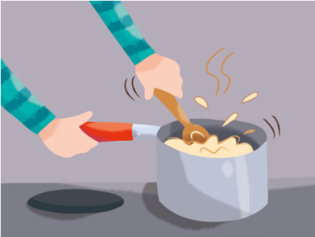 | Yes, I do.  No, I don’t.
6. Do you turn around in the park? | 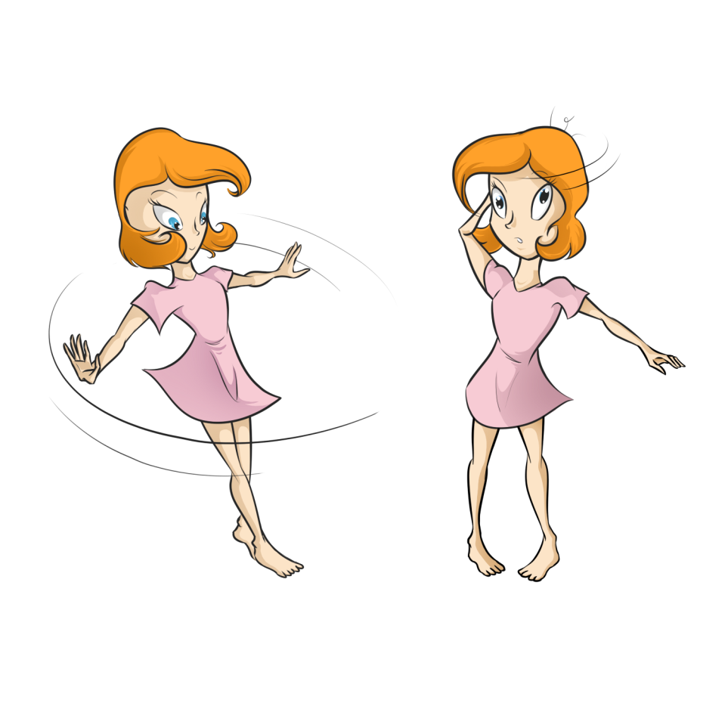 | Yes, I do.  No, I don’t.
7. Do you throw a ball to your friend? | 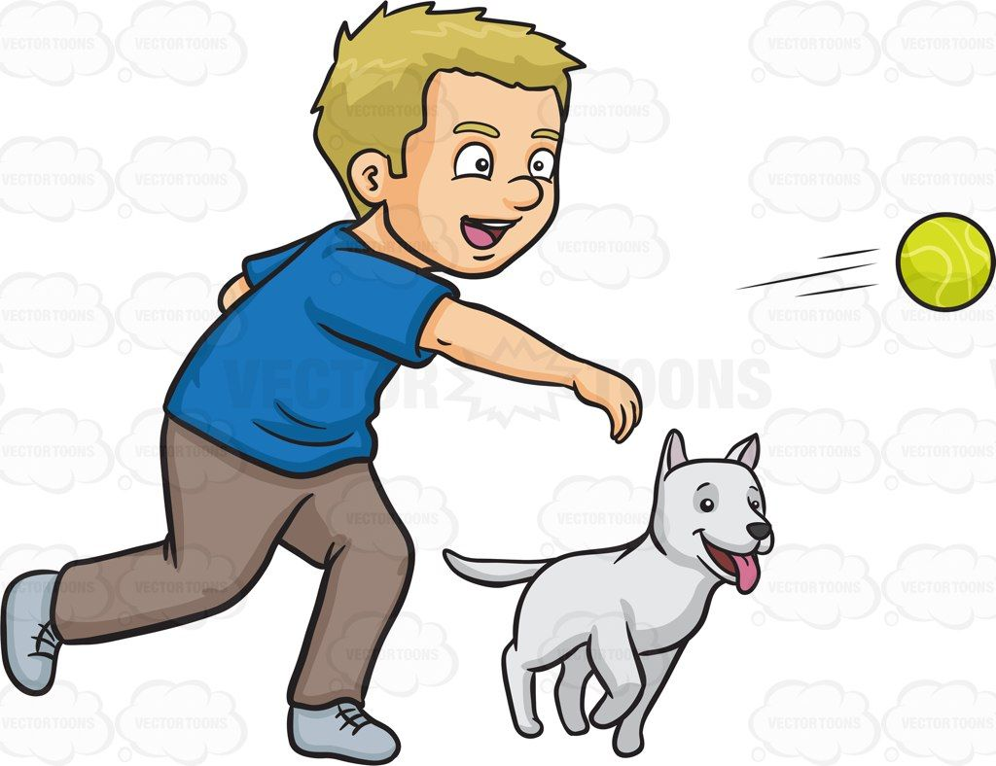 | Yes, I do.  No, I don’t.
8. Do you read books at school? | 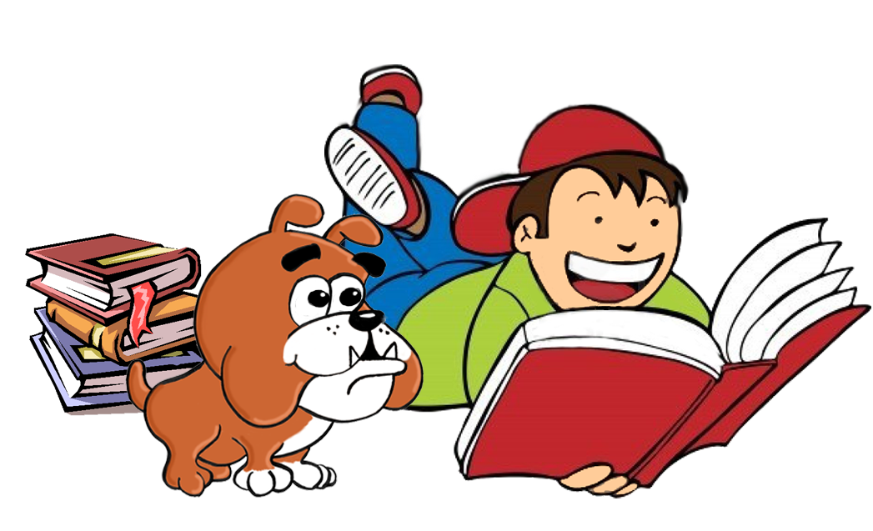 | Yes, I do.  No, I don’t.
9. Do you learn the new words in class? | 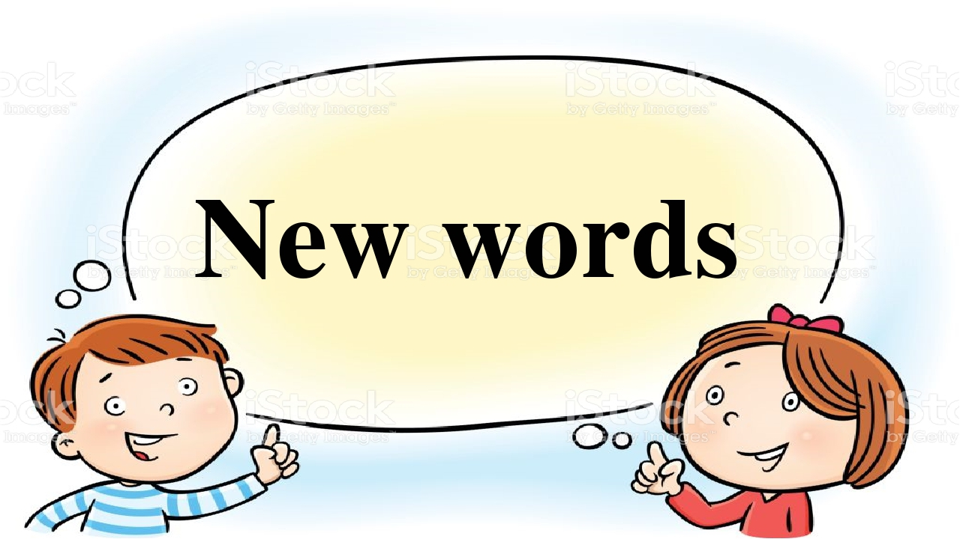 | Yes, I do.  No, I don’t.
10. Do you stay at home at the weekend? |  | Yes, I do.  No, I don’t.
11. Do you run fast at school? | 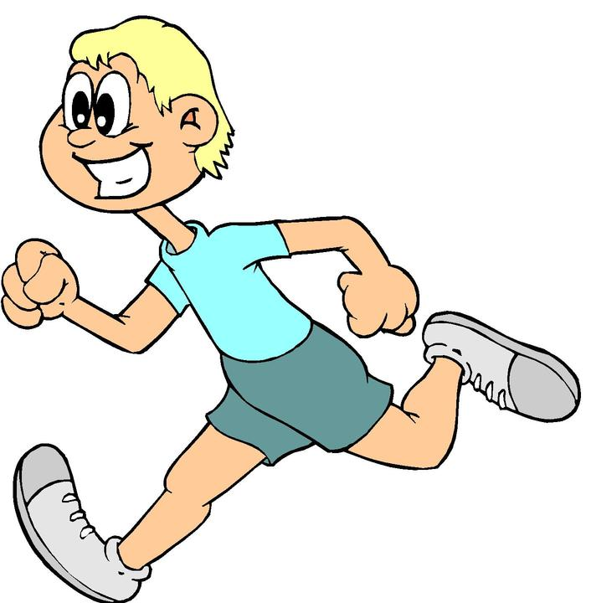 | Yes, I do.  No, I don’t.
12. Do you jump high in the classroom? |  | Yes, I do.  No, I don’t.
13. Do you write a story in class? | 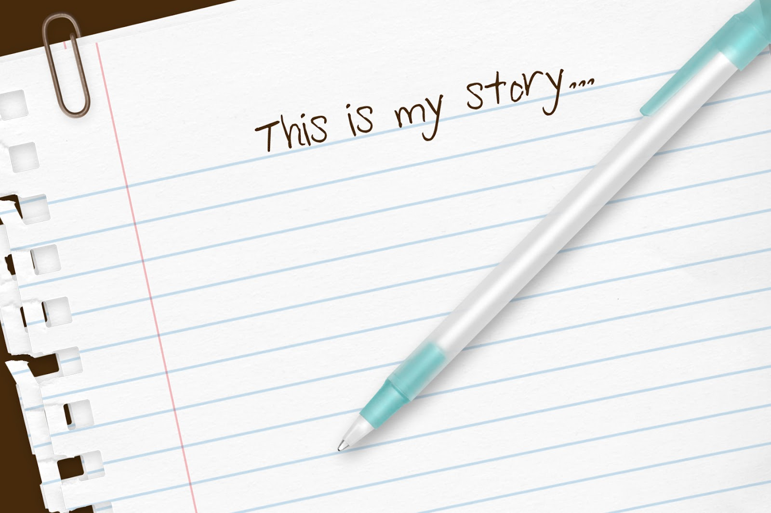 | Yes, I do.  No, I don’t.
14. Do you play tennis on Thursday? | 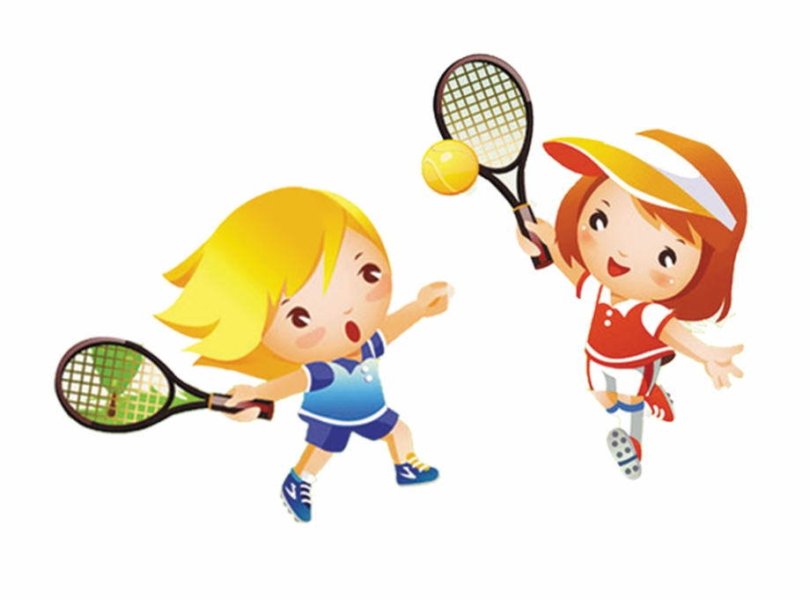 | Yes, I do.  No, I don’t.

2. Make questions.
1. read / Do you / at school? / books
____________________________________________________
2. you play / Do / Thursday? / tennis on
____________________________________________________
3. throw a / you / your friend? / Do / ball to
____________________________________________________
4. Do / a story / you write / in class?
____________________________________________________
5. climb / Do you / a tree / Sunday? / on
____________________________________________________
6. jump / the classroom? / high in / Do you
____________________________________________________
7. you / Do / have / Monday? / fun on
____________________________________________________
8. cook soup / Do you / Tuesday? / on
____________________________________________________

