Past Simple vs. Past Continuous - Fill in the blanks with the correct form of the verb in brackets.
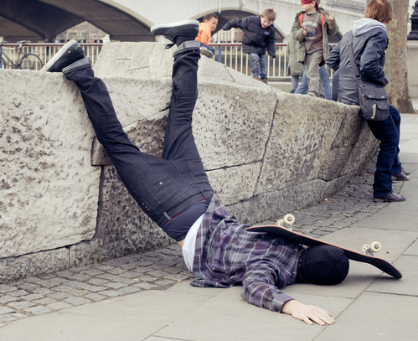
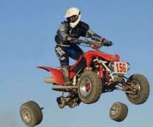
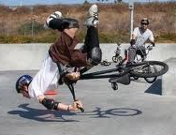
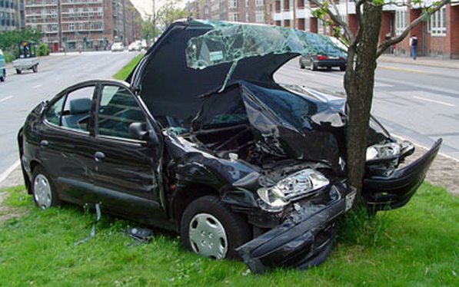
4. When he ___________ (hurt) himself, he ___________ (ride) his BMX.
3. The wheels ___________ (fall) off as he ___________ (ride) his quad.
2. He ___________ (crash) into a tree while he ___________ (drive) his car.
1. He ___________ (ride) his skateboard when he ________ (fall).

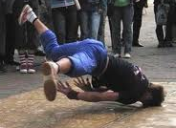
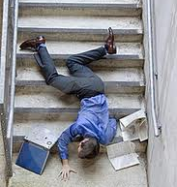



5. While he _________ (breakdance), he ___________ (hit) his head.
6. He __________ (trip) while he _________ (walk) down the stairs.
7. While she __________ (eat), she _________ (fall) asleep.
8. She ____________ (send) a text message when she ___________ (spill) her coffee.

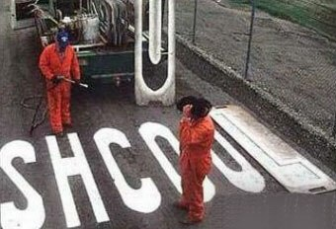
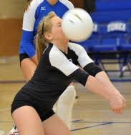
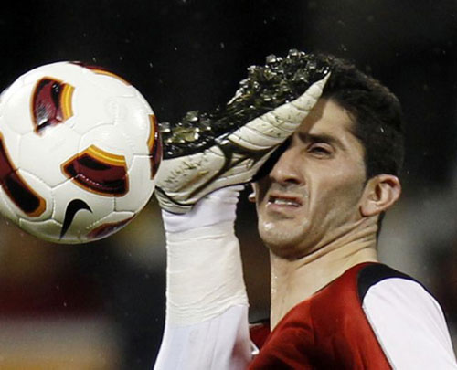
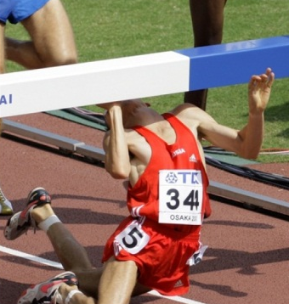
12. They __________ (make) a mistake when they ___________ (spell) “school”.
11. As she ___________ (play) volleyball, the ball ___________(hit) her face.
10. He _________ (be) kicked in the face when he ___________ (play football).
9. He _________ (run) when he ___________ (trip).

