# 1 Write: eye, ear, arm, leg, foot, feet, tail, short tail, long tail
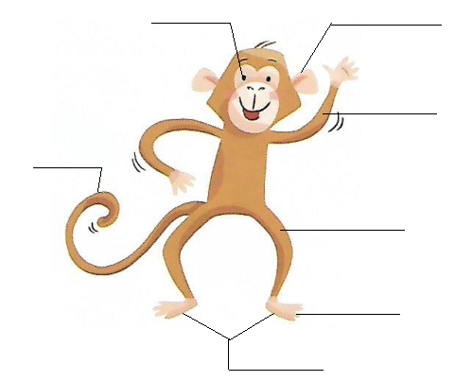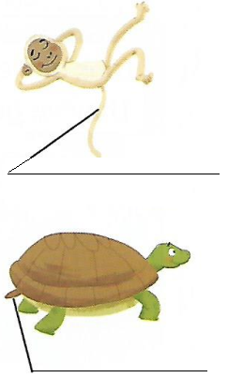
# 2 Find and write
e | y | e | l | e | g | l | o | n | g
a | r | m | f | o | o | t | s | a | q
r | s | d | e | f | g | a | h | s | w
z | q | w | e | e | h | i | o | d | e
x | s | d | t | r | j | l | r | f | r
c | v | b | n | m | a | s | t | g | t
# 3 Read and write
___ y ___ ___ ___ r ___ rm l ___ g
f___ ___ t f___ ___ t t___ ___ l l ___ ng sh___rt

