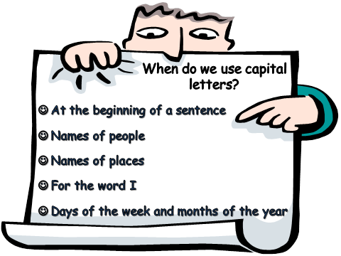
PUT IN CAPITAL LETTERS PLEASE!

- i like to eat pop-corn on Sunday.
- my friend lisa likes reading.
- my birthday is in september.
- my favourite football team is juventus.
- i like to watch spongebob.
- on tuesday and thursday i go to swim.
- my brother thomas is at school.
- i think february is the shortest month.

NOW DO THE SAME WITH THESE SENTENCES!

1) pretty bay is in birzebbuga.
2) i have two cats called rusty and lady.
3) the book is called monsters.
4) i went to england in july.
5) valletta is the capital city of malta.
6) my mum is called rita and dad’s name is peter.
7) my favourite maltese author is trevor zahra.
8) zejtun and marsaxlokk are near birzebbuga.
9) please give me a glass of water.
10) next year I wish to go to Germany.
11) my mum’s car is a skoda.
12) laura and I went to the beach yesterday.
G.Sciberras

