1. Choose the correct answer.
1. Are there any pandas?  __________ | 
2. Are there any bears?  __________ | 
3. Are there any camels?  __________ | 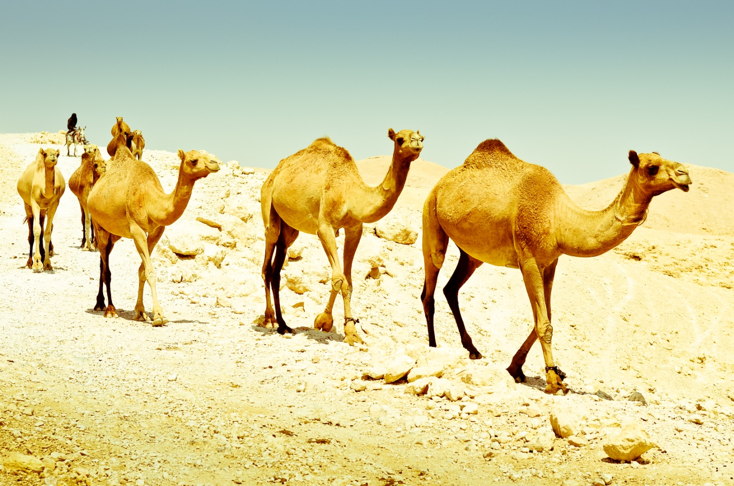
4. Are there any crocodiles?  __________ | 
5. Are there any snakes?  __________ | 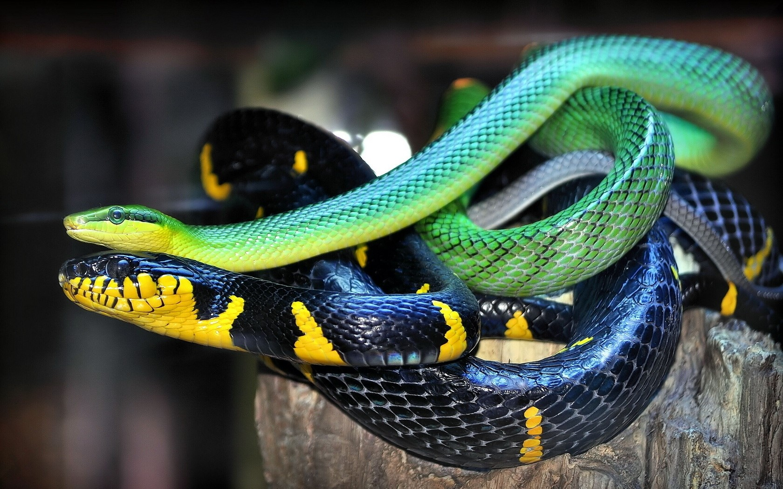
6. Are there any spiders?  __________ | 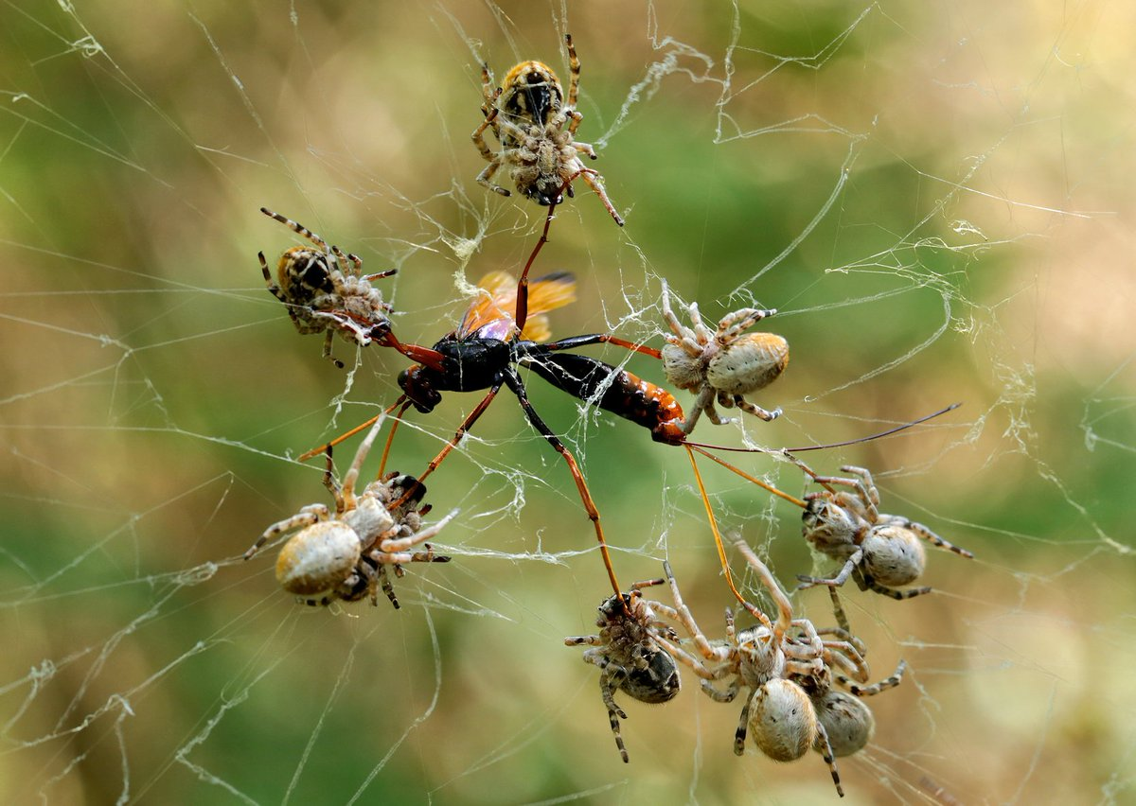
7. Are there any kangaroos?  __________ | 
8. Are there any koalas?  ___________ | 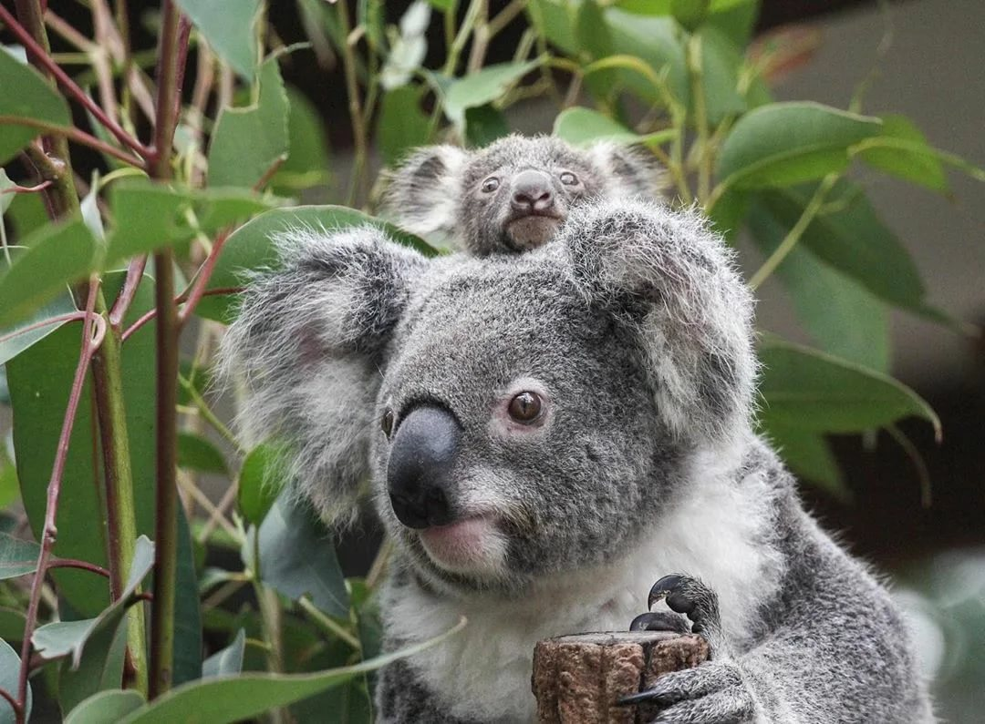

2. Write the missing words.
1. _____ there any monkeys?  Yes, there are. | 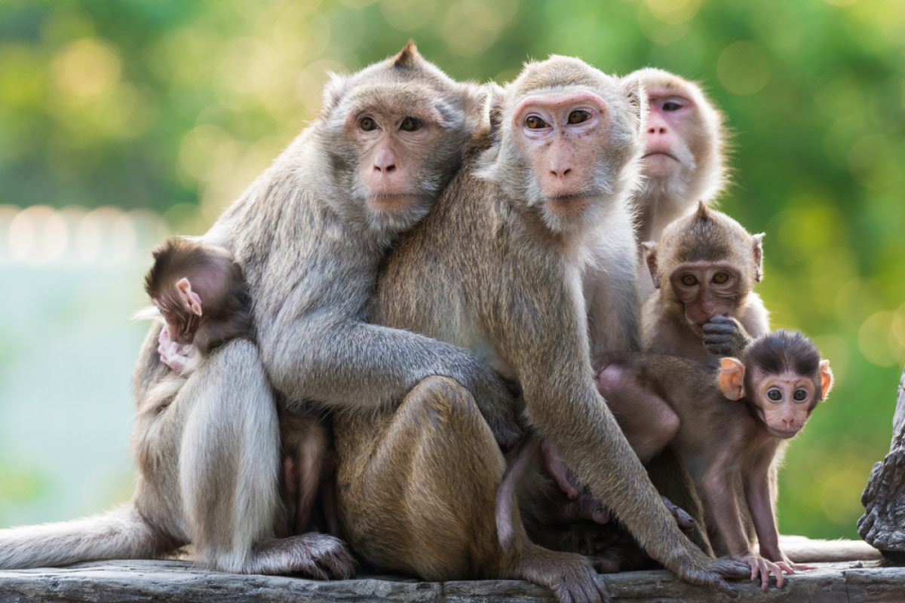
2. Are _______ any dogs?  No, there aren’t. | 
3. Are there _____ cats?  No, there aren’t. | 
4. Are there any __________?

Yes, there are.
5. Are there any elephants?  ____, there aren’t. | 
6. Are there any zebras?  No, ______ aren’t. | 
7. Are there any lions?  Yes, there _____. | 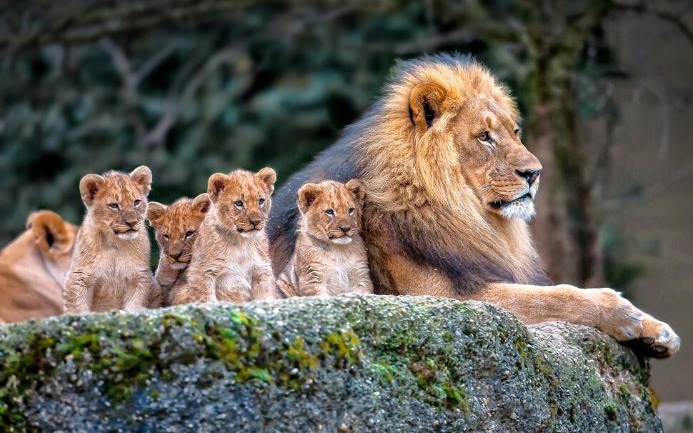
8. Are there any tigers?  _____, there are. | 