# 1 Write ‘s / are and draw
1. Where ____ the red pen? – It’s next to the blue pen. | 2. Where _____ the pencils?  They’re under the book. | 3. Where ______ the cat?  It’s in the box.
4. Where ____ the dog?  It’s next to the slide. | 5. Where _____ the shoes?  They’re under the seesaw. | 6. Where___ the rubber?  It’s on the book.
7. Where ____ the crayons?  They’re in the pencil case. | 8. Where _____ the rulers?  They’re on the table. | 9. Where ____ the tiger?  It’s under the tree.
10. Where ____ the balls?  They’re in the box. | 11. Where ____ the books?  They’re under the table. | 12. Where ___ the man?  He’s next to the car.
13. Where ___ the girl?  She’s on the trapeze. | 14. Where ____ the apples?  They’re next to the box. | 15. Where ____ the umbrella?  It’s next to the boat.

# 2 Look and write
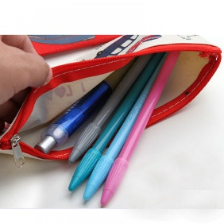 | Where / pencils? Where are the pencils?  pencil case They’re in the pencil case.
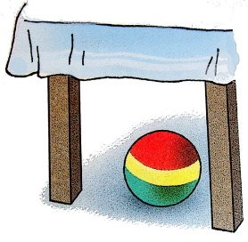 | Where / ball? Where’s the ball?  table It’s under the table.
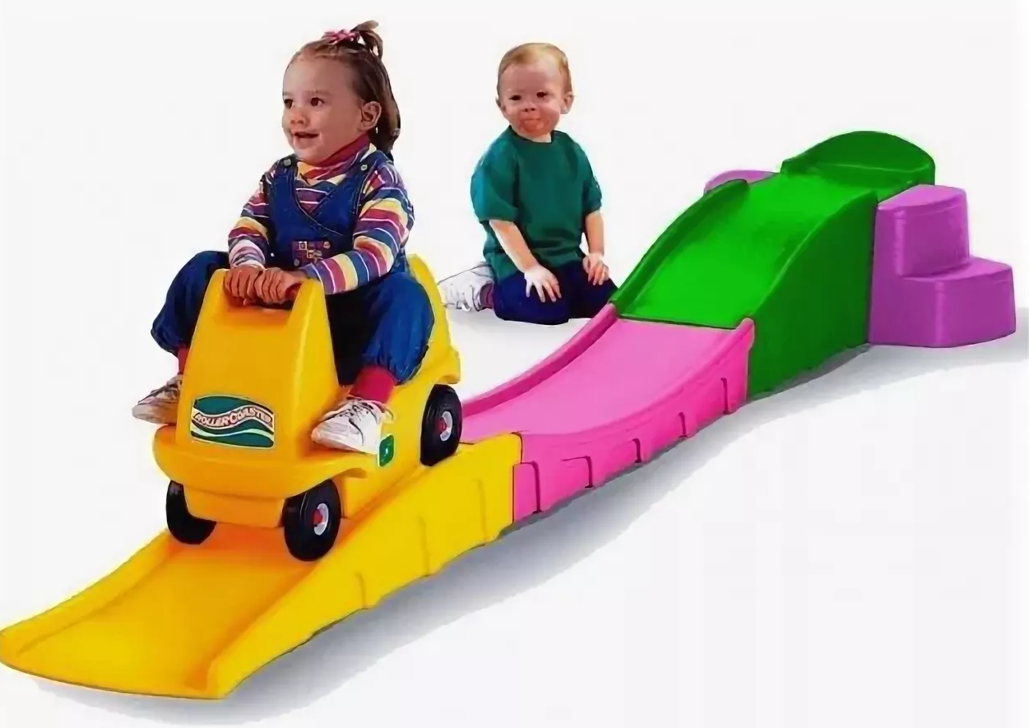 | Where / car? ________________________________________  slide _______________________________________________
 | Where / book?________________________________________  cup ________________________________________________
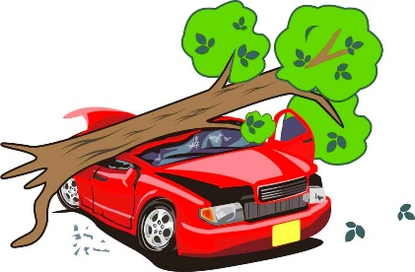 | Where / car? ________________________________________  tree _______________________________________________
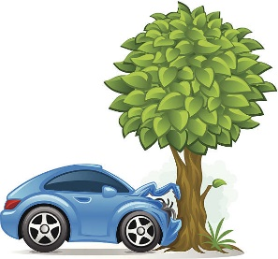 | Where / car? ________________________________________  tree _______________________________________________
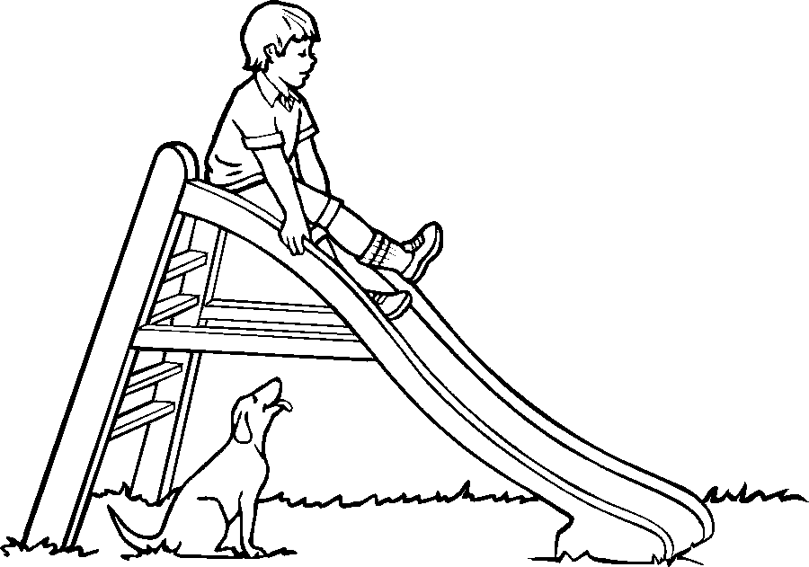 | Where / boy? ________________________________________  slide _______________________________________________  Where / dog? ________________________________________  slide _______________________________________________
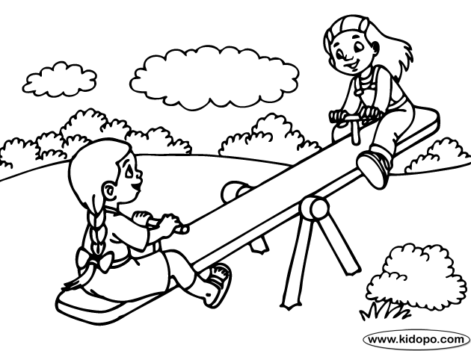 | Where / girls? _______________________________________  seesaw _____________________________________________

