4o

Hai detto:
Paraphrase the poem: I wandered lonely as a cloud That floats on high o'er vales and hills, When all at once I saw a crowd, A host, of golden daffodils; Beside the lake, beneath the trees, Fluttering and dancing in the breeze. Continuous as the stars that shine And twinkle on the milky way, They stretched in never-ending line Along the margin of a bay: Ten thousand saw I at a glance, Tossing their heads in sprightly dance. The waves beside them danced; but they Out-did the sparkling waves in glee: A poet could not but be gay, In such a jocund company: I gazed—and gazed—but little thought What wealth the show to me had brought: For oft, when on my couch I lie In vacant or in pensive mood, They flash upon that inward eye Which is the bliss of solitude; And then my heart with pleasure fills, And dances with the daffodils.
3/3

ChatGPT ha detto:
ChatGPT
Here's a paraphrase of the poem "I Wandered Lonely as a Cloud" by William Wordsworth:

I walked alone, feeling like a cloud drifting high above valleys and hills, when suddenly I saw a large group of bright yellow daffodils. They were beside the lake and under the trees, fluttering and dancing in the wind.
The flowers stretched endlessly, like stars shining in the sky, lining the edge of the bay. There were thousands of them, swaying joyfully in a lively dance.
The nearby waves also danced, but the daffodils were happier and brighter than the waves. Being among them would make any poet feel happy. I kept watching them, not realizing the happiness they would bring me.
Now, whenever I lie on my couch, lost in thought or feeling empty, the image of those daffodils comes back to my mind. I feel the joy of being alone with my thoughts, and my heart fills with happiness, dancing along with the daffodils.
4o

Hai detto:
Create an image to illustrate the poem Daffodils

ChatGPT ha detto:
ChatGPT

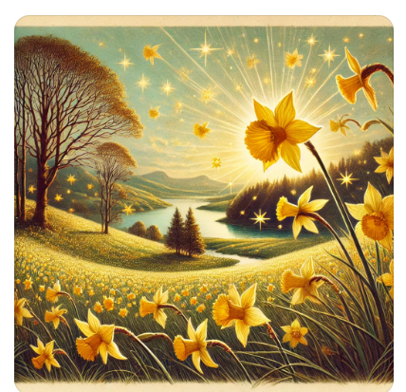
Here is the illustration inspired by the poem "Daffodils" by William Wordsworth. It captures the serene landscape, the dancing daffodils, and the peaceful atmosphere described in the poem. I hope this visual representation brings the poem to life for you!
4o

